|  |  |
| --- | --- |
|  | **MINISTRY OF EDUCATION AND TRAINING** |

|  |
| --- |
| **FPT UNIVERSITY** |
| Capstone Project Document |
| Sales Management System for Major Education |

|  |  |
| --- | --- |
| **GSP21SE12** | |
| **Group Members** | Pham Thi Ngoc Ha – SE130460 *(Leader)*  Le Gia Nguyen – SE63042 *(Team member)*  Nguyen Hoang Gia – SE63203 *(Team member)*  ~~Vu Thien Phu – SE63268~~ *~~(Team member)~~* ~~(dropped)~~ |
| **Supervisor** | Mr. Lai Duc Hung *(Instructor)* |
| **Ext Supervisor** | Mr. Pham Duy Tien *(Customer Representative)*  Ms. Tran Thi Xuan Tuyen *(Customer Representative)* |
| **Capstone Project code** | SMSME |

- Ho Chi Minh City, 01/2021 -

**Table of Contents**

Acknowledgement 21

Definition and Acronyms 22

I. Project Introduction 25

1. Overview 25

2. Product Background 25

3. Existing Systems 25

4. Business Opportunity 28

5. Software Product Vision 28

6. Project Scope & Limitations 28

II. Project Management Plan 30

1. Overview 30

2. Management Approach 35

3. Master Schedule 36

4. Project Organization 37

5. Project Communication 38

6. Configuration Management 39

III. Software Requirement Specification 40

1. Overall Description 40

2. User Requirements 43

3. Functional Requirements 114

4. Non-Functional Requirements 118

5. Other Requirements 119

IV. Software Design Description 121

1. Overall Description 121

2. System Architecture Design 121

3. System Detailed Design 125

4. Class Specifications 138

5. Data & Database Design 146

V. Software Testing Documentation 152

1. Overall Description 152

2. Test Plan 153

3. Test Cases 155

4. Test Reports 155

VI. Release Package & User Guides 156

1. Deliverable Package 156

2. Installation Guides 156

3. User Manual 157

４．ユーザーマニュアル 204

VII. Appendix 227

1. References 227

**List Tables**

Table 1. Definition and Acronyms 24

Table 2. Project Team - Supervisor 25

Table 3. Project Team - Team Members 25

*Table 4. Work Breakdown Structure & Estimation* 32

*Table 5. Project Objectives* 34

*Table 6. Project Risks* 35

*Table 7. Training Plan* 36

Table 8. Master Schedule 37

*Table 9. Roles & Responsibilities* 38

*Table 10. Communication Plan* 38

*Table 11. FU Contacts* 38

*Table 12. Customer Contacts* 39

*Table 13. Tools & Infrastructures* 39

Table 14. Business Rules 42

Table 15. System Actors 43

Table 16. Use Cases List 46

Table 17. <<Unauthorized User>> Login 47

Table 18. <<Unauthorized User>> Forget password 49

Table 19. <<Authorized User>> View profile 50

Table 20. <<Authorized User>> Edit profile 52

Table 21. <<Authorized User>> Change avatar 53

Table 22. <<Authorized User>> Logout 53

Table 23. <<Authorized User>> View notifications 54

Table 24. <<Administrator>> Create new accounts 57

Table 25. <<Administrator>> Search accounts 58

Table 26. <<Administrator>> View list of accounts 59

Table 27. <<Administrator>> View account’s details 60

Table 28. <<Administrator>> Edit account’s information 61

Table 29. <<Administrator>> Create new schools 65

Table 30. <<Administrator>> Search schools 66

Table 31. <<Administrator>> View list of schools 67

Table 32. <<Administrator>> View school’s details 68

Table 33. <<Administrator>> Edit school’s information 69

Table 34. <<Salesman>> Search tasks 71

Table 35. <<Salesman>> View list of tasks 73

Table 36. <<Salesman>> View task’s details 75

Table 37. <<Salesman>> Edit school’s information 76

Table 38. <<Salesman>> Create services 78

Table 39. <<Salesman>> View my services 79

Table 40. <<Salesman>> View service’s details 80

Table 41. <<Salesman>> Edit my services 81

Table 42. <<Salesman>> Create reports 82

Table 43. <<Salesman>> Search reports 84

Table 44. <<Salesman>> View all reports 85

Table 45. <<Salesman>> View report’s details 87

Table 46. <<Salesman>> Edit reports 88

Table 47 <<Salesman>> Remove reports 89

Table 48. <<Salesman>> Create personal activities 91

Table 49. <<Salesman>> Search other’s work-plan 92

Table 50. <<Salesman>> View work-plan 93

Table 51. <<Salesman>> View personal activity’s details 94

Table 52. <<Salesman>> Edit personal activities 97

Table 53. <<Salesman>> Remove personal activities 98

Table 53. <<Salesman>> View my KPIs 99

Table 54. <<Sales Supervisor>> Create tasks 102

Table 55. <<Sales Supervisor>> Edit tasks 103

Table 56. <<Sales Supervisor>> Assign salesmen to tasks 105

Table 57. <<Sales Supervisor>> Remove tasks 106

Table 58. <<Sales Supervisor>> Comment on Salesmen’s reports 108

Table 59. <<Sales Manager>> View all services 110

Table 53. <<Salesman>> Approve services 111

Table 53. <<Salesman>> Set KPI group 112

Table 53. <<Salesman>> View my KPIs 113

Table 53. <<Salesman>> View my KPIs **Error! Bookmark not defined.**

Table 60. Screen Details 115

Table 61. Screen Authorization 116

Table 62. Non-Screen Functions 116

Table 63. Entities List 118

Table 64. Appendix1 - Messages List 120

Table 65. Overall Architecture Data Dictionary 121

Table 66. Package Diagram Specifications 125

Table 67. Class User Specification - Attributes 139

Table 68. Class User Specification - Methods 139

Table 69. Class PersonalActivity Specification - Attributes 140

Table 70. Class PersonalActivity Specification - Methods 140

Table 71. Class Role Specification - Attributes 140

Table 72. Class Role Specification - Methods 140

Table 73. Class Service Specification - Attributes 141

Table 74. Class Service Specification - Methods 141

Table 75. Class Task Specification - Attributes 141

Table 76. Class Task Specification - Methods 141

Table 77. Class Report Specification - Attributes 142

Table 78. Class Report Specification - Methods 142

Table 79. Class School Specification - Attributes 143

Table 80. Class School Specification - Methods 143

Table 81. Class District Specification - Attributes 143

Table 82. Class District Specification - Methods 143

Table 83. Class SchoolStatus Specification - Attributes 143

Table 84. Class SchoolStatus Specification - Methods 143

Table 85. Class TargetSchoolPurpose Specification - Attributes 144

Table 86. Class TargetSchoolPurpose Specification - Methods 144

Table 23. Class EducationalLevel Specification - Attributes 144

Table 24. Class EducationalLevel Specification - Methods 144

Table 89. Enum Class SchoolType Specification 144

Table 26.Class Auditable Specification - Attributes 144

Table 27. Class Auditable Specification - Methods 145

Table 28. Class Kpi Specification - Attributes 145

Table 29. Class Kpi Specification – Methods 145

Table 30. Class KpiGroup Specification - Attributes 145

Table 31. Class KpiGroup Specification – Methods 145

Table 32. Class KpiDetails Specification – Attributes 145

Table 33. Class KpiDeatils Specification – Methods 145

Table 34. Class Criteria Specification – Attributes 146

Table 35. Class Criteria Specification – Methods 146

Table 90. Description for table "school" 147

Table 91. Description for table "district" 147

Table 92. Description for table "school_status" 147

Table 93. Description for table "target_school" 148

Table 94. Description for table "report" 148

Table 95. Description for table "target_school_purpose" 148

Table 96. Description for table "user" 149

Table 97. Description for table "role" 149

Table 98. Description for table "personal_activity" 150

Table 99. Description for table "service" 150

Table 46. Desription for table "service_type" 150

Table 47. Desription for table "kpi" 150

Table 48. Desription for table "kpi_group" 151

Table 49. Desription for table "kpi_details" 151

Table 50. Desription for table "criteria" 151

Table 51. Desription for table "educational_level" 151

Table 100. Data File Design 151

Table 101. Testing Levels 153

Table 102. Testing Types 153

Table 103. Test Stages 153

Table 104. Human Resources 153

Table 105. Environment 154

Table 106. Test Milestones 155

Table 107. Deliverables 155

Table 108. Test Cases 155

Table 109. Test Reports 155

Table 110. Source codes & documents 156

Table 111. <Installation guides> Hardware requirements for Web App 157

Table 112. <Installation guides> Hardware requirements for API service 157

Table 113. <Installation guides> Hardware requirements for Database 157

Table 114. <User Manual> Hardware requirements for Web App 158

Table 115. <User Manual> Hardware requirements for API Services 158

Table 116. <User Manual> Hardware requirements for Database 158

Table 8. View all Accounts <steps> 159

Table 9. View all Accounts <fields> 159

Table 10. View all Accounts <functions> 160

Table 11. Account Filters <steps> 160

Table 12. Accounts Filters <fields> 160

Table 13. Accounts Filters <functions> 160

Table 14. Create Account Form <steps> 161

Table 15 Create Account Form <fields> 162

Table 16 Create Account Form <functions> 162

Table 17. View Accounts details <steps> 162

Table 18. View Account details <fields> 163

Table 19. View Account details <functions> 163

Table 20. View all Schools <steps> 164

Table 21. View all Schools <fields> 164

Table 22. View all Schools <functions> 165

Table 23. Schools Filters <steps> 165

Table 24. Schools Filters <fields> 165

Table 25. Schools Filters <functions> 165

Table 26 Create School Menu <steps> 166

Table 27. Create School Menu <functions> 166

Table 28. Create School Form <steps> 167

Table 29 Create School Form <fields> 168

Table 30 Create School Form <functions> 168

Table 31. Import Schools <steps> 169

Table 32 . Import Schools <fields> 169

Table 33. Import Schools <functions> 169

Table 34. View Schools details <steps> 170

Table 35. View School details <fields> 170

Table 36. View School details <functions> 171

Table 37. View School details <steps> 171

Table 38. View School details <fields> 171

Table 39. View School details <functions> 172

Table 40. View all Tasks <steps> 173

Table 41. View all Tasks <fields> 173

Table 42. View all Tasks <functions> 173

Table 43. Tasks Filters <steps> 174

Table 44. Tasks Filters <fields> 174

Table 45. Tasks Filters <functions> 174

Table 46. View Create Tasks <steps> 175

Table 47. View Create Tasks <fields> 175

Table 48. View Create Tasks <functions> 176

Table 49. Confirm Create Tasks <steps> 176

Table 50. Confirm Create Tasks <fields> 176

Table 51 . Confirm Create Tasks <functions> 176

Table 52. Assign Tasks to Salesman <steps> 177

Table 53. Assign Tasks to Salesman <fields> 177

Table 54 Assign Tasks to Salesman <functions> 177

Table 55. Assign Tasks to Salesman <steps> 178

Table 56 Assign Tasks to Salesman <functions> 178

Table 57. View all Tasks <steps> 179

Table 58. View all Tasks <fields> 179

Table 59. View all Tasks <functions> 180

Table 60. Tasks Filters <steps> 180

Table 61. Tasks Filters <fields> 180

Table 62. Tasks Filters <functions> 181

Table 63. Summit Service <steps> 181

Table 64. Summit Service <fields> 182

Table 65 Summit Service <functions> 182

Table 66. View Task details <steps> 183

Table 67. View Task details <fields> 183

Table 68. View Task details <functions> 183

Table 69. View Task details <steps> 184

Table 70. View Task details <steps> 184

Table 71. View Task details <steps> 185

Table 72. View Task details <functions> 185

Table 73. View all Reports <steps> 186

Table 74. View all Reports <fields> 186

Table 75. View all Reports <functions> 187

Table 76. Reports Filters <steps> 187

Table 77. Reports Filters <fields> 188

Table 78. Reports Filters <functions> 188

Table 79. Create Reports Form <steps> 188

Table 80. Create Reports Form <fields> 189

Table 81. Create Reports Form <functions> 189

Table 82. View Report details <steps> 189

Table 83. View Report details <fields> 190

Table 84. View Report details <functions> 190

Table 85. View Report details <steps> 191

Table 86. View profiles <steps> 191

Table 87. View profiles <functions> 191

Table 88. Edit profiles <steps> 192

Table 89. Edit profiles <functions> 193

Table 90. View all Services <steps> 199

Table 91 View all Services <fields> 199

Table 92 View all Services <functions> 200

Table 93. Services Filters <steps> 200

Table 94. Services Filters<fields> 200

Table 95. Services Filters <functions> 201

Table 96. View Service details <steps> 201

Table 97. View Service details <fields> 201

Table 98. View Service details <functions> 202

Table 99. Login screen <steps> 202

Table 100. Login screen <fields> 203

Table 101. Login screen <functions> 203

Table 102. Log out <steps> 203

Table 103. Log out <functions> 203

Table 104. 「システム要件」 Web アプリの場合 204

Table 105. 「システム要件」 API サービスの場合 205

Table 106. 「システム要件」 Database の場合 205

**List Figures**

Figure 1. Major Features 29

Figure 2. SCRUM Framework 35

Figure 3. Team & Structures 37

Figure 4. System Context Diagram 40

Figure 5. Use case Overview 43

Figure 6. <<Unauthorized User>> Overview Use Case 46

Figure 7. <<Unauthorized User>> Login 46

Figure 8. <<Unauthorized User>> Forget password 47

Figure 9. <<Authorized User>> Overview Use Case 49

Figure 10. <<Authorized User>> View profile 49

Figure 11. <<Authorized User>> Edit profile 50

Figure 12. <<Authorized User>> Change avatar 52

Figure 13. <<Authorized User>> Logout 53

Figure 14. <<Authorized User>> View notifications 54

Figure 15. <<Administrator>> Overview Use Case 55

Figure 16. <<Administrator>> Create new accounts 55

Figure 17. <<Administrator>> Search accounts 57

Figure 18. <<Administrator>> View list of accounts 58

Figure 19. <<Administrator>> View account’s details 59

Figure 20. <<Administrator>> Edit account’s information 60

Figure 21. <<Administrator>> Create new schools 62

Figure 22. <<Administrator>> Search schools 65

Figure 23. <<Administrator>> View list of schools 66

Figure 24. <<Administrator>> View school’s details 67

Figure 25. <<Administrator>> Edit school’s information 68

Figure 26. <<Salesman>> Overview Use Case 70

Figure 27. <<Salesman>> Search tasks 70

Figure 28. <<Salesman>> View list of tasks 72

Figure 29. <<Salesman>> View task’s details 73

Figure 30. <<Salesman>> Edit school’s information 75

Figure 31 <<Salesman>> Create services 77

Figure 32. <<Salesman>> View my services 78

Figure 33. <<Salesman>> View service’s details 79

Figure 34. <<Salesman>> Edit my services 80

Figure 35. <<Salesman>> Create reports 81

Figure 36. <<Salesman>> Search reports 83

Figure 37. <<Salesman>> View all reports 84

Figure 38. <<Salesman>> View report’s details 86

Figure 39. <<Salesman>> Edit reports 87

Figure 40. <<Salesman>> Remove reports 88

Figure 41. <<Salesman>> Create personal activities 89

Figure 42. <<Salesman>> Search other’s work-plan 91

Figure 43. <<Salesman>> View work-plan 92

Figure 44. <<Salesman>> View personal activity’s details 93

Figure 45. <<Salesman>> Edit personal activities 95

Figure 46. <<Salesman>> Remove personal activities 97

Figure 46. <<Salesman>> View my KPIs 98

Figure 47. <<Sales Supervisor>> Overview Use Case 100

Figure 48. <<Sales Supervisor>> Create tasks 100

Figure 49. <<Sales Supervisor>> Edit tasks 102

Figure 50. <<Sales Supervisor>> Assign salesmen to tasks 104

Figure 51. <<Sales Supervisor>> Remove tasks 105

Figure 52. <<Sales Supervisor>> Comment on Salesmen’s reports 106

Figure 53. <<Sales Manager>> Overview Use Case 109

Figure 54. <<Sales Manager>> View all services 109

Figure 46. <<Salesman>> Approve services 110

Figure 46. <<Salesman>> Set KPI group 111

Figure 46. <<Salesman>> View my KPIs 113

Figure 46. <<Salesman>> View my KPIs **Error! Bookmark not defined.**

Figure 55. Screen Flow 114

Figure 56. Entity Relationship Diagram 117

Figure 57. System Architecture 122

Figure 58. Package Diagram 123

Figure 59. Class Diagram 125

Figure 60. Create new accounts 126

Figure 61. Edit school’s information 127

Figure 62. Remove personal activities 128

Figure 63. Edit personal activities 129

Figure 64. View task details 130

Figure 65. Remove report 131

Figure 66. Edit report 132

Figure 67. Login 133

Figure 68. Create tasks 134

Figure 70. Update task's details 135

Figure 71. Remove a task 136

Figure 72. Create reports 137

Figure 73. Update report 138

Figure 74. Database Diagram 146

Figure 75. Prototype model 152

Figure 1. List of Accounts 159

Figure 2. Accounts Filters 160

Figure 3. Create Account Form 161

Figure 4. Account’s details 162

Figure 5. List of Schools 164

Figure 6. Schools Filters 165

Figure 7. Create School Menu 166

Figure 8. Create School Form 167

Figure 9. Import Schools 169

Figure 10. School’s details<General Info> 170

Figure 11. School’s details<Principal Info> 171

Figure 12. List of Tasks<Manager view> 172

Figure 13. Tasks Filters<Sales Manager view> 173

Figure 14. View Create Tasks 175

Figure 15. Confirm Create Tasks Dialog 176

Figure 16. Assign Tasks to Salesman 177

Figure 17. Assign Tasks to Salesman<Salesman Suggestion> 178

Figure 18. List of Tasks<Salesman view> 179

Figure 19. Tasks Filters<Salesman view> 180

Figure 20. Summit Service 181

Figure 21. Task’s details<Task Info> 182

Figure 22. Task’s details<School Info> 183

Figure 23. Task’s details<Timeline> 184

Figure 24. Task’s details<Task Info> 185

Figure 25. List of Reports 186

Figure 26. Reports Filters 187

Figure 27. Create Reports Form 188

Figure 28. Report’s details<Report Info> 189

Figure 29. Report’s details<Assign Info> 190

Figure 30. View profiles <steps> 191

Figure 31 Profile 192

Figure 32 Add New Daily Activity 193

Figure 33 Add New Monthly Activity 194

Figure 34 Add New Weekly Activity 195

Figure 35 Drag Location Card to Add new 195

Figure 36 Add New Activity by Dragging Location Card 196

Figure 37 Add New Yearly Activity 196

Figure 38 Day view 197

Figure 39 Monthly view 197

Figure 40 Quick Add Form 197

Figure 41 Quick Details 198

Figure 42 Edit by Drag Activity 198

Figure 43. List of Services 199

Figure 44. Services Filters 200

Figure 45. Service's detail 201

Figure 46 Login 202

Figure 47 Logout 203

Figure 48アカウントリスト 206

Figure 49 アカウントフィルター 206

Figure 50 アカウントの作成 207

Figure 51 アカウント詳細 208

Figure 52スクールリスト 209

Figure 53 スクールフィルター 209

Figure 54 スクールの作成 209

Figure 55 スクールの作成 ＜フォーム＞ 210

Figure 56スクールの作成 ＜インポートファイル＞ 211

Figure 57スクールの詳細 211

Figure 58タスク 212

Figure 59タスクフィルター 213

Figure 60•タスクの作成 213

Figure 61タスクの作成 214

Figure 62•タスクにセールスマンの割当 214

Figure 63タスクの詳細 215

Figure 64タスクの詳細 216

Figure 65レポートのリスト 217

Figure 66レポートフィルター 217

Figure 67レポートの作成 218

Figure 68レポートの詳細 218

Figure 69プロフィール 219

Figure 70デイビュー 220

Figure 71月表示 220

Figure 72 クイック追加 221

Figure 73 活動の詳細 221

Figure 74 詳細追加 222

Figure 75 ドラッグして編集 222

Figure 76サービスのリスト 223

Figure 77サービスフィルター 224

Figure 78サービスの詳細 224

Figure 79ログイン 225

Figure 80ログアウト 225

# Acknowledgement

Throughout the time of doing this Capstone Project, our team have received a great support and assistance from many people.

We would first like to thank our instructor, Mr. Lai Duc Hung, for his patient guidance, useful critiques, encouragement and tolerance during six months of work.

We would also like to express our great appreciation to Ms. Tran Thi Xuan Tuyen and Mr. Pham Duy Tien, two of the representatives from the Major Education, for their valuable orientation and constructive suggestions in business rules. Our completion of this project could not have been accomplished without their support and guidance.

We wish to thank various people, our friends and seniors namely Mr. Nguyen Trung Hieu, Mr. Duong Tai Toan, Mr. Dang Hoang Son and a special thanks to Mr. Pham Huu Loi and Mr. Le Bui Hoang Minh for all of their time and willingness of supports and contribution to this project.

Our sincere thanks also sends to all our lectures and teachers in our past four years in FPT University. Besides, we would like to express our grateful to the rest of my Capstone Defense committees, Mr. Kieu Trong Khanh, Mr. Nguyen The Hoang, Mr. Trinh Hoang Nam, Mr. Nguyen Dinh Thien and Ms. Than Thi Ngoc Van for their insightful comments as well as suggestions what we need to improvement in this one-month extra.

Last but not least, we wish to thank our family for their understanding and companionship throughout our rough time.

# Definition and Acronyms

|  |  |
| --- | --- |
| **Acronym** | **Definition** |
| *Business Definition[1]* | |
| ME | * Full form: Major Education * Definition:   Name of our customer. Major Education is an educational organization which provides services (courses, programs, foreign English teachers lending) to other schools in Ho Chi Minh City. |
|  | This software is used by 4 roles of users: “Administration”, “Sales Manager”, “Sales Supervisor”, “Salesman”. |
| Admin | * Full form: Administrator * Definition:   This is a person who inputs and modifies raw data of all users and schools in the system. Admin will not dip into the business process. |
| Sales Manager | “Sales Manager” is someone who is responsible for leading and guiding a team of sales people in an organization. They set sales goals & quotas, build a sales plan, analyze data, assign sales training and sales territories, mentor the members of his/her sales team and are involved in the hiring and firing process.[2] |
| Sales Supervisor | “Sales Supervisor” supervises and coordinates the daily activities of sales representatives engaged in promoting and selling a product.[3] |
| Salesman / Salesmen | This is a person whose fundamental job is to sell a product/service [4].  In ME’s case, Salesmen are people who approach the target schools to introduce and sells ME’s services. |
| Schools | “School” refers to all schools from primary to high school, in Ho Chi Minh City.  They are the target partners of the ME.  A school has a “school status”, which really means the segment of customer that ME divide for easier in their business process.  Now, ME divides schools into 4 statuses: “Chưa hợp tác”, “Đang hợp tác”, “Ngưng hợp tác” and “Tiềm năng”. |
| Tiềm năng | “Tiềm năng” is a special group in the school status. Schools which are considered as “Tiềm năng” really are “Chưa hợp tác”. There are three cases of schools can be considered as “Tiềm năng”:   * A school was approached this year but could not sign a contract because they are collaborating with other partners. * A school which has close-nit relationship with ME or with one of the ME’s Salesman. * A school with high possibility to sign a contract with ME. |
| Target Schools | “Target Schools” refers to a sub list of Schools. Every school year, a number of schools will be picked to be targets and the mission of Salesmen is to take business trips to those schools in this list, for a specific purpose, to gain a specific result. |
| Tasks | “Tasks” refers to a list of mission that a Salesman need to do in the period of time.  Each task aims to one target school, with a corresponding purpose (will be list below) based on the current school’s status.  A task has start date, end date (also is called “duration”), salesman who takes responsibility for and a task status.  There are 3 task statuses: “Ongoing”, “Successful”, “Failed”. |
| Purposes | “Purposes” is reason why a salesman need to take the task.  There are 5 purposes: “Sales mới”, “Theo dõi”, “Chăm sóc”, “Tái ký hợp đồng”, “Ký mới hợp đồng” |
| PIC | * Full form: Person in charge * Definition:   “PIC” refers to a person (in ME’s case, it is Salesman) who takes responsibility for a task. |
| Timeline | “Timeline” refers to a list of events in chronological order.  There are two types of timeline in this project, one is for school, one is for task.   * School’s timeline: Contains list of tasks belongs to this school, ordered by school year. * Task’s timeline: Displays the sales process of the Salesman, starts from the task’s start date (usually the date on which a task is assigned) and ends with a services or when this task is marked as completed.   During the period of start date and end date, there is a list of daily reports related to this task. |
| Reports | “Reports” refers to daily reports of Salesmen. Every day they go for a business trip to the target schools, they need to submit a report to record the result of the meeting that day.  For easier to Salesmen/Sales Supervisor/Sales Manager to tracking the progress of the task, all reports of a task are displayed in task’s timeline (as mentioned above). |
| Services | “Services” here refers to list of products/services that ME has already signed successfully with the customer (target school in the task).  Recently, ME are providing four services to customers:  SEL (Social and Emotional Learning – soft skills program), ESL (English program with foreign English teachers), Math & Science and STEAM.  A service includes the service type, price floor, collaboration duration, number of classes applying this services, average number of students per class,…  It is like a small note copy the main content of the signed contract.  The Sales Manager based on the services as well as data analyze from the service to decide whether approve or reject that service. The approval or rejection is only meaning to evaluate KPI and performance of Salesmen, it does not mean that the contract will be canceled if Manager reject this. |
| Evaluation Criteria | “Evaluation Criteria” refers to a table of standard values to measure whether a service meets the required values or not.  The reason of this evaluation is to help the Sales Manager make decisions about a service should be approved or not.  This table includes five criteria:   * Price floor of the service.   This price floor is different depends on service types and school levels.   * Number of periods which that service is taught. * Number of classes in school applying the service. * Average number of students in the applied classes. * Validation period (duration) of the service.   It is the amount of time (by months) that a service is taken effective. |
| KPI | * Full form: Key Performance Indicator * Definition:   “KPIs” are the critical (key) indicators of progress toward an intended result[5].  A KPI is a result measured for a specific person based on a certain formula. |
| Criteria | “Criteria” is an objective or a thing that is used for measurement something (in this case, “criteria” is used to measure KPI).  Each criteria often goes with a “target value” (a desired value the KPI need to meet) and a “weight” (how important is that criteria? It is calculated by the percentage it accounts for in range of 0-100%). |
| KPI Group | “KPI Group” is a set of criteria (including “target value” and “weight”) to be able to apply to measure the KPI of a group of people.  In case of ME, they used to measure KPI of Salesmen. |
| Work Plan | “Work Plans” refers to a personal schedule that each person in the Sales Department makes a plan for themselves.  In a work plan, each item is “Personal activity”. |

Table 1. Definition and Acronyms

# I. Project Introduction

## 1. Overview

### 1.1 Project Information

* Project name: Sales Management System for Major Education
* Project code: SMSME
* Group name: GSP21SE12
* Software type: Web Application

### 1.2 Project Team

#### Supervisor

|  |  |  |  |
| --- | --- | --- | --- |
| **Full Name** | **Email** | **Phone Number** | **Title** |
| Lai Duc Hung | HungLD5@fe.edu.vn | 0976.710.580 | Instructor |

Table 2. Project Team - Supervisor

#### Team Members

|  |  |  |  |
| --- | --- | --- | --- |
| **Full Name** | **Email** | **Mobile** | **Role** |
| Pham Thi Ngoc Ha | HaPTNSE130460@fpt.edu.vn | 0946.753.053 | Leader |
| Le Gia Nguyen | NguyenLGSE63042@fpt.edu.vn | 0984.272.299 | Member |
| Nguyen Hoang Gia | GiaNHSE63203@fpt.edu.vn | 0799.651.670 | Member |
| ~~Vu Thien Phu (dropped)~~ | ~~PhuVTSE63268@fpt.edu.vn~~ | ~~0946.056.921~~ | ~~Member~~ |

Table 3. Project Team - Team Members

## 2. Product Background

Major Education is an educational organization that collaborates with primary schools, secondary schools or high schools in Ho Chi Minh City, in the fields of English, STEM or Abacus Master. All schools in Ho Chi Minh City are considered as Major Education’s customers/partners. Every school year (from May to September), salesmen from Major Education go to the target schools to introduce and sales their programs.

Currently, the Sales Department of Major Education processes all their works manually, from reports collecting, work-plan planning, salesmen managing and tasks managing, based on free software such as Microsoft Excel, Google Sheet and shared files via Google Drive cloud.

Therefore, they expect a software that can help them, for both salesmen and sales managers, to automate the existing manual workflow. Simultaneously, through this application, sales managers will be able to see the overall picture of the company's business process, to know how many schools are cooperating as well as the school’s state.

## 3. Existing Systems

Nowadays, there are a variety of applications that provide CRM (Customer Relationship Management) solutions for businesses. Major Education suggests our team refer to those softwares to visualize the concept and main features of the future product.

### 3.1 CRMViet

CRMViet is a system that provides comprehensive solutions related to CRM for small and medium-sized enterprises (SME) in Vietnam.

*Link:*

* Web application: <https://crmviet.vn/>.
* Mobile application:
  + Android: <https://play.google.com/store/apps/details?id=vn.altalab.app.crmvietpack>.
  + iOS: <https://apps.apple.com/us/app/crmviet/id1197961185>.

*System analysis:*

1. Roles:

* Administrator
* Manager
* Staff
* … (customized roles depends on each company)

1. Platforms:

* Web app
* Mobile app

1. Main features:

* Manage customers
* Support sales and marketing automation
* Manage workflow, tasks, job reminders,…
* Integrated multi-channel
* …

1. Pros:

* A complete and powerful application
* Fulfill all needs of the Major’s Sales Department

1. Cons:

* Many redundant features
* Price is expensive

### 3.2 GetFly

GetFly is a system that provides comprehensive solutions related to CRM for small and medium-sized enterprises (SME) in Vietnam.

*Link:*

* Web application: <https://getfly.vn/>.
* Mobile application:
  + Android: <https://play.google.com/store/apps/details?id=com.getflyvn.crm>.
  + iOS: <https://apps.apple.com/us/app/getflyvn/id1490060413>.

*System analysis:*

1. Roles:

* Administrator
* Manager
* Staff
* … (customized roles depends on each company)

1. Platforms:

* Web app
* Mobile app

1. Main features:

* Manage customers
* Support marketing automation (via SMS, email, or social network)
* Manage departments, sales team,…
* Manage workflow, tasks, KPIs,…
* Integrate modules extension
* …

1. Pros:

* A complete and powerful application
* User-friendly UI
* Fulfill all needs of the Major’s Sales Department

1. Cons:

* Overpowered, many redundant features
* Require monthly payment

### 3.3 EasyEdu

EasyEdu is a system to manage all activities of many departments in an educational organization, especially for language centers. EasyEdu provides solutions for managing finances, expenses, marketing, human resources, class attendance reports, CRM,…

*Link:*

* Web application: <https://easyedu.vn/>.
* Mobile application:
  + Android:

Teacher: <https://play.google.com/store/apps/details?id=com.easyedu.manager&hl=vi>.

Parent/Student: <https://play.google.com/store/apps/details?id=com.easyedu.customer&hl=vi> .

* + iOS:

Teacher: <https://apps.apple.com/vn/app/easy-manager/id1495280190?l=vi>.

Parent/Student: <https://apps.apple.com/vn/app/easy-edu/id1472824752?l=vi> .

*System analysis:*

1. Roles:

* Administrator
* Staff
* Teacher
* Parent/Student

1. Platforms:

* Web app (for all roles)
* Mobile app (one for Teacher and one for Parent/Student)

1. Main features:

* Manage finances, expenses, marketing campaigns, SMS/chats…
* Manage human resources, departments, agencies,…
* Manage customer relationship
* Manage courses, classes, attendances,…
* Manage tasks, schedules,…
* Provide an online learning platform

1. Pros:

* A complete and powerful application
* Good UI

1. Cons:

* Overpowered and too complicated for what the customer (Sales Department of Major Education) really need
* Is a B2C system (one side is the language center, one side is parent/student)
* Require payment (monthly or annually)

## 4. Business Opportunity

Although the current CRM applications in the market can partially meet the requirements of the business, Major Education still has to pay for many redundant features, which they rarely or would not use. That is why Major Education requests this Sales Management System to specify for their business model. The model of software that we are building is only used for staffs in the Sales Department of Major Education and is not public commercially to the current market. As this Sales Management Software would innovate and improve the effectiveness of Major Education’s manual workflow, so it would save employees’ time and effort to complete their daily tasks as usual.

However, in fact, due to the time and developer team’s experience limitation, we could not covered for the whole Major Education’s sales process yet some features would be upgraded in the next versions of this software.

## 5. Software Product Vision

The target users that SMSME aims to are salesmen and sales managers of the Sales Department of Major Education.

For salesmen, this software would help them manage their work-plan as well as their tasks easier and more visually, submit daily reports more directly and they can also monitor other salesmen’s works.

For sales managers, they would not have to collect and analyse all salesmen’s reports manually. Now they can supervise salesmen or search for reports more easily. Moreover, they can see the overall picture of the company's business process, including what schools are lead customers, who are the most effective salesmen.

## 6. Project Scope & Limitations

### 6.1 Major Features

There are four roles in this system, which includes the following major features:

FE-01: Administrator can manage user accounts (view, create, edit, remove).

FE-02: Administrator can manage all schools (view, create, edit, remove).

FE-03: Sales Manager and Sales Supervisor can manage all tasks (view, create, edit, remove, assign).

FE-04: Salesman can view his/her own assigned tasks.

FE-05: Salesman can manage own daily reports (create, edit, remove) and view all reports.

FE-06: Sales Manager and Sales Supervisor can comment on other’s reports.

FE-07: Salesman can submit services of his/her assigned schools.

FE-08: Sales Manager can approve or reject submitted services.

FE-09: Sales Manager can evaluate Salesmen and manage Salesman’s KPI (create, disable).

FE-10: Sales Manager, Sales Supervisor and Salesman can manage own work-plan (create, edit, remove personal activities) and view work-plan of each other.

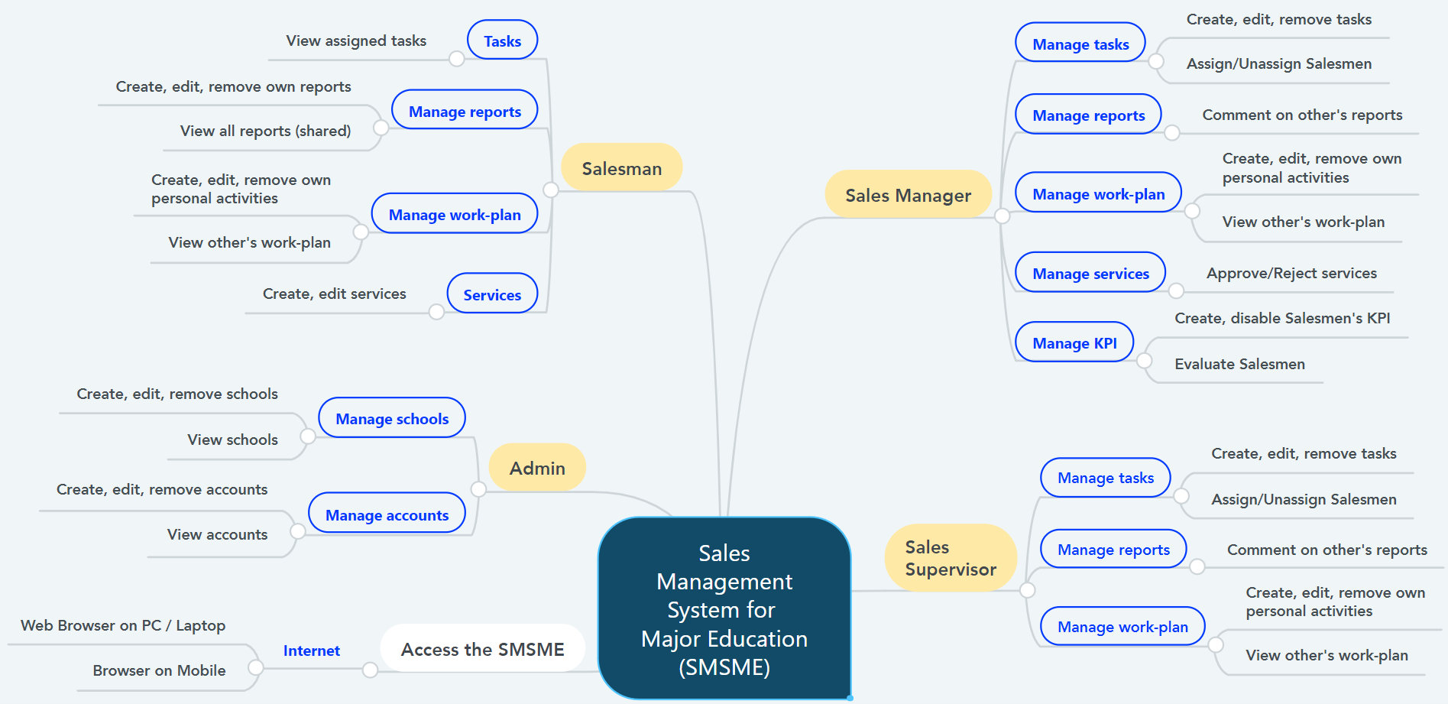

Figure 1. Major Features

### 6.2 Limitations & Exclusions

LI-1: The SMSME has not supported versions for Mobile application yet. SMSME now is a responsive Web application.

LI-2: The SMSME does not support communication channel with customers.

LI-3: The SMSME has not supported feature “Manage Salesmen” or “Manage team” yet.

LI-4: The SMSME shall be used only for the Sales Department of the Major Education.

# II. Project Management Plan

## 1. Overview

### 1.1 WBS & Estimation

|  |  |  |  |
| --- | --- | --- | --- |
| **#** | **WBS Item** | **Complexity** | **Est. Effort**  **(man-days)** |
| ***1*** | ***Initiating*** |  | ***14*** |
| 1.1 | Meet customers at Viet Anh School (Major Education) | Simple | 1 |
| 1.2 | Gain requirements | Medium | 3 |
| 1.3 | Write “Current System Description” | Medium | 4 |
| 1.4 | Confirm “Current System Description” with customers | Simple | 1 |
| 1.5 | Write Report 1 (Introduction) | Medium | 4 |
| 1.6 | Collect stakeholders’ contact information | Simple | 1 |
| ***2*** | ***Planning*** |  | ***17*** |
| 2.1 | Discuss project scope with development team | Simple | 3 |
| 2.2 | Estimate time to finish the project | Simple | 1 |
| 2.3 | Discuss project’s limitations and risks | Simple | 2 |
| 2.4 | Discuss model to use for project management | Simple | 2 |
| 2.5 | Create project plan & work breakdown structure (WBS) | Simple | 3 |
| 2.6 | Assign roles in this project for each team member | Medium | 1 |
| 2.7 | Write Report 2 (Project Management) | Medium | 5 |
| ***3*** | ***Executing*** |  | ***294*** |
| **3.1** | **Analysis** |  | **41** |
| 3.1.1 | Analyze users’ requirements:   * Identify stakeholders * Identify user roles in this system * Identify needs and activities of each role | Complex | 9 |
| 3.1.2 | Analyze materials that Major provided   * Analyze Major current working process (7 steps) * Analyze Excel files (including sample data of tasks, assignment, daily reports,…) | Medium | 4 |
| 3.1.3 | Research business definitions | Simple | 2 |
| 3.1.4 | Use free trial of CRM applications (CRMViet, EasyEdu,…) | Simple | 3 |
| 3.1.5 | Create Use case Diagram | Complex | 8 |
| 3.1.6 | Write Report 3 (Software Requirement Specification – SRS) | Complex | 15 |
| **3.2** | **Designing** |  | **34** |
| 3.2.1 | Create Entity Relationship Diagram (ERD) | Medium | 6 |
| 3.2.2 | Create Database Diagram | Simple | 3 |
| 3.2.3 | Create Class Diagram | Medium | 4 |
| 3.2.4 | Create Architecture Diagram | Medium | 3 |
| 3.2.5 | Standardize provided Excel files | Simple | 3 |
| 3.2.6 | Write Report 4 (Software Design Document – SDD) | Complex | 15 |
| **3.3** | **Prototyping** |  | **27** |
| 3.3.1 | Draw draft major screens on paper | Simple | 6 |
| 3.3.2 | Create prototype for role Admin | Simple | 3 |
| 3.3.3 | Create prototype for role Salesman | Medium | 9 |
| 3.3.4 | Create prototype for role Sales Supervisor | Medium | 6 |
| 3.3.5 | Create prototype for role Sales Manager | Medium | 3 |
| **3.4** | **Implementing** |  | **153** |
| 3.4.1 | Install coding environment (Eclipse, Visual Studio Code) | Simple | 2 |
| 3.4.2 | Identify coding conventions (Front-end & Back-end) | Medium | 2 |
| 3.4.3 | Implement “Admin” module – Iteration 1 |  |  |
| 3.4.3.1 | Update SRS and SDD (Iteration 1) | Medium | 9 |
| 3.4.3.2 | Create test plan and test cases (Iteration 1) | Medium | 6 |
| 3.4.3.3 | Code and perform unit test (Iteration 1) | Complex | 9 |
| 3.4.3.4 | Deploy package 1 | Simple | 3 |
| 3.4.4 | Implement “Salesman” module – Iteration 2 |  |  |
| 3.4.4.1 | Update SRS and SDD (Iteration 2) | Medium | 12 |
| 3.4.4.2 | Create test plan and test cases (Iteration 2) | Medium | 6 |
| 3.4.4.3 | Code and perform unit test (Iteration 2) | Complex | 15 |
| 3.4.4.4 | Execute integration test and system test (Iteration 2) | Medium | 6 |
| 3.4.4.5 | Deploy package 2 | Simple | 1 |
| 3.4.5 | Implement “Sales Supervisor” module – Iteration 3 |  |  |
| 3.4.5.1 | Update SRS and SDD (Iteration 3) | Medium | 12 |
| 3.4.5.2 | Create test plan and test cases (Iteration 3) | Medium | 6 |
| 3.4.5.3 | Code and perform unit test (Iteration 3) | Complex | 15 |
| 3.4.5.4 | Execute integration test and system test (Iteration 3) | Medium | 9 |
| 3.4.5.5 | Deploy package 3 | Simple | 1 |
| 3.4.6 | Implement “Sales Manager” module – Iteration 4 |  |  |
| 3.4.6.1 | Update SRS and SDD (Iteration 4) | Medium | 12 |
| 3.4.6.2 | Create test plan and test cases (Iteration 4) | Medium | 6 |
| 3.4.6.3 | Code and perform unit test (Iteration 4) | Complex | 9 |
| 3.4.6.4 | Execute integration test and system test (Iteration 4) | Medium | 9 |
| 3.4.6.5 | Deploy package 4 (product version Alpha) | Simple | 3 |
| **3.5** | **Testing** |  | **30** |
| 3.5.1 | Fix bugs and retest | Medium | 12 |
| 3.5.2 | Get feedback from customers after acceptance test | Medium | 8 |
| 3.5.3 | Deploy full package (product version Beta) | Simple | 4 |
| 3.5.4 | Write Report 5 (Testing) | Medium | 6 |
| **3.6** | **Support** |  | **9** |
| 3.6.1 | Write Report 6 (User Guides) | Medium | 6 |
| 3.6.2 | Train customers (end-users) how to use this application | Simple | 3 |
| ***4*** | ***Monitoring and Controlling*** |  | ***9*** |
| 4.1 | Evaluate project’s code quality | Complex | Cannot estimate due to SCRUM model |
| 4.2 | Refractor/Optimize code (optional) | Complex |
| 4.3 | Tracking project’s progress, scope and risks | Medium |
| 4.4 | Write Report 7 (Final Project Report) | Complex | 9 |
| ***5*** | ***Closing*** |  | ***18*** |
| 5.1 | Create final presentation | Simple | 6 |
| 5.2 | Practice Thesis presentation | Medium | 9 |
| 5.3 | Present at Capstone Project Defense | Complex | 3 |
| ***Total Estimated Effort (man-days)*** | | | ***352*** |

*Table 4. Work Breakdown Structure & Estimation*

### 1.2 Project Objectives

To create utility, practical and friendly sales management application for Sales Department of Major Education.

|  |  |  |  |  |
| --- | --- | --- | --- | --- |
| **#** | **Quality Stage** | **No. of Defects** | **% of Defect** | **Notes** |
| 1 | Initiating | 2 | 8.7% | * Gain sufficient and useful information for requirement analysis in the next stage. * All team members must understand clearly customer’s situation and demands. |
| 2 | Planning | 1 | 4.3% | Project plan must be attainable, time-bound and specific. |
| 3 | Analysis | 4 | 17.4% | Confirm SRS (functional requirements, non-functional requirements, business rules) with the customers before moving to “Implementing” stage. |
| 4 | Designing | 4 | 17.4% | * Design Use Cases Diagram, ERD and Database based on result of stage 3 (Analysis). * Review carefully with the Instructor before moving to the next stages. |
| 5 | Prototyping | 3 | 13.2% | Design and confirm with customers all screens of all roles before move to “Implementing” stage. |
| 6 | Implementing | 4 | 17.4% | * Strictly follow the general coding convention. * All team members need to update code regularly. |
| 7 | Testing | 2 | 8.7% | * Each developer applies unit test before merge code with each other. * Both Front-end code and Back-end code need to be tested carefully before deploying to the Server. * Have Acceptance test (-test) in the customer-side, in real business environment. |
| 8 | Support | 1 | 4.3% | Project team needs to provide User Guide documents, and also spend time in real business environment to support to the customers at the beginning of the deployment. |
| 9 | Monitoring & Controlling | 1 | 4.3% | * Not only Team Leader needs to track the progress of other team members. * Using version control to keep track of the changes in stages “Designing”, “Prototyping” and “Implementing”. * Applying SCRUM model. |
| 10 | Closing | 1 | 4.3% | All team members need to join slide designing and prepare thoroughly for the final presentation. |
| ***Total*** | | ***23*** | ***100%*** |  |

*Table 5. Project Objectives*

### 1.3 Project Risks

|  |  |  |  |  |
| --- | --- | --- | --- | --- |
| **#** | **Risk Description** | **Impact** | **Possibility** | **Response Plans** |
| **I** | **Requirement risks** | | | |
| 1 | Development team misunderstands or unclears customer requirements | High | High | Meet customers regularly to confirm our thoughts or do not hesitate to ask customers via Zalo group chat. |
| 2 | Customers do not clear about their requirements | High | Medium | Create prototypes or suggest our solutions to customers and confirm with them what features they want to use. |
| 3 | Unexpected scope change | Medium | Low | If new feature is justifiable and time remaining is enough, development team will implement that feature.  If not, team need to deal with customers to implement that feature in the next version. |
| **II** | **Techical risks** | | | |
| 4 | Lack of technical knowledge or poor coding skills | High | Medium | * Enhance self-research. * Exchange knowledge with other team members or other teams. |
| 5 | Poor code quality | Medium | Medium | Strictly follow code convention, carry out acceptance test to ensure quality source code. |
| **III** | **Human risks** | | | |
| 6 | Restricted in direct meeting and communication due to Covid-19 | High | High | * Team can use online meeting platforms (Google Meet, Zoom,…) or send resources via email. * Team can deploy live demo on Ngrok for customers using. |
| 7 | Conflicts between team members | High | High | Team need a meeting, all members share uncomfortable things. |
| 8 | Over deadline | High | High | * Each member has to report their working progress daily. * Team members need to support each other to finish tasks in time. |
| 9 | Lack of real experiences | Low | High | Ask instructor or customer Exchange knowledge with other team members or other teams. |

*Table 6. Project Risks*

## 2. Management Approach

The project management model our team chose to manage and implement in this project is Agile methodology, for more specific, is SCRUM framework.

### 2.1 Project Process

We chose Scrum framework because of the following reasons:

* As we are making real product for a real company, we need to satisfy the customers first by early deliverables.
* Scrum requires regular meeting and communication, so development team will closely follow user’s requirements, reduce deviation.
* Scrum welcome changes, even during the developing process.
* Scrum allows us to divide work into small sprints, which will deliver module package each sprint, so we can easily manage bugs, fix bugs faster and reduce risks.

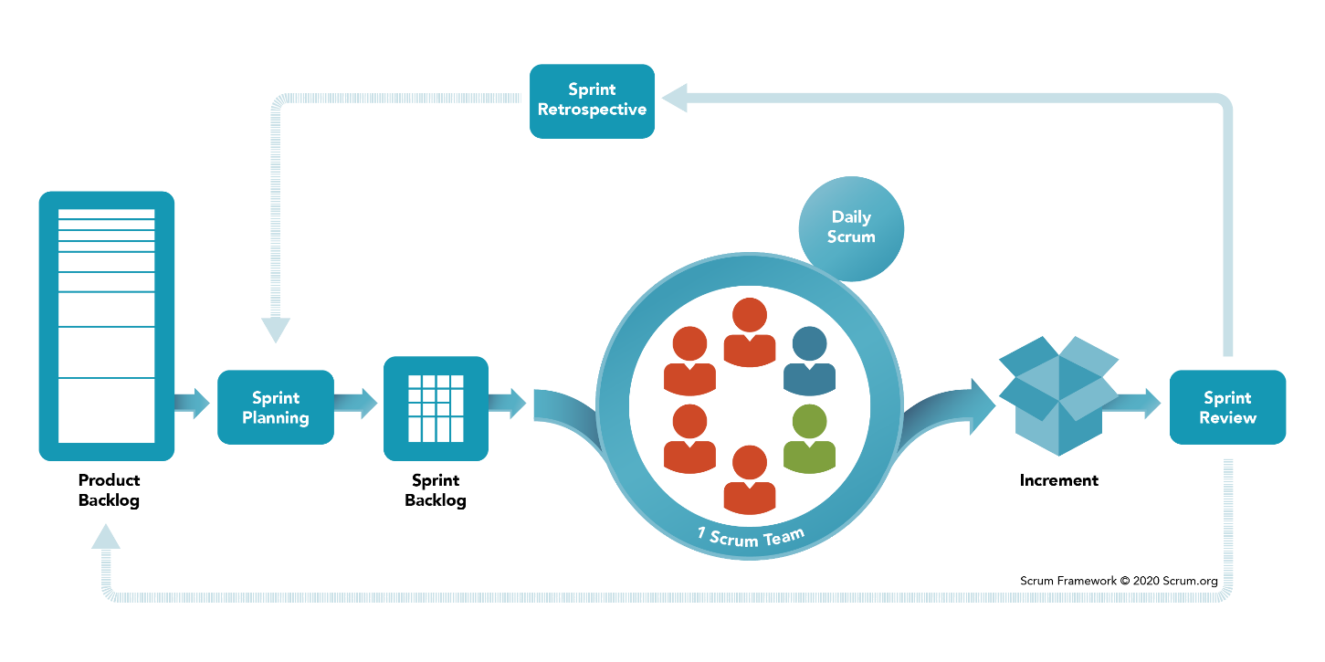

Figure 2. SCRUM Framework

*Reference:* [*https://www.scrum.org/resources/what-is-scrum*](https://www.scrum.org/resources/what-is-scrum)

Product backlog and Sprint backlog can be seen at *http://bit.ly/salesmgt-backlog*.

### 2.2 Quality Management

To enhance the quality, the team have to:

* Follow all code conventions and ensure clean code.
* Refer to and study similar working applications in the market.
* Ensure all team members clearly understand user requirements and prototype.

### 2.3 Training Plan

|  |  |  |  |
| --- | --- | --- | --- |
| Training Area | Participants | When, Duration | Waiver Criteria |
| Java Spring Boot | All team members | Week 3rd | Mandatory |
| HTML, CSS, Javascript (ES6) | All team members | Week 1st | Mandatory |
| SCSS | All team members | Week 1st | Optional |
| ReactJS | All team members | Week 3rd | Mandatory |
| UML 2.0 conventions | All team members | Week 2nd | Mandatory |
| Git, GitHub | All team members | Week 1st | Mandatory |

*Table 7. Training Plan*

## 3. Master Schedule

|  |  |  |  |
| --- | --- | --- | --- |
| **#** | **Deliverable** | **Due Date** | **Deliverable Scope** |
| 1 | Project Introduction (Report 1) | Week 2 |  |
| 2 | Project Plan (Report 2) | Week 2 | Work Breakdown Structure (WBS) |
| 3 | SRS (Report 3) | Week 4 | Use case Diagram and Specification, non-functional requirements, screen flow and description |
| 4 | Design (Report 4) | Week 6 | Architecture Diagram, Detailed Design, ERD, Database Diagram, Prototypes |
| 5 | Code Package 1: module “Admin” (Front-end) | Week 8 | Codes & Unit test cases |
| 6 | Code Package 2: module “Salesman” (Front-end) | Week 10 | Codes & Unit test, System test cases |
| 7 | Code Package 3: module “Sales Supervisor”  (Front-end) | Week 12 | Codes & Unit test, System test test cases |
| 8 | Code Package 4: module “Sales Manager”  (Front-end) | Week 12 | Codes & Unit test, System test test cases |
| 9 | Code Package 1  (Back-end) | Week 8 | Codes & Unit test cases |
| 10 | Code Package 2  (Back-end) | Week 10 | Codes & Unit test, System test test cases |
| 11 | UAT Package | Week 14 | Code, System test reports |
| 12 | Final Package | Week 15 | Final codes & documents, User guides |

Table 8. Master Schedule

## 4. Project Organization

### 4.1 Team & Structures

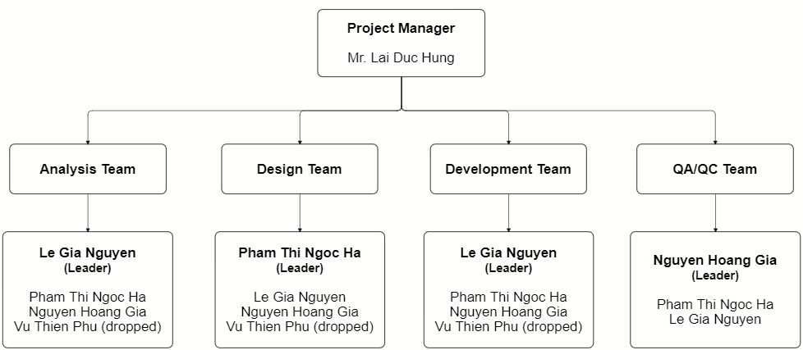

Figure 3. Team & Structures

### 4.2 Roles & Responsibilities

|  |  |
| --- | --- |
| **Role** | **Responsibility** |
| Project Manager | * Be a bridge between Major Education and FPTU development team in the initial stage of the project. * Give guidance, review deliverables during project time. |
| Analysis Leader | * Communicate with the customers to get requirements. * Analyse customer’s requirements and business then explain to team members. * Generate use cases and diagrams in Software Design Description (SDD). * Review and adjust project’s documents made by analysis members. |
| Analysis Member | * Communicate with customers to get requirements. * Analyze customer’s requirements and business. * Draw software diagrams (use cases diagram, ERD,…) and write documents (SRS, SDD). |
| Design Leader | * Design prototypes for website layouts. * Assign tasks for team members. |
| Design Member | * Design prototypes for tasks assigned by the Design Leader. * Review draft prototypes of Design Leader. * Review prototypes of each other. |
| Technical Leader | * Study and decide architecture and technologies using in the project. * Assign tasks for development team members. * Track the work progress of the project. * Review member's code and fix errors. |
| Developer | * Implement code for tasks assigned by the Technical Leader. * Implement unit test. |
| Test Leader | * Write test cases and test plan for the project. * Assign tasks for team members. * Review test results of team members and make test strategy. * Implement the system test. * Collect and Analyze customer’s comments at phase UAT. |
| Test Member | Write test cases and test modules as tasks assigned by the Test Leader. |

*Table 9. Roles & Responsibilities*

## 5. Project Communication

### 5.1 Communication Plan

|  |  |  |  |  |
| --- | --- | --- | --- | --- |
| **Communication Item** | **Who/ Target** | **Purpose** | **When, Frequency** | **Type, Tool, Method(s)** |
| First meeting | Project supervisor, Project team, Major team (customers) | Introduce the project | Once | Meeting |
| Weekly meeting | Project supervisor, Project team | Review project status | Weekly | Meeting |
| Meeting minute reports | Project supervisor, Project team | Inform supervisor and team members about weekly meeting contents | Weekly | Document file  Submit via email |

*Table 10. Communication Plan*

### 5.2 External Interface

#### FU Contacts

|  |  |  |  |
| --- | --- | --- | --- |
| Function | Contact Person  (name, position) | Contact address  (email, telephone) | Responsibility |
| Supervisor | **Lai Duc Hung**  Instructor | [HungLD5@fe.edu.vn](mailto:HungLD5@fe.edu.vn)  0976.710.580 | - Provide document templates. - Give instruction to project team. - Review deliverables. - Supervise project status. |

*Table 11. FU Contacts*

#### Customer Contacts

|  |  |  |  |
| --- | --- | --- | --- |
| Function | Contact Person  (name, position) | Contact address  (email, telephone) | Responsibility |
| Customer Representor | **Pham Duy Tien** Sales Supervisor | [duytien@truongvietanh.com](mailto:duytien@truongvietanh.com)  0963.281.235 | - Give and describe requirements.  - Review deliverables of the development team. |
| Coordinator | **Tran Thi Xuan Tuyen**  Account Manager | [xuantuyen@truongvietanh.com](mailto:xuantuyen@truongvietanh.com)  0938.137.949 | Introduce project and related person in charge of this project |
| Supporter | **Le Quy Mai Huyen**  Vice president | huyen@truongvietanh.com  0984.388.988 | Support to connect between Major team and development team. |

*Table 12. Customer Contacts*

## 6. Configuration Management

### 6.1 Tools & Infrastructures

|  |  |
| --- | --- |
| **Programming languages** | Java (Java EE 11), Javascript (ES6) |
| **Framework** | Spring Boot, MaterialUI |
| **Library** | ReactJS, Syncfusion |
| **API** | RESTful API, Postman, Swagger |
| **DBMS** | MySQL |
| **IDEs/Editors** | Eclipse, Visual Studio Code |
| **UML tools** | StarUML, LucidChart, draw.io, Cacoo |
| **Version Control** | git (GitHub) |
| **Deployment server** | Amazon Web Services (EC2, RDS) |
| **Cloud Services** | Firebase Storage (store images) Firebase Realtime Database (store notifications) |
| **Project management tool** | Google Sheet (Google Drive) |

*Table 13. Tools & Infrastructures*

### 6.2 Document Management

We create a shared GitHub account only used only for this project, all team members can access to this account.

In this account, we create a repository for storing all materials related to documents, including 7 reports, requirements analysis, Major’s files, UML diagrams of SDD and weekly meeting minutes.

Link: <https://github.com/salesmgt/documentation>.

### 6.3 Source Code Management

In the shared GitHub account mentioned in part 6.2, we create one repository for prototype, one for front-end codes and one for back-end codes.

Because this project is built for the real company so we shall not share the repositories of front-end and back-end source codes in this document.

Link: <https://github.com/salesmgt/prototype>.

# III. Software Requirement Specification

## 1. Overall Description

### 1.1 Product Overview

The Sales Management System for Major Education is a new software system that replaces the current manual working processes of the Sales Department of Major Education.

The working processes includes managing tasks and their related materials (daily reports, services), collecting daily reports, and planning work-plan.

The system context diagram below demonstrates the human components (actors) that interacted with SMSME for release 1.0.

The SMSME is expected to automate the existing manual workflow of Major Education and increase the working productivity of Major’s staffs by giving motivation between them.

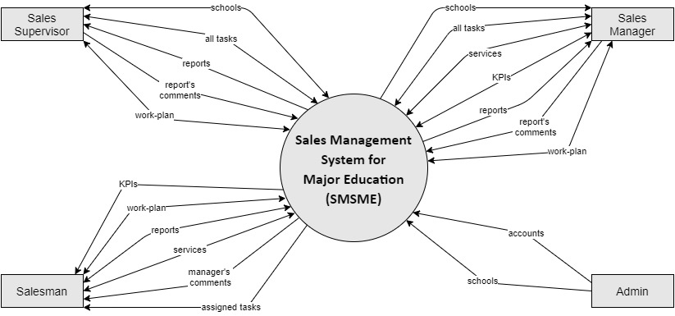

Figure 4. System Context Diagram

### 1.2 Business Rules

|  |  |
| --- | --- |
| **ID** | **Rule Definition** |
| BR-01 | This system is only used for Sales Department of the Major Education.  Public users shall not use this system. |
| BR-02 | Users shall not register an account. Only Administrators (Admin) can create new accounts for users. |
| BR-03 | Users shall reset their forgotten password.  When users send request to reset their forgotten password, the system automatically generates a verification code and sends that code to user’s email. |
| BR-04 | Admin shall create new accounts for users but not including the password.  Password is automatically generated by the system and sent to user’s email. |
| BR-05 | Users (all roles) can view and edit their profile, including email, phone number, address, avatar and password.  Users shall not edit username, full name, birthday, gender and working status (“active”/ “inactive”) (also shall not view “working status”). |
| BR-06 | When an employee quits his/her job or moves to another department, Admin shall changes his/her “working status” from “active” to “inactive”. |
| BR-07 | Users whose “working status” is “inactive” shall not log into the system. |
| BR-08 | Admin shall edit user’s phone number, gender, birthday, roles, and working status.  Admin shall not edit username and email of the existed accounts. |
| BR-09 | Admin manage the raw data of all accounts and schools in the system.  Admin shall not create or edit fields related to business process of the sales. |
| BR-10 | Only Admin shall create new schools.  Sales Managers and Sales Supervisors can view list of all schools and their details but shall not create. |
| BR-11 | Sales Managers and Sales Supervisors shall create lists of tasks.  The initial list of tasks has not had PIC and start date yet.  The initial list of tasks is required to have purpose.  After the creation, task has not started yet. Task only starts after being assign.  So assigned date plays a role as start date. |
| BR-12 | Sales Managers and Sales Supervisors can modify (create, remove, edit or assign) lists of tasks. |
| BR-13 | Sales Managers and Sales Supervisors shall not modify (create, remove, edit or assign) lists of tasks in the past. |
| BR-14 | Sales Managers and Sales Supervisors shall assign or unassigned Salesmen to tasks.  The assigned person is called “PIC” (person in charge). |
| BR-15 | Each task shall be assigned to only one PIC at a time.  A task can be assigned many times to different PIC. |
| BR-16 | An assigned task can be unassigned. |
| BR-17 | If Sales Managers want to change the PIC of a task, they need to unassign the current PIC first before assigning a new PIC. |
| BR-18 | Sales Managers and Sales Supervisors shall not remove tasks which have been assigning or having reports or being in the service’s duration. |
| BR-19 | Only Sales Managers and Sales Supervisors can view list of all tasks.  Salesmen can only view list of their own assigned tasks. |
| BR-20 | Business trips to each target school have different purposes, depends on the school status. Below is list of purposes for each school status:   * School status “Chưa hợp tác” and “Tiềm năng”: “Sales mới”. * School status “Đang hợp tác”: “Chăm sóc”, “Tái ký hợp đồng”, “Ký mới hợp đồng”. * School status “Ngưng hợp tác”: does not have any purpose. |
| BR-21 | Salesmen shall visit target schools of their assigned tasks. After every business trip to the target schools, Salesmen shall submit a daily report. |
| BR-22 | Salesmen shall successfully meet school’s representatives (principals) of at least 3 new target schools every working day. |
| BR-23 | Salesmen shall not create reports for a date in the past or the future.  The reported date is the current date. |
| BR-24 | List of all reports is shared, so any Salesmen, Sales Managers or Sales Supervisors can view it. |
| BR-25 | Sales Managers and Sales Supervisors can comment on other Salesmen’s, Sales Supervisors’ or Sales Managers’ reports, and shall not comment on their own reports. |
| BR-26 | When Sales Managers comment on reports, notifications shall be sent to the corresponding users. |
| BR-27 | Sales Managers and Sales Supervisors shall only edit or remove comments in the current school year. |
| BR-28 | The users can only edit or remove their own reports and in the current school year. |
| BR-29 | The users shall not edit or remove the reports which were commented. |
| BR-30 | After a business trip to the target schools, if the users collect some information that is different from the existed school’s details, the users can only edit data related to the school’s representative. The other school’s data, user needs to inform to the Admin to edit them. |
| BR-31 | A task may have one or multiple services. |
| BR-32 | The PIC shall only create, edit and view the services of their assigned schools. |
| BR-33 | When PIC create new services, notifications shall be sent to the Sales Managers. |
| BR-34 | Only Sales Managers shall view all services of all tasks.  However, Sales Managers shall not edit the services of others’ tasks. |
| BR-35 | Each Salesman, Sales Manager and Sales Supervisor has his/her own work-plan.  Salesmen can search to view work-plan of other Salesmen but shall not view work-plan of Sales Supervisors or Sales Managers.  Sales Manager and Sales Supervisor can view work-plan of all users.  An item in work-plan is called “personal activity”. |
| BR-36 | The users shall not modify (create, edit or remove personal activities) work-plan of the others. |
| BR-37 | A personal activity has three statuses: “pending” (not started yet or in progress), “completed” and “failed”.  When the users create a personal activity, the default status shall be “pending”. |
| BR-38 | Any personal activity has end time.  When the current time reaches end time, if users have not marked that personal activity as completed, the default status shall be changed into “failed”; otherwise, the status shall be “completed”. |
| BR-39 | Sales Managers and Sales Supervisors supervise Salesmen via daily reports and work-plan. |
| BR-40 | The PIC shall not edit the services content after Sales Manager approve or reject them. |
| BR-41 | A service has three statuses: “Pending”, “Approved” and “Rejected”.  After submitting, the default status is “Pending”. |
| BR-42 | Sales Managers shall approve or reject the services.  After approval or rejection, Salesmen’s tasks’ status changes from “Ongoing” to “Successful” or “Failed”. |

Table 14. Business Rules

## 2. User Requirements

### 2.1 Overview

#### Use Case Diagram

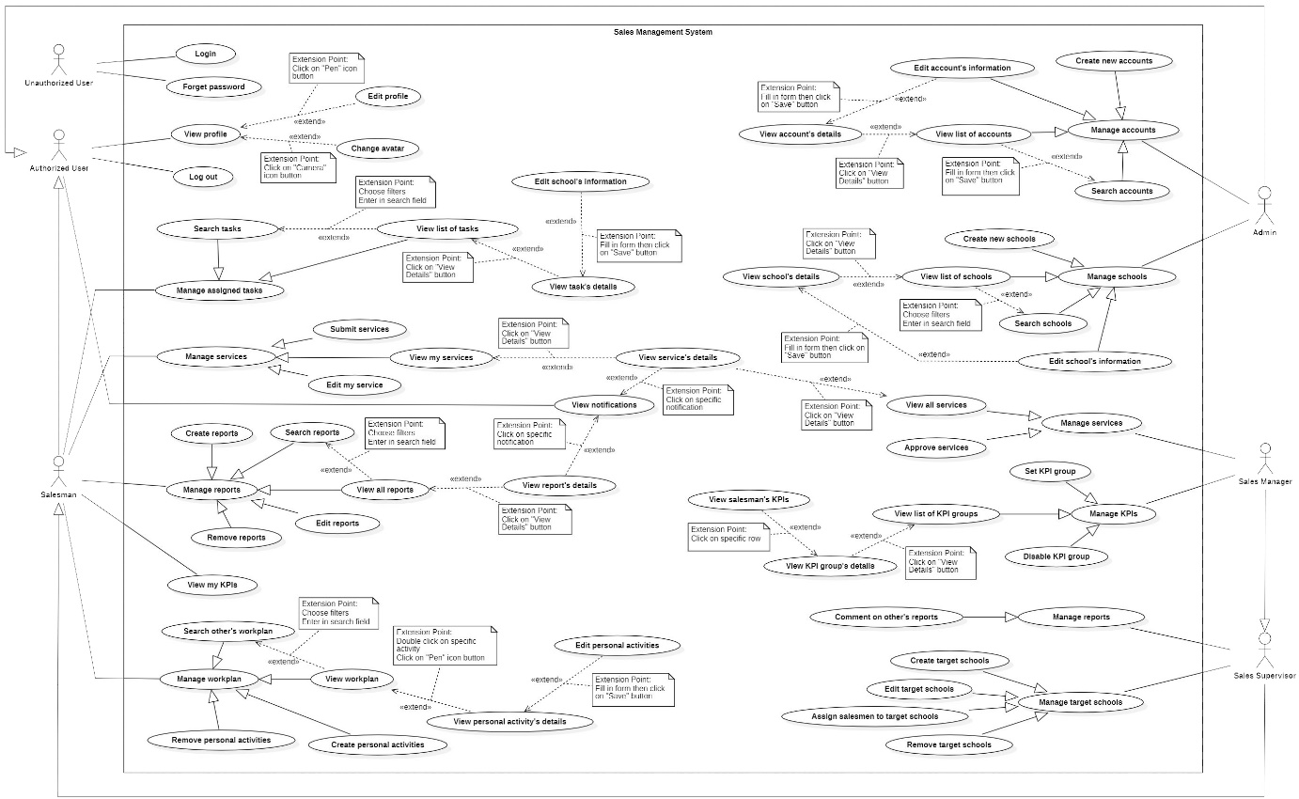

Figure 5. Use case Overview

#### System Actors

|  |  |  |
| --- | --- | --- |
| **#** | **Actor** | **Description** |
| 1 | Unauthorized User | The people who have not logged into the system yet. |
| 2 | Authorized User | The people who have logged into the system with the account (Administrator, Salesman, Sales Manager).  All functions of this user are general functions that a normal user can do without considering the role. |
| 3 | Administrator | The Administrators manage data of all accounts and all schools in the system. |
| 4 | Salesman | * The Salesmen have business trips to target schools for many purposes, such as introducing and selling Major Education’s programs to target schools for cooperation. * Salesmen shall create services of his/her own assigned tasks. |
| 5 | Sales Supervisor | * Sales Supervisor manages target schools and supervises salesmen’s reports and work-plans. * Sales Supervisor is not allow to view services of others’. |
| 6 | Sales Manager | * Sales Manager manages target schools and supervises salesmen’s reports and work-plans. * Sales Manager shall view all services of all Salesmen. |

Table 15. System Actors

#### Use Cases List

|  |  |  |  |
| --- | --- | --- | --- |
| **ID** | **Use Case** | **Primary Actors** | **Secondary Actors** |
| UC-01 | Login | Unauthorized User |  |
| UC-02 | Forget password | Unauthorized User |  |
| UC-03 | View Profile | Authorized User,  Salesman,  Sales Supervisor,  Sales Manager,  Administrator |  |
| UC-04 | Edit Profile | Authorized User,  Salesman,  Sales Supervisor,  Sales Manager,  Administrator |  |
| UC-05 | Change avatar | Authorized User,  Salesman,  Sales Supervisor,  Sales Manager,  Administrator |  |
| UC-06 | Log out | Authorized User,  Salesman,  Sales Supervisor,  Sales Manager,  Administrator |  |
| UC-07 | View notifications | Authorized User,  Salesman,  Sales Supervisor,  Sales Manager,  Administrator |  |
|  | ***Manage accounts*** | | |
| UC-08 | Create new accounts | Administrator |  |
| UC-09 | Search accounts | Administrator |  |
| UC-10 | View list of accounts | Administrator |  |
| UC-11 | View account’s details | Administrator |  |
| UC-12 | Edit account’s information | Administrator |  |
|  | ***Manage schools*** | | |
| UC-13 | Create new schools | Administrator |  |
| UC-14 | Search schools | Administrator |  |
| UC-15 | View list of schools | Administrator |  |
| UC-16 | View school’s details | Administrator |  |
| UC-17 | Edit school’s information | Administrator |  |
|  | ***Manage tasks*** |  |  |
| UC-18 | Search tasks | Salesman,  Sales Supervisor,  Sales Manager |  |
| UC-19 | View list of tasks | Salesman,  Sales Supervisor,  Sales Manager |  |
| UC-20 | View task’s details | Salesman,  Sales Supervisor,  Sales Manager |  |
| UC-21 | Edit school’s information | Salesman |  |
|  | ***Manage services*** | | |
| UC-22 | Create services | Salesman |  |
| UC-23 | View my services | Salesman |  |
| UC-24 | View service’s details | Salesman |  |
| UC-25 | Edit my services | Salesman |  |
|  | ***Manage reports*** | | |
| UC-26 | Create reports | Salesman |  |
| UC-27 | Search reports | Salesman |  |
| UC-28 | View all reports | Salesman |  |
| UC-29 | View report’s details | Salesman |  |
| UC-30 | Edit reports | Salesman |  |
| UC-31 | Remove reports | Salesman |  |
|  | ***Manage work-plan*** | | |
| UC-32 | Create personal activities | Salesman,  Sales Supervisor,  Sales Manager |  |
| UC-33 | Search other’s work-plan | Salesman,  Sales Supervisor,  Sales Manager |  |
| UC-34 | View work-plan | Salesman,  Sales Supervisor,  Sales Manager |  |
| UC-35 | View personal activity's details | Salesman,  Sales Supervisor,  Sales Manager |  |
| UC-36 | Edit personal activities | Salesman,  Sales Supervisor,  Sales Manager |  |
| UC-37 | Remove personal activities | Salesman,  Sales Supervisor,  Sales Manager |  |
|  | ***Manage tasks*** | | |
| UC-38 | Create tasks | Sales Supervisor,  Sales Manager |  |
| UC-39 | Edit tasks | Sales Supervisor,  Sales Manager |  |
| UC-40 | Assign salesmen to tasks | Sales Supervisor,  Sales Manager |  |
| UC-41 | Remove tasks | Sales Supervisor,  Sales Manager |  |
|  | ***Manage reports*** | | |
| UC-42 | Comment on salesmen's reports | Sales Supervisor,  Sales Manager |  |
|  | ***Manage Services*** | | |
| UC-43 | View all services | Sales Manager |  |
| UC-44 | Approve services | Sales Manager |  |
|  | ***Manage KPIs*** |  |  |
| UC-45 | Set KPI group | Sales Manager |  |
| UC-46 | Disable KPI group | Sales Manager |  |
| UC-47 | View list of KPI groups | Sales Manager |  |
| UC-48 | View KPI group’s details | Sales Manager |  |
| UC-49 | View salesman’s KPIs | Sales Manager |  |
| UC-50 | View my KPIs | Salesman |  |

Table 16. Use Cases List

### 2.2 <<Unauthorized User>> Overview Use Case

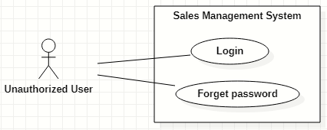

Figure 6. <<Unauthorized User>> Overview Use Case

#### Login

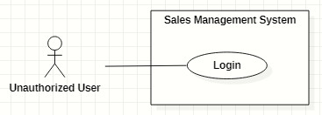

Figure 7. <<Unauthorized User>> Login

|  |  |  |  |  |  |
| --- | --- | --- | --- | --- | --- |
| ID and Name: | **UC-01 Login** | | | | |
| Created By: | GiaNH | | Date Created: | 05/02/2021 |
| Primary Actor: | Unauthorized User | | Secondary Actors: | N/A |
| Description: | This use case allows the user to log into the system to use the services of the system. | | | | |
| Trigger: | The user clicks on the “Login” button on the Login screen. | | | | |
| Preconditions: | PRE-1. The user has to own an account with a username and password.  PRE-2. The user has not logged into the system yet. | | | | |
| Post-conditions: | POST-1. The user successfully logs into the system, and be redirected to the Home screen. | | | | |
| Normal Flow: | **Step** | **Actor Action** | | **System Response** | |
| 1 | The user opens the login view in web browsers. | | The system requires identifying information from the user:   * “Username”: text input, required. * “Password”: text input, required. | |
| 2 | The user inputs into the “username” and “password” fields on Login form. | | [Exception 1] | |
| 3 | The user clicks on “Login” button. | | The system allows the user to access into and redirects to the corresponding Home screen (based on the role of user).  [Exception 2]  [Exception 3] | |
| Alternative Flows: | N/A | | | | |
| Exceptions: | **No** | **Cause** | | **System Response** | |
| 1 | The user inputs invalid format content into the “username” and “password” fields. | | The system shows the error message: “Invalid username or password”. | |
| 2 | The user inputs the wrong username or password. | | The system shows the error message: “Wrong username or password”. | |
| 3 | The user’s device does not connect to the Internet or the server has internal error. | | The system shows the error message: “Connection Failed or Internal Error”. | |
| Priority: | Normal | | | | |
| Frequency of Use: | Usually | | | | |
| Business Rules: | * BR-01, BR-07 * The required information are username, password. * The username must be 8 – 30 characters length and must not include special characters. * The password must be 8 – 30 characters length and must be hashed encrypted. | | | | |
| Other Information: | N/A | | | | |
| Assumptions: | N/A | | | | |

Table 17. <<Unauthorized User>> Login

#### Forget password

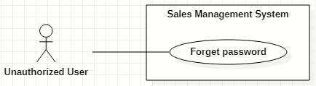

Figure 8. <<Unauthorized User>> Forget password

|  |  |  |  |  |  |
| --- | --- | --- | --- | --- | --- |
| ID and Name: | **UC-02 Forget password** | | | | |
| Created By: | HaPTN | | Date Created: | 12/04/2021 |
| Primary Actor: | Unauthorized User | | Secondary Actors: | N/A |
| Description: | This use case allows the user to reset their forgotten password. | | | | |
| Trigger: | The user clicks on “Forgot password?” link on the Login screen. | | | | |
| Preconditions: | PRE-1. The user has to own an account with a username and password.  PRE-2. The user has not logged into the system yet. | | | | |
| Post-conditions: | POST-1. The user’s password has been updated in the database.  POST-2. The user is redirected to Login screen. | | | | |
| Normal Flow: | **Step** | **Actor Action** | | **System Response** | |
| 1 | The user clicks on “Forgotten password?” link on the Login screen in Web browsers. | | The system redirects to “Reset your password” screen which requires user to input:   * “Username”: text input, required. * “Email”: text input, required. * “Send me verification code”: button. | |
| 2 | The user inputs into the “username” and “email” fields on “Reset your password” form. | | [Exception 1] | |
| 3 | The user clicks on “Send me verification code” button. | | The system sends a verification code via email that user has just provided.  [Exception 2]  [Exception 3] | |
|  | 4 |  | | The system redirects to “Enter verification code” screen which have:   * “Verification code”: text input. * “Continue”: button. | |
|  | 5 | On “Enter verification code” form, the user inputs into the “verification code” then clicks on “Continue” button. | | The system redirects to “Enter new password” screen which have:   * “New password”: text input, required. * “Re-new password”: text input, required. * “Save”: button.   [Exception 3]  [Exception 4] | |
|  | 6 | The user inputs into the “new password” and “re-new password” fields on “Enter new password”. | | [Exception 5] | |
|  | 7 | The user clicks on “Save” button. | | The system shows the successful message: “Password has been changed successfully”, then redirects to the “Login” screen  [Exception 3] | |
| Alternative Flows: | N/A | | | | |
| Exceptions: | **No** | **Cause** | | **System Response** | |
| 1 | The user inputs invalid format content into the “username” and “email” fields. | | The system shows the error message: “Invalid username or email”. | |
| 2 | The username or email in form do not match to fields “username” and “user_email” in the database. | | The system shows the error message: “Wrong username or email”. | |
| 3 | The user’s device does not connect to the Internet or the server has internal error. | | The system shows the error message: “Connection Failed or Internal Error”. | |
|  | 4 | The user inputs wrong verification code. | | The system shows the error message: “Please check your verification code and try again.”. | |
| Priority: | Normal | | | | |
| Frequency of Use: | Usually | | | | |
| Business Rules: | * BR-03 * The “new password” and “re-new password” must be 8 – 30 characters length and must be hashed encrypted. | | | | |
| Other Information: | N/A | | | | |
| Assumptions: | N/A | | | | |

Table 18. <<Unauthorized User>> Forget password

### 2.3 <<Authorized User>> Overview Use Case

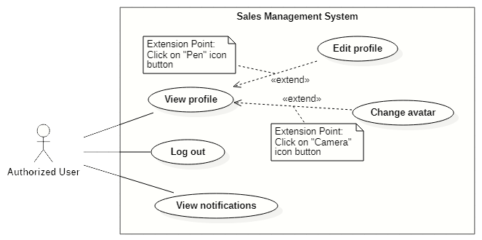

Figure 9. <<Authorized User>> Overview Use Case

#### View profile

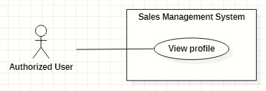

Figure 10. <<Authorized User>> View profile

|  |  |  |  |  |  |
| --- | --- | --- | --- | --- | --- |
| ID and Name: | **UC-03 View profile** | | | | |
| Created By: | GiaNH | | Date Created: | 05/02/2021 |
| Primary Actor: | Authorized User | | Secondary Actors: | N/A |
| Description: | This use case allows the user to view his/her profile. | | | | |
| Trigger: | The user selects “Profile” command in the options menu under the user avatar (at the top right corner of the screen). | | | | |
| Preconditions: | PRE-1. The user has been logged into the system. | | | | |
| Post-conditions: | POST-1. The user’s information is displayed in details as a form. | | | | |
| Normal Flow: | **Step** | **Actor Action** | | **System Response** | |
| 1 | The user clicks on the avatar on the right corner of the topbar. | | The system redirects to the “Profile” screen.  The detail information of the user is displayed on the screen.  [Exception 1] | |
| Alternative Flows: | N/A | | | | |
| Exceptions: | **No** | **Cause** | | **System Response** | |
| 1 | The user’s device does not connect to the Internet or the server has internal error. | | The system shows the error message: “Connection Failed or Internal Error”. | |
| Priority: | Normal | | | | |
| Frequency of Use: | Usually | | | | |
| Business Rules: | BR-05 | | | | |
| Other Information: | N/A | | | | |
| Assumptions: | N/A | | | | |

Table 19. <<Authorized User>> View profile

#### Edit profile

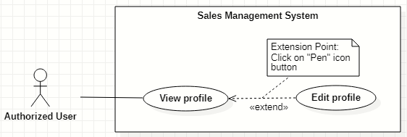

Figure 11. <<Authorized User>> Edit profile

|  |  |  |  |  |  |
| --- | --- | --- | --- | --- | --- |
| ID and Name: | **UC-04 Edit profile** | | | | |
| Created By: | GiaNH | | Date Created: | | 05/02/2021 |
| Primary Actor: | Authorized User | | Secondary Actors: | | N/A |
| Description: | This use case allows the user to edit his/her profile. | | | | |
| Trigger: | The user clicks on “Pen” icon button. | | | | |
| Preconditions: | PRE-1. The user has been logged into the system.  PRE-2. The user is at the “Profile” screen. | | | | |
| Post-conditions: | POST-1. The user’s information is edited in the system. | | | | |
| Normal Flow: | **Step** | **Actor Action** | | **System Response** | |
| 1 | On Profile screen, the user clicks on “Pen” icon button at the right of the information row that he/she wants to edit.  [Alternative 1 ] | | At the selected row, the system opens the collapsed div to show the text field with the following format:   * “Password”: text. * “Address”: text. * “Email”: text. * “Birthdate”: date. * “IsMale”: two radio buttons, required, only select one. * “Phone” text. * “Avatar”: image. | |
| 2 | The user inputs the information into the selected text field. | | [Exception 1]  [Exception 2]  [Exception 3] | |
| 3 | The user selects “Save” button.  [Exception 4] | | The system shows the the successful message: “Updated Successfully”.  [Exception 5] | |
| Alternative Flows: | **Step** | **Actor Action** | | **System Response** | |
| 1 | The user selects “Pen” icon button at “Password” line. | | The system shows the accordion that contains following information:   * “Current Password”: text, required. * “New Password”: text, required. * “Confirm New Password”: text, required.   *Continue to step 2 of Normal Flow*. | |
| Exceptions: | **No** | **Cause** | | **System Response** | |
| 1 | The user inputs invalid format content into fields. | | The system shows the error message: “Incorrect entry”. | |
| 2 | The user inputs the wrong old password. | | The system shows the error message: “Invalid password” and “Update Unsuccessful”. | |
| 3 | The user inputs the confirm-new password that does not match to new password. | | The system shows the error message: “You must enter the same password twice in order to confirm it”. | |
| 4 | The user selects “Cancel” button to cancel updating. | | The system discards all changes and returns the “Profile” screen. | |
| 5 | The user’s device does not connect to the Internet or the server has internal error. | | The system shows the error message: “Connection Failed or Internal Error”. | |
| Priority: | Normal | | | | |
| Frequency of Use: | Usually | | | | |
| Business Rules: | * BR-05 * All fields related to “password” must be 8 – 30 characters length and must be hashed encrypted. * Fields that could be edited are: password, email, phone number, address and avatar. * Phone must be in format “/(84|0[3|5|7|8|9])+([0-9]{8})\b/g” and have max length is 10 (when starts with 0) or 11 (when starts with 84).   *(Resources:* [*https://www.regextester.com/106725*](https://www.regextester.com/106725)*)*   * Fields which are not allowed users to edit are: username, fullname, birthdate and isMale. | | | | |
| Other Information: | N/A | | | | |
| Assumptions: | N/A | | | | |

Table 20. <<Authorized User>> Edit profile

#### Change avatar

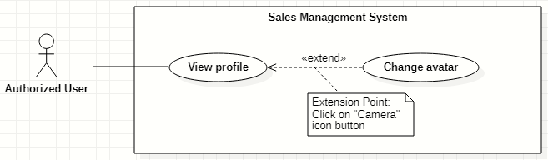

Figure 12. <<Authorized User>> Change avatar

|  |  |  |  |  |  |
| --- | --- | --- | --- | --- | --- |
| ID and Name: | **UC-05 Change avatar** | | | | |
| Created By: | HaPTN | | Date Created: | | 12/04/2021 |
| Primary Actor: | Authorized User | | Secondary Actors: | | N/A |
| Description: | This use case allows the user to update his/her profile avatar. | | | | |
| Trigger: | The user clicks on “Camera” icon button next to the avatar. | | | | |
| Preconditions: | PRE-1. The user has been logged into the system.  PRE-2. The user is at the “Profile” screen. | | | | |
| Post-conditions: | POST-1. The user’s new avatar is edited in the system. | | | | |
| Normal Flow: | **Step** | **Actor Action** | | **System Response** | |
| 1 | On Profile screen, the user clicks on “Camera” icon button next to the avatar image. | | The system opens the Windows Explorer dialog for user to upload an image. | |
| 2 | The user chooses an image in the Windows Explorer dialog and clicks on “Open” button.  [Exception 1]  [Exception 2] | | The system updates avatar with the chosen image and shows the the successful message: “Updated Successfully”.  [Exception 3] | |
| Alternative Flows: | N/A | | | | |
| Exceptions: | **No** | **Cause** | | **System Response** | |
| 1 | The user chooses invalid image format. | | The system shows the error message: “Update Unsuccessful”. | |
| 2 | The user closes the Windows Explorer (by clicking on “x” button or “Cancel” button). | | The system shows the error message: “Update Unsuccessful”. | |
| 3 | The user’s device does not connect to the Internet or the server has internal error. | | The system shows the error message: “Connection Failed or Internal Error”. | |
| Priority: | Normal | | | | |
| Frequency of Use: | Usually | | | | |
| Business Rules: | * BR-05 * In the Windows Explorer dialog, the user can only choose one image at a time. * The system only accepts image files in type “.png”, “.jpg”, “.jpeg”. | | | | |
| Other Information: | N/A | | | | |
| Assumptions: | N/A | | | | |

Table 21. <<Authorized User>> Change avatar

#### Logout

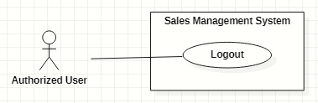

Figure 13. <<Authorized User>> Logout

|  |  |  |  |  |  |  |
| --- | --- | --- | --- | --- | --- | --- |
| ID and Name: | **UC-06 Logout** | | | | | |
| Created By: | GiaNH | | Date Created: | 05/02/2021 | |
| Primary Actor: | Authorized User | | Secondary Actors: | N/A | |
| Description: | This use case allows the users to log out of the system. | | | | | |
| Trigger: | The user clicks on “Logout” button. | | | | | |
| Preconditions: | PRE-1. The user has been logged into the system. | | | | | |
| Post-conditions: | POST-1. The user logs out the system. | | | | | |
| Normal Flow: | **Step** | **Actor Action** | | | **System Response** | |
| 1 | The user clicks on the “Avatar” icon button to open “Profile” screen. | | | The system redirects to the “Profile” screen. | |
| 2 | The user clicks on “Log out” button at the top right corner of the “Profile” screen. | | | The system clears cookies and access token then returns to the “Login” screen. | |
| Alternative Flows: | N/A | | | | | |
| Exceptions: | N/A | | | | | |
| Priority: | Normal | | | | | |
| Frequency of Use: | Usually | | | | | |
| Business Rules: | User’s token is removed in client and the session is destroyed in server. | | | | | |
| Other Information: | N/A | | | | | |
| Assumptions: | N/A | | | | | |

Table 22. <<Authorized User>> Logout

#### View notifications

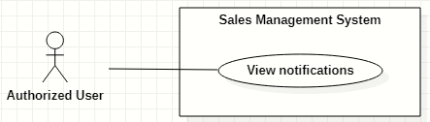

Figure 14. <<Authorized User>> View notifications

|  |  |  |  |  |  |  |
| --- | --- | --- | --- | --- | --- | --- |
| ID and Name: | **UC-07 View notifications** | | | | | |
| Created By: | HaPTN | | Date Created: | | 12/04/2021 |
| Primary Actor: | Authorized User | | Secondary Actors: | | N/A |
| Description: | This use case allows the users. | | | | | |
| Trigger: | The user clicks on “Bell” icon button (at the top right corner of the screen). | | | | | |
| Preconditions: | PRE-1. The user has been logged into the system. | | | | | |
| Post-conditions: | POST-1. The user is redirect to the corresponding screen depends on what notification he/she selects. | | | | | |
| Normal Flow: | **Step** | **Actor Action** | | **System Response** | | |
| 1 | The user clicks on “Bell” icon button (at the top right corner of the screen) to view list of notifications. | | The system shows list of notifications in a popover, near the “Bell” icon button. | | |
|  | 2 | The user select specific notification.  [Alternative 1]  [Alternative 2] | | [Exception 1] | | |
| Alternative Flows: | **Step** | **Actor Action** | | **System Response** | | |
| 1 | The user clicks on notification type “report”. | | The system redirects to “Report details” screen for user to view comment of supervisor/manager. | | |
| 2 | The user clicks on notification type “service”. | | The system redirects to “Service details” screen for user to view service’s details. | | |
| Exceptions: | **No** | **Cause** | | **System Response** | | |
| 1 | The user’s device does not connect to the Internet or the server has internal error. | | The system shows the error message: “Connection Failed or Internal Error”. | | |
| Priority: | Normal | | | | | |
| Frequency of Use: | Usually | | | | | |
| Business Rules: | * BR-26 (notification type “report”) * BR-33 (notification type “service”) | | | | | |
| Other Information: | N/A | | | | | |
| Assumptions: | N/A | | | | | |

Table 23. <<Authorized User>> View notifications

### 2.4 <<Administrator>> Overview Use Case

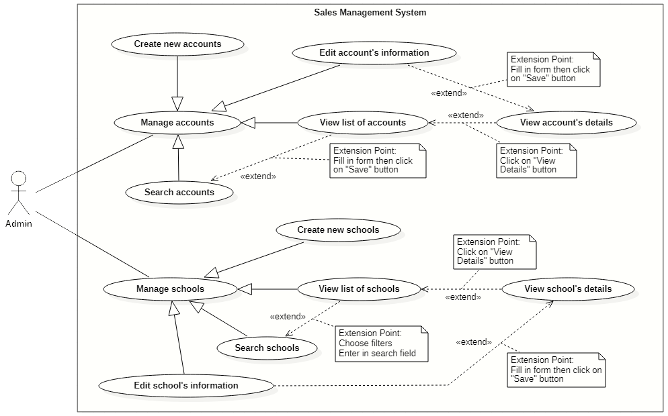

Figure 15. <<Administrator>> Overview Use Case

#### Create new accounts

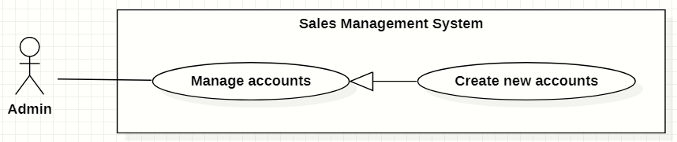

Figure 16. <<Administrator>> Create new accounts

|  |  |  |  |  |  |
| --- | --- | --- | --- | --- | --- |
| ID and Name: | **UC-08 Create new accounts** | | | | |
| Created By: | GiaNH | | Date Created: | | 15/02/2021 |
| Primary Actor: | Administrator | | Secondary Actors: | | N/A |
| Description: | This use case allows the user to create new account. | | | | |
| Trigger: | The user clicks on the “Create” button in “Accounts” screen. | | | | |
| Preconditions: | PRE-1. The user has been logged into the system with role Admin.  PRE-2. The user is on the “Accounts” screen. | | | | |
| Post-conditions: | POST-1. The new account is added in the system. | | | | |
| Normal Flow: | **Step** | **Actor Action** | | **System Response** | |
| 1 | The user selects “Accounts” on the navigation bar (sidebar). | | The system redirects the Accounts screen. | |
| 2 | The user selects on “Create” button in screen. | | The system displays the “Create Account” form with the following required information:   * “Username”: input text filed, required. * “Role”: selections (Salesman, Sales Supervisor, Sales Manager, Admin). * “Full name”: input text field, required. * “Email”: input text field. * “Phone”: input text field, required. * “Address”: input text field. * “IsMale”: radio buttons, required. * “Birthdate”: date picker. * “Save”: button. * “Cancel”: button. | |
| 3 | The user inputs into required information fields. | | [Exception 1]  [Exception 2] | |
| 4 | The user selects on the “Save” button.  [Exception 4] | | The system shows the successful message: “New account has been created successfully. Please check your email to get the password.”.  [Exception 3]  [Exception 5] | |
| 5 |  | | The system sends the new user an email which contains his/her password.  [Exception 3] | |
| 6 |  | | The system updates the table of list of schools in the “Schools” screen.  [Exception 3] | |
| Alternative Flows: | N/A | | | | |
| Exceptions: | **No** | **Cause** | | **System Response** | |
| 1 | The user leaves the blank fields or inputs the invalid format content. | | The system shows the error message: “Please input the valid format content”. | |
| 2 | The content that the user inputs into “Confirm password” is not matched the “Password” field. | | The system show the error message: “Confirm password is not matched the password”. | |
| 3 | The user’s device does not connect to the Internet or the server has internal error. | | The system shows the error message: “Connection Failed or Internal Error”. | |
| 4 | The user selects “Cancel” button. | | The system closes the “Create Account” view and returns the “Accounts” screen. | |
| 5 | The content that the user inputs into “username” field is duplicate in the system. | | The system shows the error message: “The username has already existed”. | |
| Priority: | High | | | | |
| Frequency of Use: | Usually | | | | |
| Business Rules: | * BR-04, BR-09 * The username must be 8 – 30 characters, not include special characters. * Admin does not create password for users. * Password is randomly generated by the system and is sent to the provided user’s email. * The password which is stored in the Database must be hashed encrypted by Bcript. * The email must be validated. * Phone must be in format “/(84|0[3|5|7|8|9])+([0-9]{8})\b/g” and have max length is 10 (when starts with 0) or 11 (when starts with 84).   *(Resources:* [*https://www.regextester.com/106725*](https://www.regextester.com/106725)*)* | | | | |
| Other Information: | N/A | | | | |
| Assumptions: | N/A | | | | |

Table 24. <<Administrator>> Create new accounts

#### Search accounts

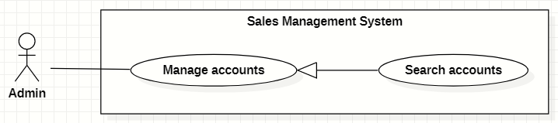

Figure 17. <<Administrator>> Search accounts

|  |  |  |  |  |  |  |  |
| --- | --- | --- | --- | --- | --- | --- | --- |
| ID and Name: | **UC-09 Search accounts** | | | | | | |
| Created By: | GiaNH | | | Date Created: | | | 16/02/2021 |
| Primary Actor: | Administrator | | | Secondary Actors: | | | N/A |
| Description: | This use case allows the users to find the accounts based on the role, status, username, phone, address,… | | | | | | |
| Trigger: | The user selects filters or inputs in search field on the “Accounts” screen. | | | | | | |
| Preconditions: | PRE-1. The user has been logged into the system with role Admin.  PRE-2. The user is on “Accounts” screen. | | | | | | |
| Post-conditions: | POST-1. The list of accounts is shown. | | | | | | |
| Normal Flow: | **Step** | | **Actor Action** | | **System Response** | | |
| 1 | | The user inputs in the search field or selects filters to looking for accounts. | | The system displays the list of accounts as the table.  Available filters on this screen:   * “isActive”: selections (true, false) * “Roles”: selections (Admin, Sales Manager, Sales Supervisor, Salesman). * Search field: text field. | | |
| 2 | |  | | The list of Accounts is shown as a table on the Accounts screen.  Table will includes these fields:   * “Username”: text. * “Fullname”: image (avatar) and text. * “Phone”: text. * “Email”: text. * “Role”: Label. | | |
| Alternative Flows: | N/A | | | | | | |
| Exceptions: | **No** | **Cause** | | | | **System Response** | |
| 1 | The content of search field or selecting filter that the user inputted is not matched any data in database. | | | | The system displays “No records found” line. | |
| Priority: | Normal | | | | | | |
| Frequency of Use: | Usually | | | | | | |
| Business Rules: | * The default values of filter “Working status” is “null” * The default values of filter “Role” is “All”. | | | | | | |
| Other Information: | N/A | | | | | | |
| Assumptions: | N/A | | | | | | |

Table 25. <<Administrator>> Search accounts

#### View list of accounts

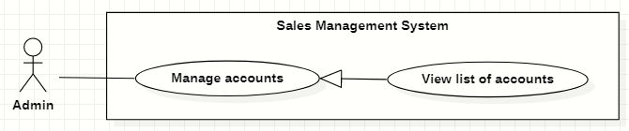

Figure 18. <<Administrator>> View list of accounts

|  |  |  |  |  |  |
| --- | --- | --- | --- | --- | --- |
| ID and Name: | **UC-10 View list of accounts** | | | | |
| Created By: | GiaNH | | Date Created: | | 15/02/2021 |
| Primary Actor: | Administrator | | Secondary Actors: | | N/A |
| Description: | This use case allows the user to view list of accounts. | | | | |
| Trigger: | The user selects “Accounts” on the navigation bar (sidebar). | | | | |
| Preconditions: | PRE-1. The user has been logged into the system with role Admin. | | | | |
| Post-conditions: | POST-1. The list of Accounts is shown as a table on the “Accounts” screen. | | | | |
| Normal Flow: | **Step** | **Actor Action** | | **System Response** | |
| 1 | The user selects “Accounts” on the navigation bar (sidebar). | | The system redirects the Accounts screen. | |
| 2 |  | | The list of Accounts is shown as a table on the Accounts screen.  Table will includes these fields:   * “Username”: text. * “Full name”: image (avatar) and text. * “Phone”: text. * “Email”: text. * “Role”: Label. | |
| Alternative Flows: | N/A | | | | |
| Exceptions: | **No** | **Cause** | | **System Response** | |
| 1 | The data is null or empty in database. | | The system shows “No records found” line on the table. | |
| Priority: | Medium | | | | |
| Frequency of Use: | Usually | | | | |
| Business Rules: | * The default values of filter “Working status” is “null” * The default values of filter “Role” is “All”. | | | | |
| Other Information: | N/A | | | | |
| Assumptions: | N/A | | | | |

Table 26. <<Administrator>> View list of accounts

#### View account’s details

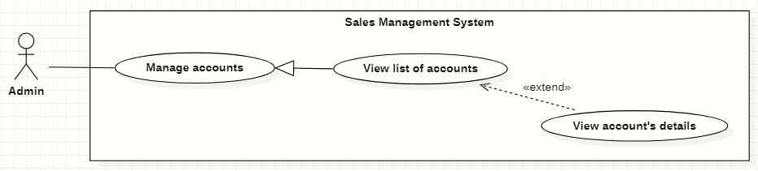

Figure 19. <<Administrator>> View account’s details

|  |  |  |  |  |  |
| --- | --- | --- | --- | --- | --- |
| ID and Name: | **UC-11 View account’s details** | | | | |
| Created By: | GiaNH | | Date Created: | | 16/02/2021 |
| Primary Actor: | Administrator | | Secondary Actors: | | N/A |
| Description: | This use case allows the user to view the detail information of an account. | | | | |
| Trigger: | The user clicks on the “View details” command on the menu options at the end of row in table list of accounts. | | | | |
| Preconditions: | PRE-1. The user has been logged into the system with role Admin.  PRE-2. The user is on the “Accounts” screen. | | | | |
| Post-conditions: | POST-1. The detail information of account is shown as a form. | | | | |
| Normal Flow: | **Step** | **Actor Action** | | **System Response** | |
| 1 | On the “Accounts” screen, at the end of each row in the table, the user clicks on action icon button, then selects “View detail” command on the menu options. | | The system displays “Account’s details” view, the account’s information is displayed as a form.   * “Username”: input text filed, required. * “Password”: input password text field, required. * “Confirm password: input password text field, required. * “Role”: selections (Salesman, Sales Supervisor, Sales Manager, Admin). * “Full name”: input text field, required. * “Email”: input text field. * “Phone”: input text field, required. * “IsMale”: radio buttons, required. * “Birthdate”: date picker. * “Address”: input text field. * “Save”: button, inactive. | |
| Alternative Flows: | N/A | | | | |
| Exceptions: | N/A | | | | |
| Priority: | Medium | | | | |
| Frequency of Use: | Usually | | | | |
| Business Rules: | N/A | | | | |
| Other Information: | N/A | | | | |
| Assumptions: | N/A | | | | |

Table 27. <<Administrator>> View account’s details

#### Edit account’s information

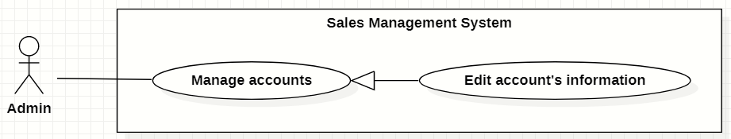

Figure 20. <<Administrator>> Edit account’s information

|  |  |  |  |  |  |  |  |
| --- | --- | --- | --- | --- | --- | --- | --- |
| ID and Name: | **UC-12 Edit account’s information** | | | | | | |
| Created By: | GiaNH | | | Date Created: | | | 16/02/2021 |
| Primary Actor: | Administrator | | | Secondary Actors: | | | N/A |
| Description: | This use case allows the users to edit the account’s information. | | | | | | |
| Trigger: | The user edits on fields in “Account’s details” screen then clicks “Save” button. | | | | | | |
| Preconditions: | PRE-1. The user has been logged into the system with role Admin.  PRE-2. The user is on the “Account’s details” screen. | | | | | | |
| Post-conditions: | POST-1. The Account information is edited in database. | | | | | | |
| Normal Flow: | **Step** | | **Actor Action** | | | **System Response** | |
| 1 | |  | | | The system displays the “Account’s detail” screen as a form with the following required information:   * “Username”: text field, disabled. * “Full name”: input text field. * “Email”: input text field. * “Phone”: input text field, required. * “IsMale”: radio buttons. * “Birthdate”: date picker. * “Address”: input text field. * “Roles”: selections (Admin, Sales Manager, Sales Supervisor, Salesman). * “isActive”: toggle, required. * “Save”: button, only active when the form is dirty. | |
| 2 | | The user edits on fields in this form. | | | [Exception 1] | |
| 3 | | The user clicks “Save” button when finish. | | | The system has successful edit and displays the successful message: “Updated Successfully”. [Exception 2] | |
| Alternative Flows: | N/A | | | | | | |
| Exceptions: | **No** | **Cause** | | | **System Response** | | |
| 1 | The user inputs invalid format content into fields. | | | The system informs the users that the content of fields is invalid format. | | |
| 2 | The user’s device does not connect to the Internet or the server has internal error. | | | The system shows the error message: “Connection Failed or Internal Error”. | | |
| Priority: | Medium | | | | | | |
| Frequency of Use: | Usually | | | | | | |
| Business Rules: | * BR-06, BR-08, BR-09 * Phone must be in format “/(84|0[3|5|7|8|9])+([0-9]{8})\b/g” and have max length is 10 (when starts with 0) or 11 (when starts with 84).   *(Resources:* [*https://www.regextester.com/106725*](https://www.regextester.com/106725)*)* | | | | | | |
| Other Information: | N/A | | | | | | |

Table 28. <<Administrator>> Edit account’s information

#### Create new schools

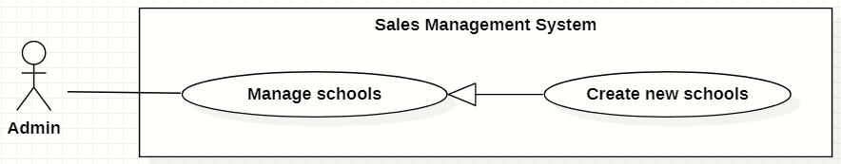

Figure 21. <<Administrator>> Create new schools

|  |  |  |  |  |  |  |  |
| --- | --- | --- | --- | --- | --- | --- | --- |
| ID and Name: | **UC-13 Create new schools** | | | | | | |
| Created By: | GiaNH | | | | Date Created: | | 15/02/2021 |
| Primary Actor: | Administrator | | | | Secondary Actors: | | N/A |
| Description: | This use case allows the user to create new school. | | | | | | |
| Trigger: | The user clicks on the “Create” button in “Schools” screen. | | | | | | |
| Preconditions: | PRE-1. The user has been logged into the system with role Admin.  PRE-2. The user is on the “Schools” screen. | | | | | | |
| Post-conditions: | POST-1. The new account is added in the system. | | | | | | |
| Normal Flow: | **Step** | | **Actor Action** | | | **System Response** | |
| 1 | | The user selects “Schools” on the navigation bar (sidebar). | | | The system redirects to the “Schools” screen. | |
| 2 | | The user hovers on “Create” button in screen. | | | The systems shows a menu list which contains two options (“Import”, “Create a school”). | |
| 3 | | The user clicks on “Create a school” option in the menu list.  [Alternative 1] | | | The system displays the “Create new schools” form with the following required information:  *School’s information:*   * “School name”: input text filed, required. * “School phone”: input text field. * “District”: selections, required. * “Address”: input text field. * “isActive”: boolean, default value is true. * “Description”: input text field. * “School type”: selections (Công lập, Ngoài công lập, Bán công), required. * “Educational level”: selections (Tiểu học, THCS, THPT), required. * “School scale”: selections (Lớn, Vừa, Nhỏ).   “School status”: selections (Chưa hợp tác, Đang hợp tác, Ngưng hợp tác).  *Representative’s information:*   * “Full name”: input text field. * “Email”: input text field. * “Phone”: input text field. * “IsMale”: radio buttons. * “Cancel”: button. * “Save”: button. | |
| 4 | | The user inputs into information fields. | | | [Exception 1] | |
| 5 | | The user selects on the “Save” button.  [Exception 3] | | | The system shows the successful message: “Create Successfully”.  [Exception 2] | |
| 6 | |  | | | The system updates the table of list of schools in the “Schools” screen.  [Exception 2] | |
| Alternative Flows: | **No** | **Step** | | **Actor Action** | | **System Response** | |
| 1 | 1 | | The user clicks on “Import” option in the menu list. | | The system displays the “Import” dialog which contains:   * “You can download the sample template *here*”: text, link. * “Browse”: button. * “Cancel”: button. * “Save”: button. | |
| 2 | | The user clicks on “Browse” button to upload a file from the device.  [Alternative 1.1]  [Exception 4]  [Exception 5]  [Exception 6] | | The system displays the Windows Explorer dialog for user to retrieve file in user’s device. | |
| 3 | | The user selects the file to import and chooses confirm command.  [Exception 2] | | The system shows the selected file’s name on the “Import” dialog. | |
| 4 | | The users clicks on “Save” button.  [Alternative 1.2]  [Exception 3] | | The system shows the successful message: “Create Successfully”.  *Continue to the step 6 in Normal Flow.* | |
| 1.1 | 1 | | The user clicks on “You can download the sample template *here*” link. | | The systems downloads a sample Excel file to the user’s device. | |
| 2 | | The users add data in that Excel file and upload it. | | *Continue to the step 2 in the Alternative Flow 1.* | |
| 1.2 | 1 | | The user clicks on “Browse” button again and chooses another file to upload. | | *Continue to the step 3 in the Alternative Flow 1.* | |
| Exceptions: | **No** | | **Cause** | | | **System Response** | |
| 1 | | The user leaves the blank fields or inputs the invalid format content. | | | The system shows the error message: “Please input the valid format content”. | |
| 2 | | The user’s device does not connect to the Internet or the server has internal error. | | | The system shows the error message: “Connection Failed or Internal Error”. | |
| 3 | | The user selects “Cancel” button. | | | The system closes the “Create School” view and returns the “Schools” screen. | |
| 4 | | The user chooses invalid image format. | | | The system shows the error message: “Please choose the right file format”. | |
| 5 | | The size of file is larger than 5MB. | | | The system shows the error message: “This file is too large. Please choose file with size within 5MB”. | |
| 6 | | The user closes the Windows Explorer (by clicking on “x” button or “Cancel” button). | | | The system closes the Windows Explorer and does not shows anything errors or messages. | |
| Priority: | High | | | | | | |
| Frequency of Use: | Usually | | | | | | |
| Business Rules: | * BR-09, BR-10 * Phone must be in format “/(84|0[3|5|7|8|9])+([0-9]{8})\b/g” and have max length is 10 (when starts with 0) or 11 (when starts with 84).   *(Resources:* [*https://www.regextester.com/106725*](https://www.regextester.com/106725)*)*   * The system only accepts Excel files in type “.xlsx”, “.xls”, “.csv”, “.xslx” or “.xml”. * The size of file is no larger than 5MB. * In the Windows Explorer dialog, the user can only choose one file at a time. | | | | | | |
| Other Information: | N/A | | | | | | |
| Assumptions: | N/A | | | | | | |

Table 29. <<Administrator>> Create new schools

#### Search schools

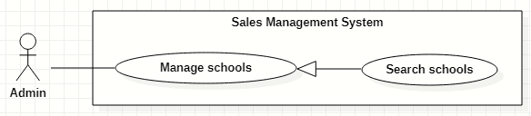

Figure 22. <<Administrator>> Search schools

|  |  |  |  |  |  |  |  |
| --- | --- | --- | --- | --- | --- | --- | --- |
| ID and Name: | **UC-14 Search schools** | | | | | | |
| Created By: | GiaNH | | | Date Created: | | | 16/02/2021 |
| Primary Actor: | Administrator | | | Secondary Actors: | | | N/A |
| Description: | This use case allows the users to find the schools based on school’s name, district, school status, school educational level, school type, address,… | | | | | | |
| Trigger: | The user selects filters or inputs in search field on the “Schools” screen. | | | | | | |
| Preconditions: | PRE-1. The user has been logged into the system with role Admin.  PRE-2. The user is on “Schools” screen. | | | | | | |
| Post-conditions: | POST-1. The list of schools is shown. | | | | | | |
| Normal Flow: | **Step** | | **Actor Action** | | **System Response** | | |
| 1 | | The user inputs in the search field or selects filters to looking for schools. | | The system displays the list of accounts as the table.  Available filters on this screen:   * “Districts”: selections (24 districts in Ho Chi Minh City) * “School Statuses”: selections (Chưa hợp tác, Đang hợp tác, Ngưng hợp tác). * “School Types”: selections (Công lập, Ngoài công lập, Bán công). * “School Levels”: selections (Tiểu học, THCS, THPT). * “School Scales”: selections (Lớn, Vừa, Nhỏ). * Search field: text field. | | |
| 2 | |  | | The list of Schools is shown as a table on the “Schools” screen.  Table will includes these fields:   * “School Name”: text. * “Address”: text. * “Principal”: text. * “Status”: Label. | | |
| Alternative Flows: | N/A | | | | | | |
| Exceptions: | **No** | **Cause** | | | | **System Response** | |
| 1 | The content of search field or selecting filter that the user inputted is not matched any data in database. | | | | The system displays “No records found” line. | |
| Priority: | Normal | | | | | | |
| Frequency of Use: | Usually | | | | | | |
| Business Rules: | The default values of all filters are “All”. | | | | | | |
| Other Information: | N/A | | | | | | |
| Assumptions: | N/A | | | | | | |

Table 30. <<Administrator>> Search schools

#### View list of schools

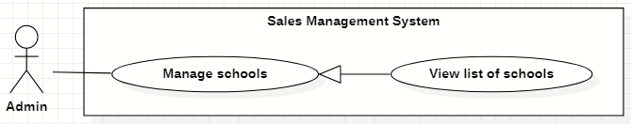

Figure 23. <<Administrator>> View list of schools

|  |  |  |  |  |  |
| --- | --- | --- | --- | --- | --- |
| ID and Name: | **UC-15 View list of schools** | | | | |
| Created By: | GiaNH | | Date Created: | | 15/02/2021 |
| Primary Actor: | Administrator | | Secondary Actors: | | N/A |
| Description: | This use case allows the user to view list of schools. | | | | |
| Trigger: | The user selects “Schools” on the navigation bar (sidebar). | | | | |
| Preconditions: | PRE-1. The user has been logged into the system with role Admin. | | | | |
| Post-conditions: | POST-1. The list of Schools is shown as a table on the “Schools” screen. | | | | |
| Normal Flow: | **Step** | **Actor Action** | | **System Response** | |
| 1 | The user selects “Schools” on the navigation bar (sidebar). | | The system redirects the “Schools” screen. | |
| 2 |  | | The list of Schools is shown as a table on the “Schools” screen.  Table will includes these fields:   * “School Name”: text. * “Address”: text. * “Principal”: text. * “Status”: Label. | |
| Alternative Flows: | N/A | | | | |
| Exceptions: | **No** | **Cause** | | **System Response** | |
| 1 | The data is null or empty in database. | | The system shows “No records found” line on the table. | |
| Priority: | Medium | | | | |
| Frequency of Use: | Usually | | | | |
| Business Rules: | The default values of all filters are “All”. | | | | |
| Other Information: | N/A | | | | |
| Assumptions: | N/A | | | | |

Table 31. <<Administrator>> View list of schools

#### View school’s details

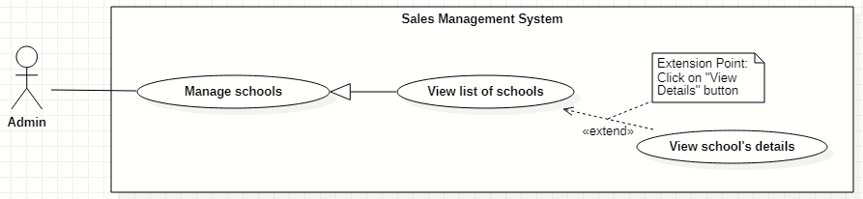

Figure 24. <<Administrator>> View school’s details

|  |  |  |  |  |  |
| --- | --- | --- | --- | --- | --- |
| ID and Name: | **UC-16 View school’s details** | | | | |
| Created By: | GiaNH | | Date Created: | | 16/02/2021 |
| Primary Actor: | Administrator | | Secondary Actors: | | N/A |
| Description: | This use case allows the user to view the detail information of a school. | | | | |
| Trigger: | The user clicks on the “View details” command on the menu options at the end of row in table list of schools. | | | | |
| Preconditions: | PRE-1. The user has been logged into the system with role Admin.  PRE-2. The user is on the “Schools” screen. | | | | |
| Post-conditions: | POST-1. The detail information of school is shown as a form. | | | | |
| Normal Flow: | **Step** | **Actor Action** | | **System Response** | |
| 1 | On the “Schools” screen, at the end of each row in the table, the user clicks on action icon button, then selects “View detail” command on the menu options. | | The system displays “School’s details” view, the school’s information is displayed as a form.  *School’s information:*   * “School name”: input text filed, required. * “School phone”: input text field. * “District”: selections (24 districts in Ho Chi Minh City). * “Address”: input text field. * “isActive”: boolean, default value is true. * “Description”: input text field. * “School type”: selections (Công lập, Ngoài công lập, Bán công), required. * “Educational level”: selections (Tiểu học, THCS, THPT), required. * “School scale”: selections (Lớn, Vừa, Nhỏ). * “School status”: selections (Chưa hợp tác, Đang hợp tác, Ngưng hợp tác).   *Representative’s information:*   * “Full name”: input text field. * “Email”: input text field. * “Phone”: input text field. * “IsMale”: radio buttons (Male, Female). | |
| Alternative Flows: | N/A | | | | |
| Exceptions: | N/A | | | | |
| Priority: | Medium | | | | |
| Frequency of Use: | Usually | | | | |
| Business Rules: | N/A | | | | |
| Other Information: | N/A | | | | |
| Assumptions: | N/A | | | | |

Table 32. <<Administrator>> View school’s details

#### Edit school’s information

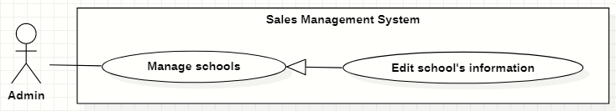

Figure 25. <<Administrator>> Edit school’s information

|  |  |  |  |  |  |  |  |
| --- | --- | --- | --- | --- | --- | --- | --- |
| ID and Name: | **UC-17 Edit school’s information** | | | | | | |
| Created By: | GiaNH | | | Date Created: | | | 16/02/2021 |
| Primary Actor: | Administrator | | | Secondary Actors: | | | N/A |
| Description: | This use case allows the users to edit the school’s information. | | | | | | |
| Trigger: | The user edits on fields in “School’s details” screen then clicks “Save” button. | | | | | | |
| Preconditions: | PRE-1. The user has been logged into the system with role Admin.  PRE-2. The user is on the “School’s details” screen. | | | | | | |
| Post-conditions: | POST-1. The School information is edited in database. | | | | | | |
| Normal Flow: | **Step** | | **Actor Action** | | | **System Response** | |
| 1 | |  | | | The system displays the “School’s detail” screen as a form with the following required information:  *School’s information:*   * “School name”: input text filed, required. * “School phone”: input text field. * “District”: selections (24 districts in Ho Chi Minh City). * “Address”: input text field. * “isActive”: boolean, default value is true. * “Description”: input text field. * “School type”: selections (Công lập, Ngoài công lập, Bán công), required. * “Educational level”: selections (Tiểu học, THCS, THPT), required. * “School scale”: selections (Lớn, Vừa, Nhỏ). * “School status”: selections (Chưa hợp tác, Đang hợp tác, Ngưng hợp tác). * “Save”: button, only active when the form is dirty.   *Representative’s information:*   * “Full name”: input text field. * “Email”: input text field. * “Phone”: input text field. * “IsMale”: radio buttons (Male, Female). * “Save”: button, only active when the form is dirty. | |
| 2 | | The user edits on fields in this form.  [Exception 1] | | |  | |
| 3 | | The user clicks “Save” button when finish. | | | The system has successful edit and displays the successful message: “Updated Successfully”.  [Exception 2] | |
| Alternative Flows: | N/A | | | | | | |
| Exceptions: | **No** | **Cause** | | | **System Response** | | |
| 1 | The user inputs invalid format content into fields. | | | The system informs the users that the content of fields is invalid format. | | |
| 2 | The user’s device does not connect to the Internet or the server has internal error. | | | The system shows the error message: “Connection Failed or Internal Error”. | | |
| Priority: | Medium | | | | | | |
| Frequency of Use: | Usually | | | | | | |
| Business Rules: | * BR-09 * Phone must be in format “/(84|0[3|5|7|8|9])+([0-9]{8})\b/g” and have max length is 10 (when starts with 0) or 11 (when starts with 84).   *(Resources:* [*https://www.regextester.com/106725*](https://www.regextester.com/106725)*)* | | | | | | |
| Other Information: | N/A | | | | | | |

Table 33. <<Administrator>> Edit school’s information

### 2.5 <<Salesman>> Overview Use Case

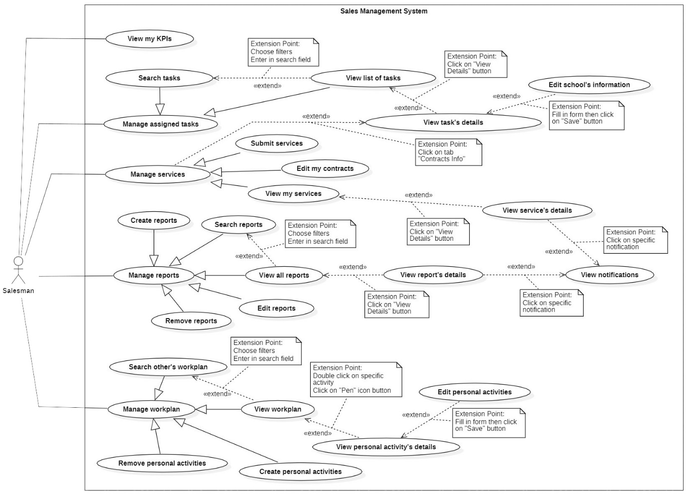

Figure 26. <<Salesman>> Overview Use Case

#### Search tasks

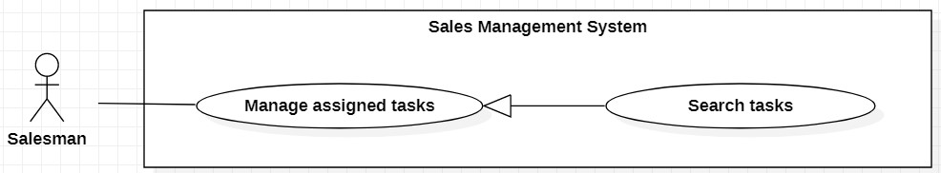

Figure 27. <<Salesman>> Search tasks

|  |  |  |  |  |  |
| --- | --- | --- | --- | --- | --- |
| ID and Name: | **UC-18 Search tasks** | | | | |
| Created By: | GiaNH | | Date Created: | | 07/02/2021 |
| Primary Actor: | Salesman, Sales Supervisor, Sales Manager | | Secondary Actors: | | N/A |
| Description: | This use case allows the users to find the tasks based on school’s name, district, school status, school educational level, school type, address,… | | | | |
| Trigger: | The user selects filters or inputs in search field on the “Tasks” screen. | | | | |
| Preconditions: | PRE-1. The user has been logged into the system with role Salesman, Sales Supervisor or Sales Manager.  PRE-2. The user is on the “Tasks” screen. | | | | |
| Post-conditions: | POST-1. The list of tasks is shown as a table. | | | | |
| Normal Flow: | **Step** | **Actor Action** | | **System Response** | |
| 1 | The user inputs in the search field or selects filters to looking for schools. | | The system displays the list of accounts as the table.  Available filters on this screen:   * “Purposes”: selections (   - Chưa hợp tác: Sales mới, Theo dõi;  - Đang hợp tác: Chăm sóc, Tái ký hợp đồng, Ký mới hợp đồng;  - Ngưng hợp tác  )   * “Districts”: selections (24 districts in Ho Chi Minh City) * “School Years”: selections (2020-2021, 2019-2020, 2018-2019,…). * “School Types”: selections (Công lập, Ngoài công lập, Bán công). * “School Levels”: selections (Tiểu học, THCS, THPT). * “School Scales”: selections (Lớn, Vừa, Nhỏ). * Search field: text field. | |
| 2 |  | | The system displays the list of tasks as a table.   * “School Name”: text. * “Principal”: text. * “School Year”: text. * “Purpose”: Label.   [Exception 1]  [Exception 2] | |
| Alternative Flows: | N/A | | | | |
| Exceptions: | **No** | **Cause** | | **System Response** | |
| 1 | The content of search field or selecting filter that The user inputted do not match any stored data in the system. | | The system displays “No records found” line on the table. | |
| 2 | The user’s device does not connect to the Internet or the server has internal error. | | The system shows the error message: “Connection Failed or Internal Error”. | |
| Priority: | Normal | | | | |
| Frequency of Use: | Usually | | | | |
| Business Rules: | * BR-19, BR-20, BR-40 * The default values of all filters are “All”. | | | | |
| Other Information: | N/A | | | | |
| Assumptions: | N/A | | | | |

Table 34. <<Salesman>> Search tasks

#### View list of tasks

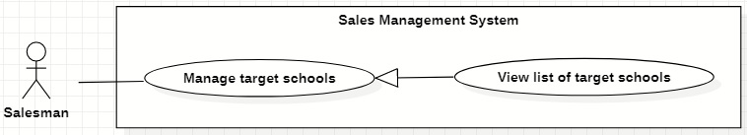

Figure 28. <<Salesman>> View list of tasks

|  |  |  |  |  |  |
| --- | --- | --- | --- | --- | --- |
| ID and Name: | **UC-19 View list of tasks** | | | | |
| Created By: | GiaNH | | Date Created: | | 07/02/2021 |
| Primary Actor: | Salesman, Sales Supervisor, Sales Manager | | Secondary Actors: | | N/A |
| Description: | This use case allows the user to view list of his assigned tasks. | | | | |
| Trigger: | The user selects “Tasks” on the navigation bar (sidebar). | | | | |
| Preconditions: | PRE-1. The user has been logged into the system with role Salesman, Sales Supervisor or Sales Manager. | | | | |
| Post-conditions: | POST-1. The list of tasks is shown as a table. | | | | |
| Normal Flow: | **Step** | **Actor Action** | | **System Response** | |
| 1 | The user selects “Tasks” on the navigation bar (sidebar). | | The system redirects to the “Tasks” screen and shows the tasks table with following columns:   * “School Name”: text. * “Principal”: text. * “School Year”: text. * “Purpose”: label.   Available filters on this screen:   * “Purposes”: selections (   - Chưa hợp tác: Sales mới, Theo dõi;  - Đang hợp tác: Chăm sóc, Tái ký hợp đồng, Ký mới hợp đồng;  - Ngưng hợp tác  )   * “Districts”: selections (24 districts in Ho Chi Minh City) * “School Years”: selections (2020-2021, 2019-2020, 2018-2019,…). * “School Types”: selections (Công lập, Ngoài công lập, Bán công). * “School Levels”: selections (Tiểu học, THCS, THPT). * “School Scales”: selections (Lớn, Vừa, Nhỏ). * Search field: text field.   [Exception 1]  [Exception 2] | |
| Alternative Flows: | N/A | | | | |
| Exceptions: | **No** | **Cause** | | **System Response** | |
| 1 | No stored tasks data in the system. | | The system displays “No records found” line on the table. | |
| 2 | The user’s device does not connect to the Internet or the server has internal error. | | The system shows the error message: “Connection Failed or Internal Error”. | |
| Priority: | Normal | | | | |
| Frequency of Use: | Usually | | | | |
| Business Rules: | * BR-19, BR-20, BR-40 * The default values of all filters are “All”. | | | | |
| Other Information: | N/A | | | | |
| Assumptions: | N/A | | | | |

Table 35. <<Salesman>> View list of tasks

#### View task’s details

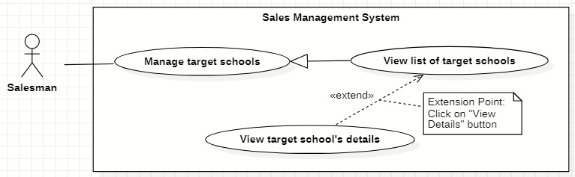

Figure 29. <<Salesman>> View task’s details

|  |  |  |  |  |  |
| --- | --- | --- | --- | --- | --- |
| ID and Name: | **UC-20 View task’s details** | | | | |
| Created By: | GiaNH | | Date Created: | | 07/02/2021 |
| Primary Actor: | Salesman, Sales Supervisor, Sales Manager | | Secondary Actors: | | N/A |
| Description: | This use case allows the user to view the detail information of the task. | | | | |
| Trigger: | The user clicks on the “View details” command on the menu options at the end of row in table list of tasks. | | | | |
| Preconditions: | PRE-1. The user has been logged into the system with role Salesman, Sales Supervisor or Sales Manager.  PRE-2. The user is at the “Tasks” screen. | | | | |
| Post-conditions: | POST-1. The detail information of task is shown as a form. | | | | |
| Normal Flow: | **Step** | **Actor Action** | | **System Response** | |
| 1 | On the “Tasks” screen, at the end of each row in the table, the user clicks on action icon button, then selects “View detail” command on the menu options. | | The system shows “Task’s Details” screen, which contains 3 tabs. Each tab has a form with following information:   1. Tab “General Info”:   *School’s information:*   * “School name”: input text filed, required. * “School phone”: input text field. * “District”: selections (24 districts in Ho Chi Minh City). * “Address”: input text field. * “isActive”: boolean, default value is true. * “Description”: input text field. * “School type”: selections (Công lập, Ngoài công lập, Bán công), required. * “Educational level”: selections (Tiểu học, THCS, THPT), required. * “School scale”: selections (Lớn, Vừa, Nhỏ). * “School status”: selections (Chưa hợp tác, Đang hợp tác, Ngưng hợp tác).   *Representative’s information:*   * “Full name”: input text field. * “Email”: input text field. * “Phone”: input text field. * “IsMale”: radio buttons (Male, Female).   2> Tab “Assign info”:  *Assign information:*   * “PIC”: text. * “PIC’s phone”: text. * “PIC’s email”: text. * “Purpose”: text. * “Note”: input text field.   [Exception 1] | |
| Alternative Flows: | N/A | | | | |
| Exceptions: | **No** | **Cause** | | **System Response** | |
| 1 | The user’s device does not connect to the Internet or the server has internal error. | | The system shows the error message: “Connection Failed or Internal Error”. | |
| Priority: | Medium | | | | |
| Frequency of Use: | Usually | | | | |
| Business Rules: | * BR-40 * Services belongs to this task. | | | | |
| Other Information: | N/A | | | | |
| Assumptions: | N/A | | | | |

Table 36. <<Salesman>> View task’s details

#### Edit school’s information

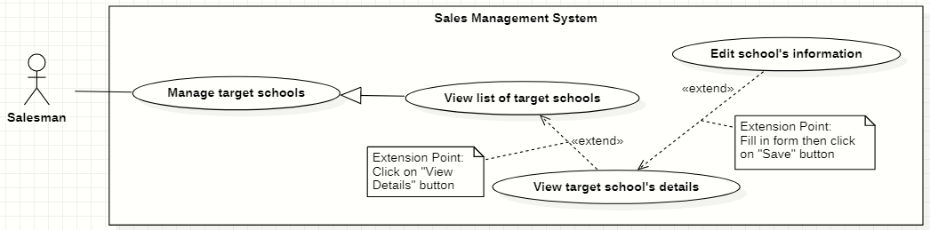

Figure 30. <<Salesman>> Edit school’s information

|  |  |  |  |  |  |
| --- | --- | --- | --- | --- | --- |
| ID and Name: | **UC-21 Edit school’s information** | | | | |
| Created By: | HaPTN | | Date Created: | | 12/04/2021 |
| Primary Actor: | Salesman | | Secondary Actors: | | N/A |
| Description: | This use case allows the user to view the detail information of the task. | | | | |
| Trigger: | The user edits on fields in “Task’s details” screen then clicks “Save” button. | | | | |
| Preconditions: | PRE-1. The user has been logged into the system with role Salesman, Sales Supervisor or Sales Manager.  PRE-2. The user is on the tab “General Info” in “Task’s details” screen. | | | | |
| Post-conditions: | POST-1. The detail information of task is edited in database. | | | | |
| Normal Flow: | **Step** | **Actor Action** | | **System Response** | |
|  | 1 | The user edits on fields in “Task’s details” screen then clicks “Save” button. | | The system displays the “Task’s detail” screen, on the tab “General Info”, there is a form with the following information:  *School’s information:*   * “School name”: input text filed, read only. * “School phone”: input text field, read only. * “District”: selections (24 districts in Ho Chi Minh City), read only. * “Address”: input text field, read only. * “isActive”: boolean, read only. * “Description”: input text field, read only. * “School type”: selections (Công lập, Ngoài công lập, Bán công), read only. * “Educational level”: selections (Tiểu học, THCS, THPT), read only. * “School scale”: selections (Lớn, Vừa, Nhỏ), read only. * “School status”: selections (Chưa hợp tác, Đang hợp tác, Ngưng hợp tác), read only.   *Representative’s information:*   * “Full name”: input text field. * “Email”: input text field. * “Phone”: input text field. * “IsMale”: radio buttons (Male, Female). * “Save”: button, only active when the form is dirty. | |
|  | 2 | The user edits on fields in this form.  [Exception 1] | |  | |
|  | 3 | The user clicks “Save” button when finish. | | The system edits new data in the database and displays the successful message: “Updated Successfully”.  [Exception 2] | |
| Alternative Flows: | N/A | | | | |
| Exceptions: | **No** | **Cause** | | **System Response** | |
| 1 | The user inputs invalid format content into fields. | | The system informs the users that the content of fields is invalid format. | |
| 2 | The user’s device does not connect to the Internet or the server has internal error. | | The system shows the error message: “Connection Failed or Internal Error”. | |
| Priority: | Medium | | | | |
| Frequency of Use: | Usually | | | | |
| Business Rules: | * BR-30, BR-09, BR-40 * The user can only edit fields related to the school’s representative: full name, isMale, email, phone. * Phone must be in format “/(84|0[3|5|7|8|9])+([0-9]{8})\b/g” and have max length is 10 (when starts with 0) or 11 (when starts with 84).   *(Resources:* [*https://www.regextester.com/106725*](https://www.regextester.com/106725)*)*   * Any school’s data, the user needs to inform to the Admin and only Admin have right to edit school’s information. | | | | |
| Other Information: | N/A | | | | |
| Assumptions: | N/A | | | | |

Table 37. <<Salesman>> Edit school’s information

#### Create services

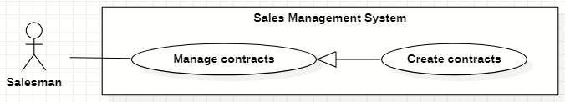

Figure 31 <<Salesman>> Create services

|  |  |  |  |  |  |
| --- | --- | --- | --- | --- | --- |
| ID and Name: | **UC-22 Create services** | | | | |
| Created By: | HaPTN | | Date Created: | | 12/04/2021 |
| Primary Actor: | Salesman | | Secondary Actors: | | N/A |
| Description: | This use case allows the user to create services of his/her assigned tasks. | | | | |
| Trigger: | The user selects the “Create” button on “Services” screen. | | | | |
| Preconditions: | PRE-1. The user has been logged into the system with role Salesman, Sales Supervisor or Sales Manager.  PRE-2. The user is on the tab “Services” in “Task’s details” screen. | | | | |
| Post-conditions: | POST-1. A new service is created in the system. | | | | |
| Normal Flow: | **Step** | **Actor Action** | | **System Response** | |
| 1 | The user selects the “Create” button on “Services” screen. | | The system shows “Create Service” view that contains following information fields:   * “ID”: text. * “Tasks”: text. * “Duration”: input text field, required. * “Service”: checkbox, required. * “Revenue Criteria”: checkbox, required. * “Note”: input text field, required. | |
| 2 | The user inputs the information into the required fields.  [ | |  | |
| 3 | The user selects “Save” button to create a new service.  [Exception 3] | | The system shown the successful message: “Create Successfully”.  [Exception 1]  [Exception 2] | |
| 4 |  | | The system updates the table of list of services in the “Services” screen.  [Exception 2] | |
| Alternative Flows: | N/A | | | | |
| Exceptions: | **No** | **Cause** | | **System Response** | |
| 1 | The user leaves the blank fields or inputs invalid format content. | | The system shows the error message: “Please input the valid format content”. | |
| 2 | The user’s device does not connect to the Internet or the server has internal error. | | The system shows the error message: “Connection Failed or Internal Error”. | |
| 3 | The user selects “Cancel” button. | | The system closes the “Create Service” view and returns the Services screen. | |
| Priority: | High | | | | |
| Frequency of Use: | Usually | | | | |
| Business Rules: | BR-31, BR-32, BR-33, BR-40 | | | | |
| Other Information: | N/A | | | | |
| Assumptions: | N/A | | | | |

Table 38. <<Salesman>> Create services

#### View my services

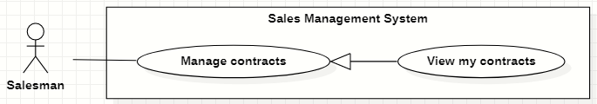

Figure 32. <<Salesman>> View my services

|  |  |  |  |  |  |
| --- | --- | --- | --- | --- | --- |
| ID and Name: | **UC-23 View my services** | | | | |
| Created By: | HaPTN | | Date Created: | | 12/04/2021 |
| Primary Actor: | Salesman | | Secondary Actors: | | N/A |
| Description: | This use case allows the user to view the list of services’ of his/her assigned tasks. | | | | |
| Trigger: | The user selects tab “Services” in “Task’s details” screen. | | | | |
| Preconditions: | PRE-1. The user has been logged into the system with role Salesman, Sales Supervisor or Sales Manager.  PRE-2. The user is on the tab “Services” in “Task’s details” screen. | | | | |
| Post-conditions: | POST-1. Service’s list is displayed as the table in “Services” screen. | | | | |
| Normal Flow: | **Step** | **Actor Action** | | **System Response** | |
| 1 | The user selects tab “Services” in “Task’s details” screen. | | The system displays “Services” screen, service’s list is displayed as the table.   * “Tasks”: text. * “Duration”: text. * “Service”: text. * “Revenue Criteria”: text. * “Note”: text. | |
| Alternative Flows: | N/A | | | | |
| Exceptions: | **No** | **Cause** | | **System Response** | |
| 1 | No stored services data in the system. | | The system displays “No records found” line on the table. | |
|  | 2 | The user’s device does not connect to the Internet or the server has internal error. | | The system shows the error message: “Connection Failed or Internal Error”. | |
| Priority: | High | | | | |
| Frequency of Use: | Usually | | | | |
| Business Rules: | BR-31, BR-32, BR-34, BR-40 | | | | |
| Other Information: | N/A | | | | |
| Assumptions: | N/A | | | | |

Table 39. <<Salesman>> View my services

#### View service’s details

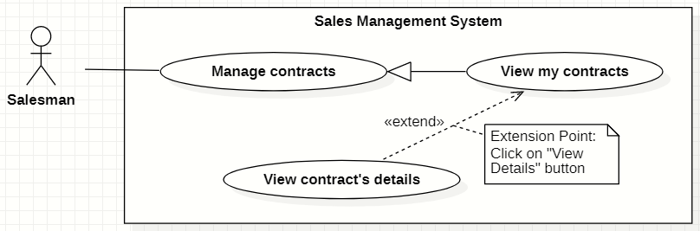

Figure 33. <<Salesman>> View service’s details

|  |  |  |  |  |  |
| --- | --- | --- | --- | --- | --- |
| ID and Name: | **UC-24 View service’s details** | | | | |
| Created By: | HaPTN | | Date Created: | | 12/04/2021 |
| Primary Actor: | Salesman | | Secondary Actors: | | N/A |
| Description: | This use case allows the user to view a service’s details. | | | | |
| Trigger: | The user selects a specific service in the list of services in tab “Services” on “Task’s details” screen. | | | | |
| Preconditions: | PRE-1. The user has been logged into the system with role Sales Manager.  PRE-2. The user is on the tab “Services” in “Task’s details” screen. | | | | |
| Post-conditions: | POST-1. Service’s details is displayed as the dialog in “Services” screen. | | | | |
| Normal Flow: | **Step** | **Actor Action** | | **System Response** | |
|  | 1 | The user clicks on a specific service in the list of services in tab “Services” on “Task’s details” screen. | | The system displays the “Service’s details” dialog with the following information:   * “ID”: text. * “Tasks”: text. * “Duration”: text. * “Service”: text. * “Revenue Criteria”: text. * “Note”: text.   [Exception 1] | |
| Alternative Flows: | N/A | | | | |
| Exceptions: | **No** | **Cause** | | **System Response** | |
|  | 1 | The user’s device does not connect to the Internet or the server has internal error. | | The system shows the error message: “Connection Failed or Internal Error”. | |
| Priority: | Medium | | | | |
| Frequency of Use: | Usually | | | | |
| Business Rules: | BR-31, BR-32, BR-34, BR-40 | | | | |
| Other Information: | N/A | | | | |
| Assumptions: | N/A | | | | |

Table 40. <<Salesman>> View service’s details

#### Edit my services

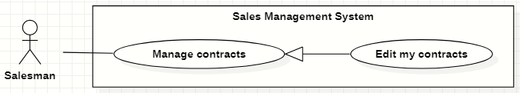

Figure 34. <<Salesman>> Edit my services

|  |  |  |  |  |  |
| --- | --- | --- | --- | --- | --- |
| ID and Name: | **UC-25 Edit my services** | | | | |
| Created By: | HaPTN | | Date Created: | | 12/04/2021 |
| Primary Actor: | Salesman | | Secondary Actors: | | N/A |
| Description: | This use case allows the user to edit the information of services’ of his/her assigned tasks. | | | | |
| Trigger: | The user selects tab “Services” in “Task’s details” screen. | | | | |
| Preconditions: | PRE-1. The user has been logged into the system with role Salesman, Sales Supervisor or Sales Manager.  PRE-2. The user is on the tab “Services” in “Task’s details” screen. | | | | |
| Post-conditions: | POST-1. The detail information of this service is edited in database. | | | | |
| Normal Flow: | **Step** | **Actor Action** | | **System Response** | |
| 1 | The user selects a specific row of services in “Task’s details” screen. | | The system displays “Service’s detail” dialog which contains:   * “Tasks”: text, read only. * “Duration”: input text field. * “Service”: check boxes. * “Revenue Criteria”: check boxes. * “Note”: text area. * “Cancel”: button. * “Save”: button. | |
|  | 2 | The user edits on fields in this form.  [Exception 1] | |  | |
|  | 3 | The user clicks “Save” button when finish. | | The system update new information in the database, then displays the successful message: “Updated Successfully”.  [Exception 2] | |
| Alternative Flows: | N/A | | | | |
| Exceptions: | **No** | **Cause** | | **System Response** | |
| 1 | The user inputs invalid format content into fields. | | The system informs the users that the content of fields is invalid format. | |
|  | 2 | The user’s device does not connect to the Internet or the server has internal error. | | The system shows the error message: “Connection Failed or Internal Error”. | |
| Priority: | High | | | | |
| Frequency of Use: | Usually | | | | |
| Business Rules: | BR-31, BR-32, BR-34, BR-40 | | | | |
| Other Information: | N/A | | | | |
| Assumptions: | N/A | | | | |

Table 41. <<Salesman>> Edit my services

#### Create reports

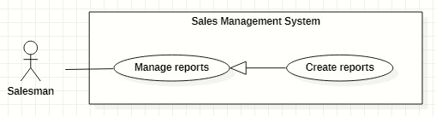

Figure 35. <<Salesman>> Create reports

|  |  |  |  |  |  |
| --- | --- | --- | --- | --- | --- |
| ID and Name: | **UC-26 Create reports** | | | | |
| Created By: | GiaNH | | Date Created: | | 08/02/2021 |
| Primary Actor: | Salesman | | Secondary Actors: | | N/A |
| Description: | This use case allows the user to create daily reports. | | | | |
| Trigger: | The user selects the “Create” command on “Reports” screen. | | | | |
| Preconditions: | PRE-1. The user has been logged into the system with role Salesman, Sales Supervisor or Sales Manager.  PRE-2. The user is on the “Reports” screen. | | | | |
| Post-conditions: | POST-1. A new report is created in the system. | | | | |
| Normal Flow: | **Step** | **Actor Action** | | **System Response** | |
| 1 | The user selects the “Create” button on “Reports” screen.  [Alternative] | | The system shows “Create Report” view that contains following information fields:   * “Tasks”: input text field, required. * “Date”: date, read only, default is current date. * “Result”: input text field, required. * “Description”: input text field, required. * “Positivity”: input text field. * “Difficulty”: input text field. * “Future plan”: input text field. | |
| 2 | The user inputs the information into the required fields.  [Exception 1] | |  | |
| 3 | The user clicks on “Save” button to create a new daily report.  [Alternative 1] | | The system shows the successful message: “Created successfully”.  [Exception 2]  [Exception 3] | |
| 4 |  | | The system updates the table of list of reports in the “Reports” screen.  [Exception 2] | |
| Alternative Flows: | **Step** | **Actor Action** | | **System Response** | |
| 1 | The user clicks on “+” button to continue create daily report for another school. | | The system resets the “Create Report” form and shows the previous inputted reports in “Preview” table.  Table contains these columns:   * “School Name”: text. * “Result”: text. * “Description”: text.   *Continue to step 2 of Normal Flow*. | |
| Exceptions: | **No** | **Cause** | | **System Response** | |
| 1 | The user leaves the blank fields or inputs invalid format content. | | The system shows the error message: “Please input the valid format content”. | |
| 2 | The user’s device does not connect to the Internet or the server has internal error. | | The system shows the error message: “Connection Failed or Internal Error”. | |
| 3 | The user selects “Cancel” button. | | The system closes the “Create Report” view and returns the Reports screen. | |
| Priority: | High | | | | |
| Frequency of Use: | Usually | | | | |
| Business Rules: | BR-21, BR-22, BR-23, BR-24, BR-40 | | | | |
| Other Information: | N/A | | | | |
| Assumptions: | N/A | | | | |

Table 42. <<Salesman>> Create reports

#### Search reports

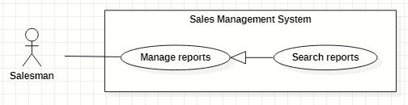

Figure 36. <<Salesman>> Search reports

|  |  |  |  |  |  |
| --- | --- | --- | --- | --- | --- |
| ID and Name: | **UC-27 Search reports** | | | | |
| Created By: | HaPTN | | Date Created: | | 09/02/2021 |
| Primary Actor: | Salesman | | Secondary Actors: | | N/A |
| Description: | This use case allows the user to find the reports based on task’s name, district, PIC’s name, from date to date,…. | | | | |
| Trigger: | The user selects on the searching command on “Reports” screen. | | | | |
| Preconditions: | PRE-1. The user has been logged into the system with role Salesman, Sales Supervisor or Sales Manager.  PRE-2. The user is on the “Reports” screen. | | | | |
| Post-conditions: | POST-1. The list of reports is displayed as the table. | | | | |
| Normal Flow: | **Step** | **Actor Action** | | **System Response** | |
| 1 | The user inputs the search field or select searching filters on toolbar to find reports. | | The system displays the list of reports as the table.  Available filters on this screen:  “PICs”: selections (all salesmen in the Sales Department)   * “Districts”: selections (24 districts in Ho Chi Minh City) * “School Years”: selections (2020-2021, 2019-2020, 2018-2019,…). * “From date” – “To date”: date range picker, disable future days. * “School Statuses”: selections (Chưa hợp tác, Đang hợp tác, Ngưng hợp tác). * “Purposes”: selections (   - Chưa hợp tác: Sales mới, Theo dõi;  - Đang hợp tác: Chăm sóc, Tái ký hợp đồng, Ký mới hợp đồng;  - Ngưng hợp tác  )   * Search field: text field. | |
|  | 2 |  | | The system displays the list of tasks as a table.   * “Date”: date. * “School Name”: text. * “PIC”: image (avatar) and text. * “Purpose”: Label. * “Result”: text. * “Description”: text.   [Exception 1]  [Exception 2] | |
| Alternative Flows: | N/A | | | | |
| Exceptions: | **No** | **Cause** | | **System Response** | |
| 1 | The content of search field or selecting filter that The user inputted is not matched any stored data in the system. | | The system displays “No records found” line on the table. | |
| 2 | The user’s device does not connect to the Internet or the server has internal error. | | The system shows the error message: “Connection Failed or Internal Error”. | |
| Priority: | Medium | | | | |
| Frequency of Use: | Usually | | | | |
| Business Rules: | * BR-20, BR-24, BR-39, BR-40 * The default values of all filters are “All”. | | | | |
| Other Information: | N/A | | | | |
| Assumptions: | N/A | | | | |

Table 43. <<Salesman>> Search reports

#### View all reports

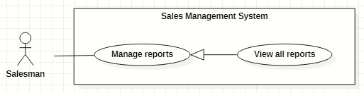

Figure 37. <<Salesman>> View all reports

|  |  |  |  |  |  |
| --- | --- | --- | --- | --- | --- |
| ID and Name: | **UC-28 View all reports** | | | | |
| Created By: | GiaNH | | Date Created: | | 08/02/2021 |
| Primary Actor: | Salesman | | Secondary Actors: | | N/A |
| Description: | This use case allows the user to view list of all daily report’s of all members in Major Sales Department. | | | | |
| Trigger: | The user selects “Reports” on the navigation bar (sidebar). | | | | |
| Preconditions: | PRE-1. The user has been logged into the system with role Salesman, Sales Supervisor or Sales Manager. | | | | |
| Post-conditions: | POST-1. Report’s list is displayed as the table in “Reports” screen. | | | | |
| Normal Flow: | **Step** | **Actor Action** | | **System Response** | |
| 1 | The user selects “Reports” on the navigation bar (sidebar). | | The system displays “Reports” screen, report’s list is displayed as the table.   * “Date”: date. * “School Name”: text. * “PIC”: image (avatar) and text. * “Purpose”: label. * “Result”: text. * “Description”: text.   Available filters on this screen:  “PICs”: selections (all salesmen in the Sales Department)   * “Districts”: selections (24 districts in Ho Chi Minh City) * “School Years”: selections (2020-2021, 2019-2020, 2018-2019,…). * “From date” – “To date”: date range picker, disable future days. * “School Statuses”: selections (Chưa hợp tác, Đang hợp tác, Ngưng hợp tác). * “Purposes”: selections (   - Chưa hợp tác: Sales mới, Theo dõi;  - Đang hợp tác: Chăm sóc, Tái ký hợp đồng, Ký mới hợp đồng;  - Ngưng hợp tác  )   * Search field: text field.   [Exception 1]  [Exception 2] | |
| Alternative Flows: | N/A | | | | |
| Exceptions: | **No** | **Cause** | | **System Response** | |
| 1 | No stored reports data in the system. | | The system displays “No records found” line on the table. | |
|  | 2 | The user’s device does not connect to the Internet or the server has internal error. | | The system shows the error message: “Connection Failed or Internal Error”. | |
| Priority: | High | | | | |
| Frequency of Use: | Usually | | | | |
| Business Rules: | BR-20, BR-24, BR-39, BR-40 | | | | |
| Other Information: | N/A | | | | |
| Assumptions: | N/A | | | | |

Table 44. <<Salesman>> View all reports

#### View report’s details

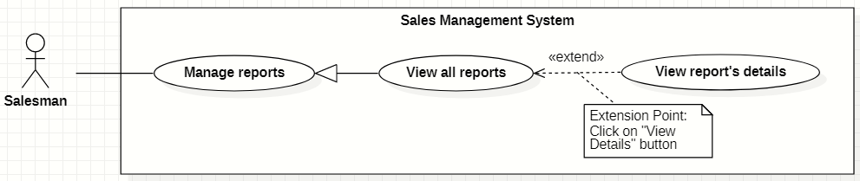

Figure 38. <<Salesman>> View report’s details

|  |  |  |  |  |  |
| --- | --- | --- | --- | --- | --- |
| ID and Name: | **UC-29 View report’s details** | | | | |
| Created By: | HaPTN | | Date Created: | | 12/04/2021 |
| Primary Actor: | Salesman | | Secondary Actors: | | N/A |
| Description: | This use case allows the user to view the detail information of a report. | | | | |
| Trigger: | The user clicks on the “View details” command on the menu options at the end of row in table list of reports. | | | | |
| Preconditions: | PRE-1. The user has been logged into the system with role Salesman, Sales Supervisor or Sales Manager.  PRE-2. The user is on the “Reports” screen. | | | | |
| Post-conditions: | POST-1. The detail information of report is shown as a form. | | | | |
| Normal Flow: | **Step** | **Actor Action** | | **System Response** | |
| 1 | On the “Reports” screen, at the end of each row in the table, the user clicks on action icon button, then selects “View detail” command on the menu options. | | The system displays “Report’s details” view, the report’s information is displayed as a form.   * “School Year”: text. * “Date”: text. * “School Name”: text. * “PIC”: image (avatar) and text. * “Purpose”: text. * “Result”: input text field, required. * “Description”: input text field, required. * “Positivity”: input text field. * “Difficulty”: input text field. * “Future plan”: input text field. * “Supervisor comment”: input text field, read only. * “Save”: button, inactive.   [Exception 1] | |
| Alternative Flows: | N/A | | | | |
| Exceptions: | **No** | **Cause** | | **System Response** | |
| 1 | The user’s device does not connect to the Internet or the server has internal error. | | The system shows the error message: “Connection Failed or Internal Error”. | |
| Priority: | Medium | | | | |
| Frequency of Use: | Usually | | | | |
| Business Rules: | BR-20, BR-24, BR-39, BR-40 | | | | |
| Other Information: | N/A | | | | |
| Assumptions: | N/A | | | | |

Table 45. <<Salesman>> View report’s details

#### Edit reports

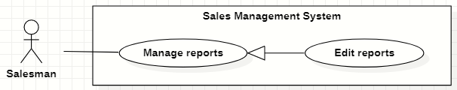

Figure 39. <<Salesman>> Edit reports

|  |  |  |  |  |  |
| --- | --- | --- | --- | --- | --- |
| ID and Name: | **UC-30 Edit reports** | | | | |
| Created By: | HaPTN | | Date Created: | | 12/04/2021 |
| Primary Actor: | Salesman | | Secondary Actors: | | N/A |
| Description: | This use case allows the user to edit a daily report. | | | | |
| Trigger: | The user edits on fields in “Report’s details” screen then clicks “Save” button. | | | | |
| Preconditions: | PRE-1. The user has been logged into the system with role Salesman, Sales Supervisor or Sales Manager.  PRE-2. The user is on the “Report’s details” screen. | | | | |
| Post-conditions: | POST-1. A new report is updated in the database. | | | | |
| Normal Flow: | **Step** | **Actor Action** | | **System Response** | |
| 1 | The user edits on fields in “Report’s details” screen then clicks “Save” button. | | The system displays “Report’s details” view, the report’s information is displayed as a form.   * “School Year”: text. * “Date”: text. * “School Name”: text. * “PIC”: image (avatar) and text. * “Purpose”: text. * “Result”: input text field, required. * “Description”: input text field, required. * “Positivity”: input text field. * “Difficulty”: input text field. * “Future plan”: input text field. * “Supervisor comment”: input text field, read only. * “Save”: button, only active when the form is dirty. | |
| 2 | The user edits on fields in this form.  [Exception 1] | |  | |
| 3 | The user clicks “Save” button when finish. | | The system has successful edit and displays the successful message: “Updated Successfully”.  [Exception 2] | |
| Alternative Flows: | N/A | | | | |
| Exceptions: | **No** | **Cause** | | **System Response** | |
| 1 | The user inputs invalid format content into fields. | | The system informs the users that the content of fields is invalid format. | |
|  | 2 | The user’s device does not connect to the Internet or the server has internal error. | | The system shows the error message: “Connection Failed or Internal Error”. | |
| Priority: | High | | | | |
| Frequency of Use: | Usually | | | | |
| Business Rules: | * BR-24, BR-28, BR-29, BR-30, BR-39, BR-40 * The user can only edit reports which have not been commented by the supervisor or the manager. | | | | |
| Other Information: | N/A | | | | |
| Assumptions: | N/A | | | | |

Table 46. <<Salesman>> Edit reports

#### Remove reports

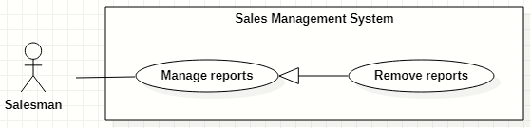

Figure 40. <<Salesman>> Remove reports

|  |  |  |  |  |  |
| --- | --- | --- | --- | --- | --- |
| ID and Name: | **UC-31 Remove reports** | | | | |
| Created By: | HaPTN | | Date Created: | | 12/04/2021 |
| Primary Actor: | Salesman | | Secondary Actors: | | N/A |
| Description: | This use case allows the user to remove a daily report. | | | | |
| Trigger: | The user clicks on the “Remove” command on the menu options at the end of row in table list of reports. | | | | |
| Preconditions: | PRE-1. The user has been logged into the system with role Salesman, Sales Supervisor or Sales Manager.  PRE-2. The user is on the “Reports” screen. | | | | |
| Post-conditions: | POST-1. A daily report is removed in the database. | | | | |
| Normal Flow: | **Step** | **Actor Action** | | **System Response** | |
|  | 1 | The user clicks on the “Remove” command on the menu options at the end of row in table list of reports. | | The system shows a “Confirm Remove” dialog to alert.   * “Cancel”: button. * “Remove”: button. | |
|  | 2 | The user clicks on “Remove” button.  [Exception 1] | | The system shows a successful message: “Removed successfully”, and closes the confirm dialog. | |
| Alternative Flows: | N/A | | | | |
| Exceptions: | **No** | **Cause** | | **System Response** | |
| 1 | The user selects “Cancel” button. | | The system closes the “Confirm Remove” dialog and returns the Reports screen. | |
| 2 | The user’s device does not connect to the Internet or the server has internal error. | | The system shows the error message: “Connection Failed or Internal Error”. | |
| Priority: | High | | | | |
| Frequency of Use: | Sometimes | | | | |
| Business Rules: | * BR-28, BR-29, BR-40 * The user can only edit reports The user can only remove reports which have not been commented by the supervisor or the manager. | | | | |
| Other Information: | N/A | | | | |
| Assumptions: | N/A | | | | |

Table 47 <<Salesman>> Remove reports

#### Create personal activities

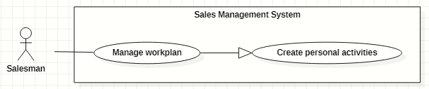

Figure 41. <<Salesman>> Create personal activities

|  |  |  |  |  |  |  |  |
| --- | --- | --- | --- | --- | --- | --- | --- |
| ID and Name: | **UC-32 Create personal activities** | | | | | | |
| Created By: | GiaNH, HaPTN | | | | Date Created: | | 12/04/2021 |
| Primary Actor: | Salesman, Sales Supervisor, Sales Manager | | | | Secondary Actors: | | N/A |
| Description: | This use case allows the user to create one or multiple personal activities in his/her work-plan. | | | | | | |
| Trigger: | The user wants to create one or multiple personal activities. | | | | | | |
| Preconditions: | PRE-1. The user has been logged into the system with role Salesman, Sales Supervisor or Sales Manager.  PRE-2. The user is on the “Work-plan” screen. | | | | | | |
| Post-conditions: | POST-1. New personal activity/personal activities is/are added in work-plan schedule. | | | | | | |
| Normal Flow: | **Step** | | **Actor Action** | | | **System Response** | |
| 1 | | The user clicks on a cell and chooses “More details” button on the “Work-plan” screen.  [Alternative 1] | | | The system displays the “Add Activity” form dialog that contains the following format fields:   * “Title”: text, required. * “Location”: text. * “Description”: text. * “Remark”: text. * “Start time”: date time, required. * “End time”: date time, required. * “isAllDay”:check box [True- False] , default is “False”. * “Repeat”: selection (Never, Daily, Weekly, Monthly, Yearly), default is “Never”. * “isCompleted”: check box [True, False], defalt is False. * “Cancel”: button. * “Save”: button. | |
| 2 | | The user inputs into the information fields.  [Exception 1]  [Alternative 2] | | |  | |
| 3 | | The user selects the “Save” button. | | | The system creates new activity in the database and update the “Work-plan” screen.  [Exception 2] | |
| Alternative Flows: | No | **Step** | | **Actor Action** | | **System Response** | |
| 1 | 1 | | The user clicks on a cell and on the “Work-plan” screen. | | The system shows a quick create dialog which contains:   * “Title”: text, required. * “Time”: text, read only. * “More details”: button. * “Save”: button. | |
| 2 | | The user selects the “Save” button. | | The system creates new activity in the database and update the “Work-plan” screen.  [Exception 2] | |
| 2 | 1 | | The user selects other options (Daily, Weekly, Monthly, Yearly). | | The system shows relative option’s details for each case. | |
| 2 | | The user selects the “Save” button. | | The system creates a serie of activities in the database and update the “Work-plan” screen.  [Exception 2] | |
| Exceptions: | **No** | | **Actor Action** | | | **System Response** | |
| 1 | | The user leaves the blank fields or inputs invalid format content into fields. | | | The system shows the error message: “Please input the valid format content”. | |
| 2 | | The user’s device does not connect to the Internet or the server has internal error. | | | The system shows the error message: “Connection Failed or Internal Error”. | |
| Priority: | Normal | | | | | | |
| Frequency of Use: | Usually | | | | | | |
| Business Rules: | BR-35, BR-36, BR-37, BR-38, BR-40 | | | | | | |
| Other Information: | N/A | | | | | | |
| Assumptions: | N/A | | | | | | |

Table 48. <<Salesman>> Create personal activities

#### Search other’s work-plan

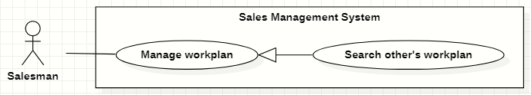

Figure 42. <<Salesman>> Search other’s work-plan

|  |  |  |  |  |  |
| --- | --- | --- | --- | --- | --- |
| ID and Name: | **UC-33 Search other’s work-plan** | | | | |
| Created By: | GiaNH, HaPTN | | Date Created: | | 12/04/2021 |
| Primary Actor: | Salesman, Sales Supervisor, Sales Manager | | Secondary Actors: | | N/A |
| Description: | This use case allows the user to search the work-plan of other users. | | | | |
| Trigger: | The user input in the search field on “Work-plan” screen. | | | | |
| Preconditions: | PRE-1. The user has been logged into the system with role Salesman, Sales Supervisor or Sales Manager.  PRE-2. The user is on the “Work plan” screen. | | | | |
| Post-conditions: | POST-1. The work plan schedule is displayed on the screen. | | | | |
| Normal Flow: | **Step** | **Actor Action** | | **System Response** | |
| 1 | On the “Work plan” screen, the user inputs into the search field username or full name of people he/she wants to view the work-plan. | | The system provides suggestions that presents Salesman to users as they enter their search query into the search box. | |
|  | 2 | The user selects a Salesman item in suggestions. | | The system displays “work-plan” screen. The Work-plan has the personal activity items that present as a schedule. | |
| Alternative Flows: | N/A | | | | |
| Exceptions: | **No** | **Actor Action** | | **System Response** | |
| 1 | The content of search field or selecting filter that the user inputted is not matched any stored data in the system. | | The system displays “No records found” line on the table. | |
|  | 2 | The user’s device does not connect to the Internet or the server has internal error. | | The system shows the error message: “Connection Failed or Internal Error”. | |
| Priority: | Normal | | | | |
| Frequency of Use: | Usually | | | | |
| Business Rules: | * BR-35, BR-39, BR-40 * The Sales Manager can view the Salesman’s work-plan and other Sales Manager’s work-plan. * The Salesman can only view the work-plan of other Salesman. * The user is not allowed to create/edit/remove anything in other person’s work-plan. | | | | |
| Other Information: | N/A | | | | |
| Assumptions: | N/A | | | | |

Table 49. <<Salesman>> Search other’s work-plan

#### View work-plan

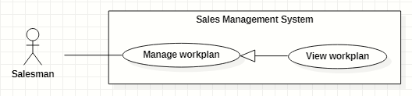

Figure 43. <<Salesman>> View work-plan

|  |  |  |  |  |  |
| --- | --- | --- | --- | --- | --- |
| ID and Name: | **UC-34 View work-plan** | | | | |
| Created By: | GiaNH, HaPTN | | Date Created: | | 12/04/2021 |
| Primary Actor: | Salesman, Sales Supervisor, Sales Manager | | Secondary Actors: | | N/A |
| Description: | This use case allows the user to view a whole work-plan of himself/herself or other’s. | | | | |
| Trigger: | The user selects “Work-plans” on the navigation bar (sidebar). | | | | |
| Preconditions: | PRE-1. The user has been logged into the system with role Salesman, Sales Supervisor or Sales Manager. | | | | |
| Post-conditions: | POST-1. The personal activities are displayed in work-plan schedule. | | | | |
| Normal Flow: | **Step** | **Actor Action** | | **System Response** | |
| 1 | The user selects “Work-plans” on the navigation bar (sidebar). | | The system displays “work-plan” screen. The Work-plan has the personal activity items that present as a schedule  [Exception 1] | |
| Alternative Flows: | N/A | | | | |
| Exceptions: | **No** | **Cause** | | **System Response** | |
| 1 | The user’s device does not connect to the Internet or the server has internal error. | | The system shows the error message: “Connection Failed or Internal Error”. | |
| Priority: | Normal | | | | |
| Frequency of Use: | Usually | | | | |
| Business Rules: | * BR-35, BR-39, BR-40 * The system displays the “Work-plan” as a week’s schedule with the activity item is a cell in the schedule. * The activity items have different colors to distinguish based on status. * The users can view the Work-plan by Day, Week, Month. | | | | |
| Other Information: | N/A | | | | |
| Assumptions: | N/A | | | | |

Table 50. <<Salesman>> View work-plan

#### View personal activity’s details

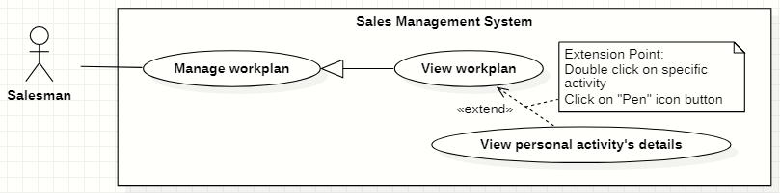

Figure 44. <<Salesman>> View personal activity’s details

|  |  |  |  |  |  |
| --- | --- | --- | --- | --- | --- |
| ID and Name: | **UC-35 View personal activity’s details** | | | | |
| Created By: | GiaNH, HaPTN | | Date Created: | | 12/04/2021 |
| Primary Actor: | Salesman, Sales Supervisor, Sales Manager | | Secondary Actors: | | N/A |
| Description: | This use case allows the user to view the detail information of personal activity. | | | | |
| Trigger: | The user clicks on the personal activity item on work-plan screen. | | | | |
| Preconditions: | PRE-1. The user has been logged into the system with role Salesman, Sales Supervisor or Sales Manager.  PRE-2. The user is on the “Work-plan” screen. | | | | |
| Post-conditions: | POST-1. The detail information of personal activity is shown as a form. | | | | |
| Normal Flow: | **Step** | **Actor Action** | | **System Response** | |
| 1 | The user clicks on an item and chooses “pen” icon button on the “Work-plan” screen.  [Alternative 1] | | *If the user is viewing his/her own work-plan*:  The system displays the “Activity’s details” form dialog that contains the following format fields:   * “Title”: text, required. * “Location”: text. * “Description”: text. * “Remark”: text. * “Start time”: date time, required. * “End time”: date time, required. * “isAllDay”:check box [True- False] , default is “False”. * “Repeat”: selection (Never, Daily, Weekly, Monthly, Yearly), default is “Never”. * “isCompleted”: check box [True, False], defalt is False.   ----------  *If the user is viewing other’s work-plan*:  The system displays the “Activity’s details” quick dialog that contains:   * “Title”: text. * “Location”: text. * “Description”: text. * “Time”: text (including start time and end time). * “isCompleted” is displayed by different colors. | |
| Alternative Flows: | **Step** | **Actor Action** | | **System Response** | |
| 1 | The user double clicks on an item on the “Work-plan” screen. | | The system displays the “Activity’s details” quick dialog that contains the following format fields:   * “Title”: text, required. * “Location”: text. * “Description”: text. * “Time”: text (including start time and end time). * “isCompleted” is displayed by different colors. | |
| Exceptions: | **No** | **Actor Action** | | **System Response** | |
| 1 | The user’s device does not connect to the Internet or the server has internal error. | | The system shows the error message: “Connection Failed or Internal Error”. | |
| Priority: | Normal | | | | |
| Frequency of Use: | Usually | | | | |
| Business Rules: | BR-35, BR-39, BR-40 | | | | |
| Other Information: | N/A | | | | |
| Assumptions: | N/A | | | | |

Table 51. <<Salesman>> View personal activity’s details

#### Edit personal activities

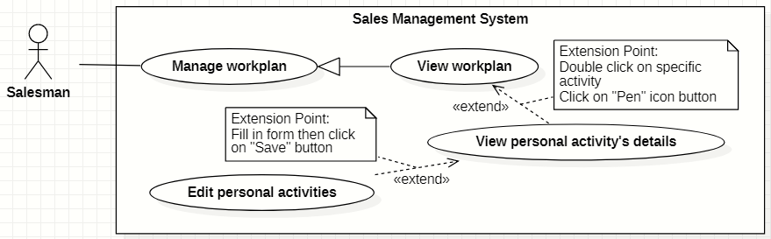

Figure 45. <<Salesman>> Edit personal activities

|  |  |  |  |  |  |
| --- | --- | --- | --- | --- | --- |
| ID and Name: | **UC-36 Edit personal activities** | | | | |
| Created By: | GiaNH, HaPTN | | Date Created: | | 12/04/2021 |
| Primary Actor: | Salesman, Sales Supervisor, Sales Manager | | Secondary Actors: | | N/A |
| Description: | This use case allows the user to edit personal activities in his/her work-plan. | | | | |
| Trigger: | The user wants to edit one or multiple personal activities. | | | | |
| Preconditions: | PRE-1. The user has been logged into the system with role Salesman, Sales Supervisor or Sales Manager.  PRE-2.1. The user is on the “Work-plan” screen. | | | | |
| Post-conditions: | POST-1. The personal activity/personal activities is/are updated in the database. | | | | |
| Normal Flow: | **Step** | **Actor Action** | | **System Response** | |
| 1 | The user clicks on an item and chooses “pen” icon button on the “Work-plan” screen.  [Alternative 1] | | The system displays the “Edit Activity” form dialog that contains the following format fields:   * “Title”: text, required. * “Location”: text. * “Description”: text. * “Remark”: text. * “Start time”: date time, required. * “End time”: date time, required. * “isAllDay”:check box [True- False] , default is “False”. * “Repeat”: selection (Never, Daily, Weekly, Monthly, Yearly), default is “Never”. * “isCompleted”: check box [True, False], default is False. * “Cancel”: button. * “Save”: button. * “Delete”: button. | |
| 2 | The user inputs the new content in the fields. | |  | |
| 3 | The user clicks “Save” button.  [Exception 1] | | The system update “Work-plan” screen with new data.  [Exception 2] | |
| Alternative Flows: | **Step** | **Actor Action** | | **System Response** | |
| 1 | The user double clicks on an item on the “Work-plan” screen. | | The system shows the dialog “Edit event” for the use to choose whether edit an activity or edit the entire series. | |
| 2 |  | | The system displays the “Edit Activity” form dialog that contains the following format fields:   * “Title”: text, required. * “Location”: text. * “Description”: text. * “Remark”: text. * “Start time”: date time, required. * “End time”: date time, required. * “isAllDay”:check box [True- False] , default is “False”. * “Repeat”: selection (Never, Daily, Weekly, Monthly, Yearly), default is “Never”. * “isCompleted”: check box [True, False], default is False. * “Cancel”: button. * “Save”: button. * “Delete”: button.   *Continue to step 2 in the Normal Flow.* | |
| Exceptions: | **No** | **Actor Action** | | **System Response** | |
| 1 | The user selects “Cancel” button to cancel the editing. | | The system discards all changes and close the “Edit Activity” dialog. | |
| 2 | The user’s device does not connect to the Internet or the server has internal error. | | The system shows the error message: “Connection Failed or Internal Error”. | |
| Priority: | Normal | | | | |
| Frequency of Use: | Usually | | | | |
| Business Rules: | BR-35, BR-36, BR-38, BR-39, BR-40 | | | | |
| Other Information: | N/A | | | | |
| Assumptions: | N/A | | | | |

Table 52. <<Salesman>> Edit personal activities

#### Remove personal activities

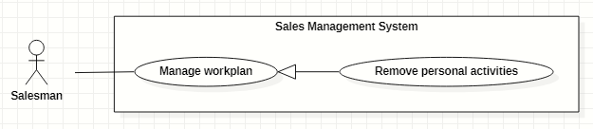

Figure 46. <<Salesman>> Remove personal activities

|  |  |  |  |  |  |
| --- | --- | --- | --- | --- | --- |
| ID and Name: | **UC-37 Remove personal activities** | | | | |
| Created By: | GiaNH, HaPTN | | Date Created: | | 12/04/2021 |
| Primary Actor: | Salesman, Sales Supervisor, Sales Manager | | Secondary Actors: | | N/A |
| Description: | This use case allows the user to remove personal activities in his/her work-plan. | | | | |
| Trigger: | The user wants to remove one or multiple personal activities. | | | | |
| Preconditions: | PRE-1. The user has been logged into the system with role Salesman, Sales Supervisor or Sales Manager.  PRE-2.1. The user is on the “Work-plan” screen. | | | | |
| Post-conditions: | POST-1. The personal activity/personal activities is/are removed in the database. | | | | |
| Normal Flow: | **Step** | **Actor Action** | | **System Response** | |
| 1 | On the “Work-plan” screen, the user clicks on an item and selects “Remove” icon button in the quick view pop-up.  [Alternative 1] | | The system shows the dialog “Delete Activity” for the use to choose whether remove an activity or remove the entire series. | |
| 2 | The user selects a button to confirm the removing.  [Exception 1] | | The system update “Work-plan” screen with new data.  [Exception 2] | |
| Alternative Flows: | **Step** | **Actor Action** | | **System Response** | |
| 1 | The user double clicks on an item on the “Work-plan” screen. | | The system displays the “Edit Activity” form dialog that contains the following format fields:   * “Title”: text, required. * “Location”: text. * “Description”: text. * “Remark”: text. * “Start time”: date time, required. * “End time”: date time, required. * “isAllDay”:check box [True- False] , default is “False”. * “Repeat”: selection (Never, Daily, Weekly, Monthly, Yearly), default is “Never”. * “isCompleted”: check box [True, False], default is False. * “Cancel”: button. * “Save”: button. * “Delete”: button. | |
|  | 2 | The user clicks on “Delete” button.  [Exception 1] | | The system shows confirmation dialog “Delete Activity” which includes:   * “Delete”: button. * “Cancel”: button. | |
|  | 3 | The user clicks on “Delete” button.  [Exception 1] | | The system update “Work-plan” screen with new data.  [Exception 2] | |
| Exceptions: | **No** | **Actor Action** | | **System Response** | |
| 1 | The user selects “Cancel” button to cancel the removing. | | The system returns the “Work-plan” screen. | |
|  | 2 | The user’s device does not connect to the Internet or the server has internal error. | | The system shows the error message: “Connection Failed or Internal Error”. | |
| Priority: | Normal. | | | | |
| Frequency of Use: | Usually | | | | |
| Business Rules: | BR-35, BR-36, BR-39, BR-40 | | | | |
| Other Information: | N/A | | | | |
| Assumptions: | N/A | | | | |

Table 53. <<Salesman>> Remove personal activities

#### View my KPIs

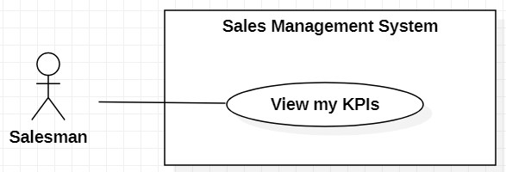

Figure 47. <<Salesman>> View my KPIs

|  |  |  |  |  |  |
| --- | --- | --- | --- | --- | --- |
| ID and Name: | **UC-50 View my KPIs** | | | | |
| Created By: | HaPTN | | Date Created: | | 30/05/2021 |
| Primary Actor: | Salesman | | Secondary Actors: | | N/A |
| Description: | This use case allows the user to view personal KPI. | | | | |
| Trigger: | The user clicks on options KPI in the sidebar. | | | | |
| Preconditions: | PRE-1. The user has been logged into the system with role Salesman.  PRE-2.1. The user is on the “KPIs” screen. | | | | |
| Post-conditions: | POST-1. The personal KPIs details are displayed on the screen. | | | | |
| Normal Flow: | **Step** | **Actor Action** | | **System Response** | |
| 1 |  | | The system shows the table list of KPI groups that are applied for this user. | |
| 2 | The user clicks on option “View Details” at row of KPI group they want to view. | | The system redirects to “KPI group’s details” screen.  In this screen, on the left side, there are panels to show chart and information of the user’s KPIs.  On the right side, there is a table of list of criteria and weight of each criteria.  [Exception 1] | |
| Alternative Flows: | N/A | | | | |
| Exceptions: | **No** | **Actor Action** | | **System Response** | |
| 1 | The user’s device does not connect to the Internet or the server has internal error. | | The system shows the error message: “Connection Failed or Internal Error”. | |
| Priority: | Normal | | | | |
| Frequency of Use: | Usually | | | | |
| Business Rules: | N/A | | | | |
| Other Information: | N/A | | | | |
| Assumptions: | N/A | | | | |

Table 54. <<Salesman>> View my KPIs

### 2.6 <<Sales Supervisor>> Overview Use Case

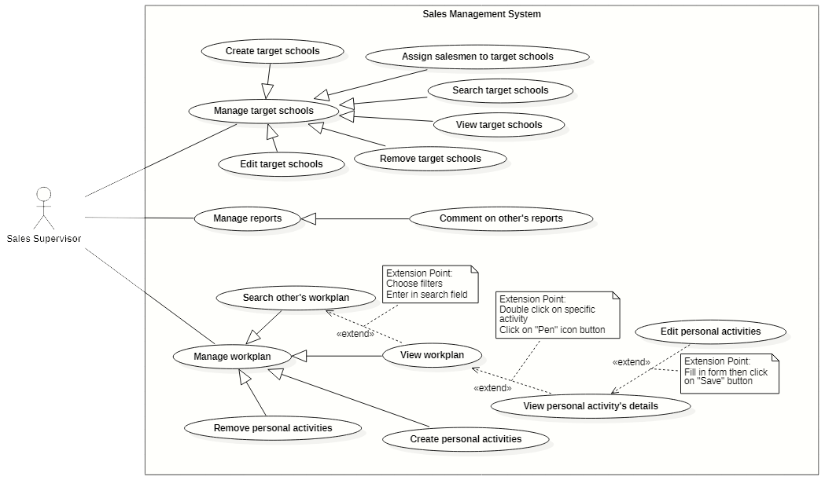

Figure 48. <<Sales Supervisor>> Overview Use Case

#### Create tasks

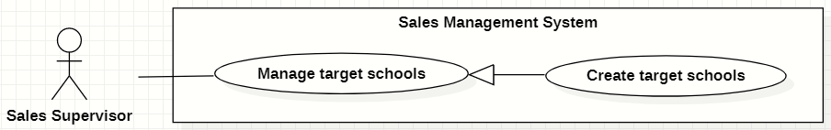

Figure 49. <<Sales Supervisor>> Create tasks

|  |  |  |  |  |  |
| --- | --- | --- | --- | --- | --- |
| ID and Name: | **UC-38 Create tasks** | | | | |
| Created By: | GiaNH, HaPTN | | | Date Created: | 15/02/2021 |
| Primary Actor: | Sales Supervisor, Sales Manager | | | Secondary Actors: | N/A |
| Description: | This use case allows the user to create new tasks from the list of all schools. | | | | |
| Trigger: | The user clicks on the “Create” button on “Tasks” screen. | | | | |
| Preconditions: | PRE-1. The user has been logged into the system with role Sales Supervisor or Sales Manager.  PRE-2. The user is on the “Tasks” screen. | | | | |
| Post-conditions: | POST-1. The new tasks are created in the system. | | | | |
| Normal Flow: | **Step** | **Actor Action** | **System Response** | | |
| 1 | The user clicks on the “Create” button on “Tasks” screen. | The system displays the “Create Task” form with following information:   * 2 tabs: “Chưa hợp tác” and “Đang hợp tác” * 4 filters: 3 selections for “districts”, “school types”, “school levels” and 1 check box “Tiềm năng” * “Search”: input field * “+”: button. * A table of all schools which has the following columns: * “”: checkbox. * “School Name”: text. * “Address”: text. * “Principal”: text. * “School Status”: label. | | |
| 2 | The user ticks the checkboxes and clicks on “+” button. | The system displays the “Confirm Create Task” form with following information:   * “Purpose”: selections (   - Chưa hợp tác: Sales mới, Theo dõi;  - Đang hợp tác: Chăm sóc, Tái ký hợp đồng, Ký mới hợp đồng;  - Ngưng hợp tác  ) (value of purpose depends on value of “School Status”), required.   * “School Year”: text, read only. * A table of selected schools * “Cancel”: button. * “Save”: button. | | |
| 3 |  |  | | |
| 2 | The user ticks the checkboxes and chooses “Purpose” in the selections.  [Alternative 1] |  | | |
| 3 | The user selects “Save” button.  [Exception 2] | The system shows the successful message: “Created successfully”.  [Exception 1] | | |
| 4 |  | The system updates the table of list of tasks in the “Tasks” screen.  [Exception 1] | | |
| Alternative Flows: | **Step** | **Actor Action** | **System Response** | | |
| 1 | The users clicks on a table row. | The systems display that school’s details in the preview panel.   * “School Name”: text. * “School level”: text. * “School type”: text. * “School scale”: text. * “School status”: text. * “Address”: text. * “School phone”: text. * “Representative name”: text. * “Representative phone”: text. * “Representative email”: text. * “Representative isMale”: text. * “This school also be targeted in”: text, list of school year.   *Continue to step 2 of Normal Flow*. | | |
| Exceptions: | **No** | **Cause** | **System Response** | | |
| 1 | The user’s device does not connect to the Internet or the server has internal error. | The system shows the error message: “Connection Failed or Internal Error”. | | |
| 2 | The user selects “Cancel” button. | The system closes the “Create Tasks” form and returns to the “Tasks” screen. | | |
| Priority: | High | | | | |
| Frequency of Use: | Usually | | | | |
| Business Rules: | * BR-11, BR-12, BR-13 * Sales Supervisor/Sales Manager can only create the tasks at the current school year. | | | | |
| Other Information: | N/A | | | | |
| Assumptions: | N/A | | | | |
| Assumptions: | N/A | | | | |

Table 55. <<Sales Supervisor>> Create tasks

#### Edit tasks

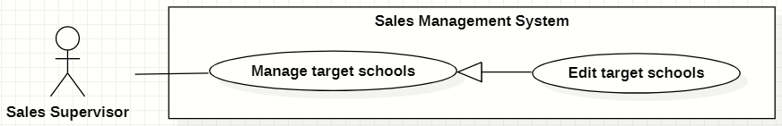

Figure 50. <<Sales Supervisor>> Edit tasks

|  |  |  |  |  |  |
| --- | --- | --- | --- | --- | --- |
| ID and Name: | **UC-39 Edit tasks** | | | | |
| Created By: | HaPTN | | Date Created: | | 12/04/2021 |
| Primary Actor: | Sales Supervisor, Sales Manager | | Secondary Actors: | | N/A |
| Description: | This use case allows the user to edit a task. | | | | |
| Trigger: | The user edits on fields in “Task’s details” screen then clicks “Save” button. | | | | |
| Preconditions: | PRE-1. The user has been logged into the system with role Sales Supervisor or Sales Manager.  PRE-2. The user is on the tab “Assign Info” in “Task’s details” screen. | | | | |
| Post-conditions: | POST-1. The detail information of task is edited in database. | | | | |
| Normal Flow: | **Step** | **Actor Action** | | **System Response** | |
|  | 1 | The user edits on fields in “Task’s details” screen then clicks “Save” button. | | The system displays the “Task’s detail” screen, on the tab “Assign Info”, there is a form with the following information:   * “School year”: text. * “PIC”: input text field, read only. * “PIC’s phone”: input text field, disabled. * “PIC’s email”: input text field, disabled. * “Purpose”: label. * “Note”: input text field. | |
|  | 2 | The user edits on fields in this form.  [Exception 1] | |  | |
|  | 3 | The user clicks “Save” button when finish. | | The system has successful edit and displays the successful message: “Updated Successfully”.  [Exception 2] | |
| Alternative Flows: | N/A | | | | |
| Exceptions: | **No** | **Cause** | | **System Response** | |
| 1 | The user inputs invalid format content into fields. | | The system informs the users that the content of fields is invalid format. | |
| 2 | The user’s device does not connect to the Internet or the server has internal error. | | The system shows the error message: “Connection Failed or Internal Error”. | |
| Priority: | Normal | | | | |
| Frequency of Use: | Usually | | | | |
| Business Rules: | * BR-12, BR-13 * The user can only edit fields: note. * To change PIC, the user needs to unassign the current PIC and then assign a new PIC. | | | | |
| Other Information: | N/A | | | | |
| Assumptions: | N/A | | | | |

Table 56. <<Sales Supervisor>> Edit tasks

#### Assign salesmen to tasks

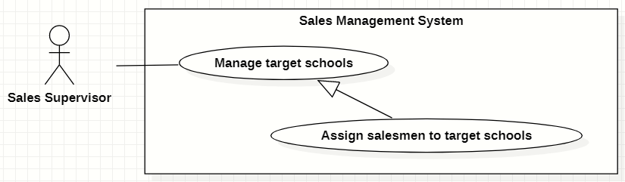

Figure 51. <<Sales Supervisor>> Assign salesmen to tasks

|  |  |  |  |  |  |
| --- | --- | --- | --- | --- | --- |
| ID and Name: | **UC-40 Assign salesmen to tasks** | | | | |
| Created By: | GiaNH | | Date Created: | | 11/02/2021 |
| Primary Actor: | Sales Supervisor, Sales Manager | | Secondary Actors: | | N/A |
| Description: | This use case allows the user to assign salesmen to one or multiple tasks. | | | | |
| Trigger: | The user clicks on the “Assign” button in “Tasks” screen. | | | | |
| Preconditions: | PRE-1. The user has been logged into the system with role Sales Supervisor or Sales Manager.  PRE-2. The user is on the “Tasks” screen. | | | | |
| Post-conditions: | POST-1. The tasks are assigned to salesmen. | | | | |
| Normal Flow: | **Step** | **Actor Action** | | **System Response** | |
| 1 | The user ticks on the task rows that he/she wants to assign, then clicks on “Assign” button on the “Tasks” screen.  [Exception 1]  [Alternative 1] | | The system displays the “Assign Salesmen” form with the following information:   * + “PICs”: input text field, required.   + Table of tasks, which contains columns: * “School Name”: text. * “PIC”: text (get value from “PICs” input text field above). * “Purpose”: text. * “Note”: input text field / editable table cell.   + “Cancel”: button.   + “Save”: button. | |
| 2 | The user inputs/chooses a PIC in the input text field and inputs “Note”. | |  | |
| 3 | The user selects “Save” button.  [Exception 4] | | The system updates tasks’ data with field “PIC”, then shows the successful message: “Updated Successfully”.  [Exception 2]  [Exception 3] | |
| Alternative Flows: | **Step** | **Actor Action** | | **System Response** | |
| 1 | On the “Tasks” screen, at the end of each row in the table, the user clicks on action icon button, then selects “Assign” command on the menu options. | | The system displays the “Assign” form with the following information:  -“Salesman”: input text field, required.  - “Note”: input text field.  *Continue step 2 of Normal Flow* | |
| Exceptions: | **No** | **Cause** | | **System Response** | |
| 1 | The user selects the tasks which have already been assigned. | | The system shows an alert dialog to state that “The school *[…school name]* is assigned already. If you want to assign to a new PIC, you need to unassign before assigning again.” | |
| 2 | The task has been already assigned in the same school year. | | The system shows the error message: “The task has been already assigned in the same school year”. | |
| 3 | The user’s device does not connect to the Internet or the server has internal error. | | The system shows the error message: “Connection Failed or Internal Error”. | |
| 4 | The user selects “Cancel” button. | | The system closes the “Assign” form and returns the “Task” screen. | |
| Priority: | Usually | | | | |
| Frequency of Use: | N/A | | | | |
| Business Rules: | BR-12, BR-13, BR-14, BR-15, BR-16, BR-17, BR-18 | | | | |
| Other Information: | N/A | | | | |
| Assumptions: | N/A | | | | |

Table 57. <<Sales Supervisor>> Assign salesmen to tasks

#### Remove tasks

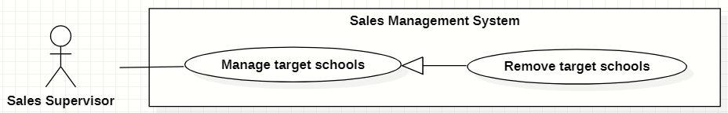

Figure 52. <<Sales Supervisor>> Remove tasks

|  |  |  |  |  |  |
| --- | --- | --- | --- | --- | --- |
| ID and Name: | **UC-41 Remove tasks** | | | | |
| Created By: | GiaNH | | Date Created: | | 15/02/2021 |
| Primary Actor: | Sales Supervisor, Sales Manager | | Secondary Actors: | | N/A |
| Description: | This use case allows the user to remove a task. | | | | |
| Trigger: | The user clicks on the “Remove” command on the menu options at the end of row in table list of tasks. | | | | |
| Preconditions: | PRE-1. The user has been logged into the system with role Sales Supervisor or Sales Manager.  PRE-2. The user is on the “Tasks” screen. | | | | |
| Post-conditions: | POST-1. The task is removed out of table. | | | | |
| Normal Flow: | **Step** | **Actor Action** | | **System Response** | |
| 1 | The user clicks on the “Remove” command on the menu options at the end of row in table list of tasks. | | The system shows a “Confirm Remove” dialog to alert.   * “Cancel”: button. * “Remove”: button. | |
|  | 2 | The user clicks on “Remove” button.  [Exception 1] | | The system shows a successful message: “Removed successfully”, and closes the confirm dialog.  [Exception 2] | |
| Alternative Flows: | N/A | | | | |
| Exceptions: | **No** | **Cause** | | **System Response** | |
| 1 | The user clicks on “Cancel” button. | | The system closes the “Confirm Remove” dialog and returns to the “Tasks” screen. | |
| 2 | The user’s device does not connect to the Internet or the server has internal error. | | The system shows the error message: “Connection Failed or Internal Error”. | |
| Priority: | High | | | | |
| Frequency of Use: | Usually | | | | |
| Business Rules: | * BR-12, BR-13, BR-18 * The user must not remove the task if: * This task has been being assigned. * The service(s) of this task has not expired yet. | | | | |
| Other Information: | N/A | | | | |
| Assumptions: | N/A | | | | |

Table 58. <<Sales Supervisor>> Remove tasks

#### Comment on Salesmen’s reports

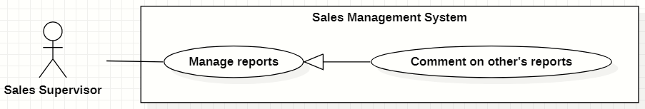

Figure 53. <<Sales Supervisor>> Comment on Salesmen’s reports

|  |  |  |  |  |  |
| --- | --- | --- | --- | --- | --- |
| ID and Name: | **UC-42 Comment on Salesmen’s reports** | | | | |
| Created By: | GiaNH | | Date Created: | | 12/02/2021 |
| Primary Actor: | Sales Supervisor, Sales Manager | | Secondary Actors: | | N/A |
| Description: | This use case allows the user to comment on Salesmen’s Reports. | | | | |
| Trigger: | The user clicks on the “Comment” command on the menu options at the end of row in table list of reports. | | | | |
| Preconditions: | PRE-1. The user has been logged into the system with role Sales Supervisor or Sales Manager.  PRE-2. The user is on the “Reports” screen. | | | | |
| Post-conditions: | POST-1. The comment is added on Salesmen’s reports. | | | | |
| Normal Flow: | **Step** | **Actor Action** | | **System Response** | |
| 1 | The user clicks on the “Comment” command on the menu options at the end of row in table list of reports.  [Alternative 1] | | The system displays “Comment on Report” dialog with the following information.   * “School Year”: text. * “Date”: text. * “School Name”: text. * “PIC”: image (avatar) and text. * “Purpose”: text. * “Result”: text. * “Description”: text. * “Positivity”: text. * “Difficulty”: text. * “Future plan”: text. * “Supervisor comment”: input text field, required. * “Cancel”: button. * “Save”: button. | |
| 2 | The user inputs his/her comment into the text field. | |  | |
|  | 3 | The user selects “Save” button.  [Exception 1] | | The system updates this report in the database with the new comment and closes the “Comment on Report” dialog .  [Exception 2] | |
| Alternative Flows: | **Step** | **Actor Action** | | **System Response** | |
| 1 | On the “Reports” screen, at the end of each row in the table, the user clicks on action icon button, then selects “View detail” command on the menu options. | | The system displays “Report’s details” view, the report’s information is displayed as a form.   * “School Year”: text. * “Date”: text. * “School Name”: text. * “PIC”: image (avatar) and text. * “Purpose”: text. * “Result”: input text field, read only. * “Description”: input text field, read only. * “Positivity”: input text field, read only. * “Difficulty”: input text field, read only. * “Future plan”: input text field, read only. * “Supervisor comment”: input text field. * “Save”: button, only active when the form is dirty. | |
| 2 | The user inputs his/her comment into the text field. | |  | |
| 3 | The user selects “Save” button.  [Exception 3]  [Exception 4] | | The system updates this report in the database with the new comment and shows the successful message “Updated Successfully”.  [Exception 2] | |
| Exceptions: | **No** | **Cause** | | **System Response** | |
| 1 | The user clicks on “Cancel” button. | | The system closes the “Comment on Report” dialog and returns to the “Reports” screen. | |
| 2 | The user’s device does not connect to the Internet or the server has internal error. | | The system shows the error message: “Connection Failed or Internal Error”. | |
| 3 | The user clicks on back button to go to “Reports” screen without edit anything in the form. | | The system discards all changes in the form and do not update anything to the database. | |
| 4 | The user edits in the form’s fields but does not clicks on “Save” button before going back to “Reports” screen. | | The system discards all changes in the form and do not update anything to the database. | |
| Priority: | High | | | | |
| Frequency of Use: | Usually | | | | |
| Business Rules: | * BR-25, BR-26, BR-27, BR-29 * The user is not allowed to comment on his/her own reports. * The user shall comment on reports of other Sales Managers or Sales Supervisors. | | | | |
| Other Information: | N/A | | | | |
| Assumptions: | N/A | | | | |

Table 59. <<Sales Supervisor>> Comment on Salesmen’s reports

### 2.7 <<Sales Manager>> Overview Use Case

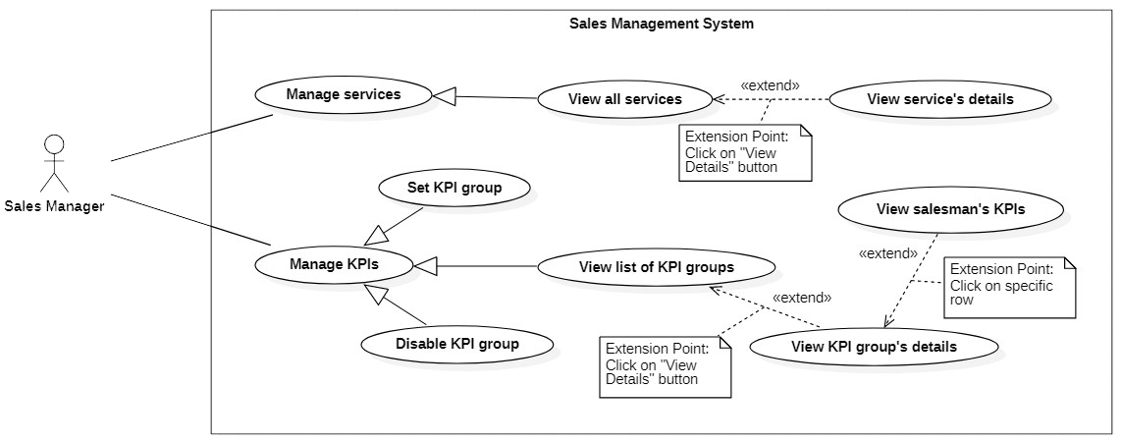

Figure 54. <<Sales Manager>> Overview Use Case

#### View all services

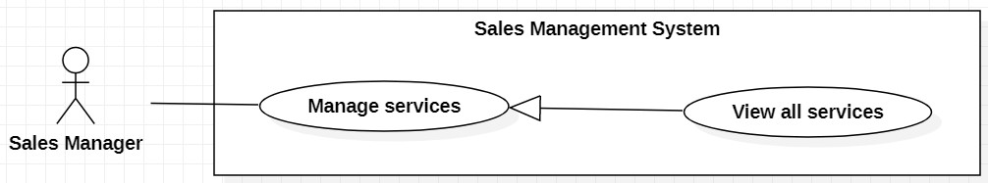

Figure 55. <<Sales Manager>> View all services

|  |  |  |  |  |  |  |
| --- | --- | --- | --- | --- | --- | --- |
| ID and Name: | **UC-43 View all services** | | | | | |
| Created By: | HaPTN | | | Date Created: | | 12/04/2021 |
| Primary Actor: | Sales Manager | | | Secondary Actors: | | N/A |
| Description: | This use case allows the user to view all services of all tasks. | | | | | |
| Trigger: | The user selects tab “Services” in “Task’s details” screen. | | | | | |
| Preconditions: | PRE-1. The user has been logged into the system with role Sales Manager.  PRE-2. The user is on the tab “Services” in “Task’s details” screen. | | | | | |
| Post-conditions: | POST-1. Service’s list is displayed as the table in “Services” screen. | | | | | |
| Normal Flow: | **Step** | | **Actor Action** | | **System Response** | |
| 1 | | The user selects tab “Services” in “Task’s details” screen. | | The system displays “Services” screen, service’s list is displayed as the table.   * “ID”: text. * “Tasks”: text. * “Duration”: text. * “Service”: text. * “Revenue Criteria”: text. * “Note”: text.   [Exception 1] | |
| Alternative Flows: | N/A | | | | | |
| Exceptions: | **No** | **Cause** | | | **System Response** | |
| 1 | No stored services data in the system. | | | The system displays “No records found” line on the table. | |
| 2 | The user’s device does not connect to the Internet or the server has internal error. | | | The system shows the error message: “Connection Failed or Internal Error”. | |
| Priority: | High | | | | | |
| Frequency of Use: | Usually | | | | | |
| Business Rules: | BR-31, BR-34 | | | | | |
| Other Information: | N/A | | | | | |
| Assumptions: | N/A | | | | | |
| Assumptions: | N/A | | | | | |

Table 60. <<Sales Manager>> View all services

#### Approve services

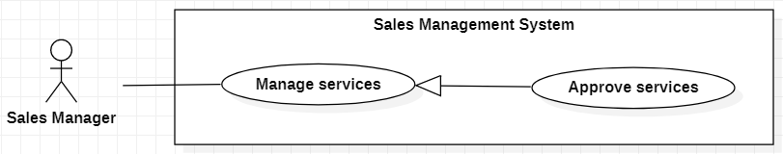

Figure 56. <<Salesman>> Approve services

|  |  |  |  |  |  |
| --- | --- | --- | --- | --- | --- |
| ID and Name: | **UC-44 Approve services** | | | | |
| Created By: | HaPTN | | Date Created: | | 30/05/2021 |
| Primary Actor: | Sales Manager | | Secondary Actors: | | N/A |
| Description: | This use case allows the user to approve or reject a service. | | | | |
| Trigger: | The user clicks on button “Approve” or “Reject” in “Service Details” screen. | | | | |
| Preconditions: | PRE-1. The user has been logged into the system with role Sales Manager.  PRE-2.1. The user is on the “Service Details” screen. | | | | |
| Post-conditions: | POST-1. The service status is change from “Pending” to “Approved” or “Rejected”. | | | | |
| Normal Flow: | **Step** | **Actor Action** | | **System Response** | |
| 1 | The user clicks on button “Approve” on the screen.  [Alternative 1] | | The system shows the “Confirm Approve Service” dialog to ask whether the user are sure or not to approve for this service.  - “Approve”: button  - “Cancel”: button | |
| 2 | The user clicks on button “Approve”.  [Exception 1] | | The system updates the service status from “Pending” to “Approved” and refresh the UI.  [Exception 2] | |
| Alternative Flows: | **Step** | **Actor Action** | | **System Response** | |
| 1 | The user clicks on button “Rejected” on the screen. | | The system shows the “Confirm Reject Service” dialog to ask whether the user are sure or not to approve for this service.  - “Service type”: text, read only.  - “School name”: text, read only.  - “Rejected reason”: text area.  - “Reject”: button  - “Cancel”: button | |
| 2 | The user clicks on button “Reject”.  [Exception 1] | | The system updates the service status from “Pending” to “Rejected” and refresh the UI.  [Exception 2] | |
| Exceptions: | **No** | **Actor Action** | | **System Response** | |
| 1 | The user clicks on “Cancel” button. | | The system close the confirm dialog and do nothing. | |
| 2 | The user’s device does not connect to the Internet or the server has internal error. | | The system shows the error message: “Connection Failed or Internal Error”. | |
| Priority: | Normal | | | | |
| Frequency of Use: | Usually | | | | |
| Business Rules: | BR-41, BR-42 | | | | |
| Other Information: | N/A | | | | |
| Assumptions: | N/A | | | | |

Table 61. <<Salesman>> Approve services

#### Set KPI group

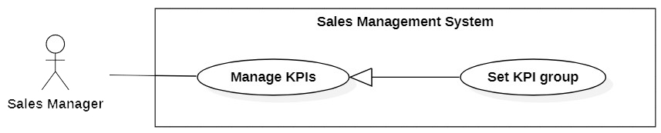

Figure 57. <<Salesman>> Set KPI group

|  |  |  |  |  |  |
| --- | --- | --- | --- | --- | --- |
| ID and Name: | **UC-45 Set KPI group** | | | | |
| Created By: | HaPTN | | Date Created: | | 30/05/2021 |
| Primary Actor: | Sales Manager | | Secondary Actors: | | N/A |
| Description: | This use case allows the user to view personal KPI. | | | | |
| Trigger: | The user clicks on “+” button on the “KPI” screen. | | | | |
| Preconditions: | PRE-1. The user has been logged into the system with role Sales Manager.  PRE-2.1. The user is on the “KPIs” screen. | | | | |
| Post-conditions: | POST-1. A KPI group is create in the database. | | | | |
| Normal Flow: | **Step** | **Actor Action** | | **System Response** | |
| 1 | The user clicks on “+” button on the “KPI” screen. | | The system shows the dialog form with 3 steps.  At “Step 1” tab:  - “Group name”: input field.  - “Description”: input field.  - “Criteria” input field.  - “Next”: button  - “Back”: button  At “Step 2” tab:  - A table with the following columns:  + “Criteria name”: text, read only  + “Target value”: input field  + “Weight”: input field.  - “Next”: button  - “Back”: button  At “Step 3” tab:  - “Start date”: Date, input field  - “End date”: Date, input field  - “Salesman”: auto suggest search field  - A table with the following columns:  + “Salesman”: text  + a list of targetValue and weight for each criteria.  - “Finish”: button  - “Back”: button | |
| 2 | The user fills in all fields and clicks “Next” button. | | The system redirect users to the next step screen. | |
| 3 | At “Step 3” tab, the user clicks button “Finish”. | | The system get data from all the step screen to insert a KPI group in the Database.  The system notify “Created successfully”.  [Exception 1] | |
| Alternative Flows: | N/A | | | | |
| Exceptions: | **No** | **Actor Action** | | **System Response** | |
| 1 | The user’s device does not connect to the Internet or the server has internal error. | | The system shows the error message: “Connection Failed or Internal Error”. | |
| Priority: | Normal | | | | |
| Frequency of Use: | Usually | | | | |
| Business Rules: | N/A | | | | |
| Other Information: | N/A | | | | |
| Assumptions: | N/A | | | | |

Table 62. <<Salesman>> Set KPI group

#### Disable KPI group

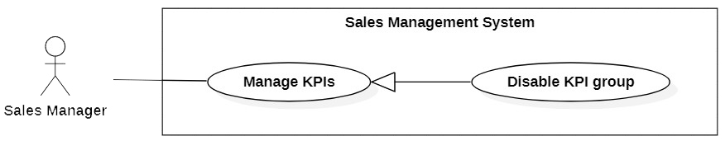

Figure 58. <<Salesman>> Disable KPI group

|  |  |  |  |  |  |
| --- | --- | --- | --- | --- | --- |
| ID and Name: | **UC-50 Disable KPI group** | | | | |
| Created By: | HaPTN | | Date Created: | | 30/05/2021 |
| Primary Actor: | Sales Manager | | Secondary Actors: | | N/A |
| Description: | This use case allows the user to diable a KPI group. | | | | |
| Trigger: | The user clicks on options “Disable” at the row of KPI group. | | | | |
| Preconditions: | PRE-1. The user has been logged into the system with role Sales Manager.  PRE-2.1. The user is on the “KPIs” screen. | | | | |
| Post-conditions: | POST-1. A KPI group is disable in the database. | | | | |
| Normal Flow: | **Step** | **Actor Action** | | **System Response** | |
| 1 | The user clicks on option “Disable” at row of KPI group in the table. | | The system shows the “Confirm Diable KPI group” dialog with two buttons:  - “Disable”: button  - “Cancel”: button | |
| 2 | The user clicks on option “Disable” button.  [Exception 2] | | The system disable the KPI group in the Database and refresh the UI.  [Exception 1] | |
| Alternative Flows: | N/A | | | | |
| Exceptions: | **No** | **Actor Action** | | **System Response** | |
| 1 | The user’s device does not connect to the Internet or the server has internal error. | | The system shows the error message: “Connection Failed or Internal Error”. | |
| 2 | The user clicks on option “Cancel” button. | | The system close the dialog and do nothing. | |
| Priority: | Normal | | | | |
| Frequency of Use: | Usually | | | | |
| Business Rules: | N/A | | | | |
| Other Information: | N/A | | | | |
| Assumptions: | N/A | | | | |

Table 63. <<Salesman>> Disable KPI group

## 3. Functional Requirements

### 3.1 System Functional Overview

#### Screen Flow

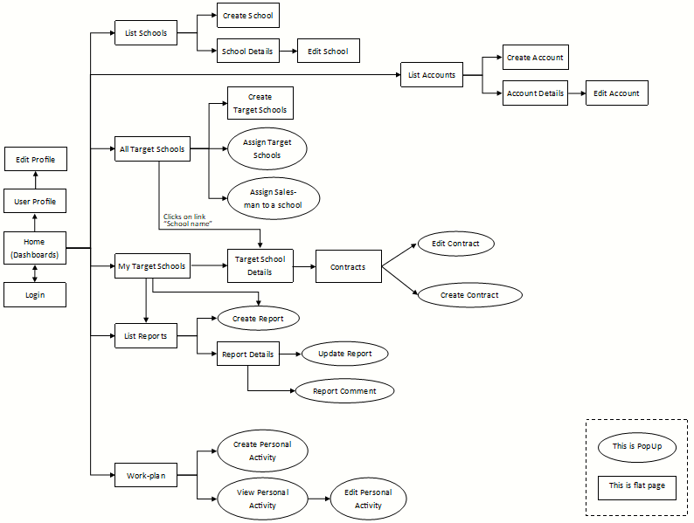

Figure 59. Screen Flow

#### Screen Details

|  |  |  |  |
| --- | --- | --- | --- |
| **#** | **Feature** | **Screen** | **Description** |
| 1 | Login | Login |  |
| 2 |  | Home (Dashboards) |  |
| 3 | View Profile | User Profile |  |
| 4 | Edit Profile | Edit Profile |  |
| 5 | * View list of schools * Search schools | List Schools |  |
| 6 | Create new schools | Create School |  |
| 7 | View school’s details | School Details |  |
| 8 | Edit school’s information | Edit School |  |
| 9 | * View list of accounts * Search accounts | List Accounts |  |
| 10 | Create new accounts | Create Account |  |
| 11 | View account’s details | Account Details |  |
| 12 | Edit account’s information | Edit Account |  |
| 13 | View list of all tasks | All Tasks |  |
| 14 | Create tasks | Create Tasks |  |
| 15 | Assign Salesmen to tasks | Assign Tasks |  |
| 16 | Assign Salesmen to tasks | Assign Salesman to a school |  |
| 17 | * View list of assigned tasks * Search assigned tasks | My Tasks |  |
| 18 | View task’s details | Tasks Details |  |
| 19 | Edit school’s information | Edit Task Info |  |
| 20 | * View all reports * Search reports | List Reports |  |
| 21 | Create reports | Create Report |  |
| 22 | View report’s details | Report Details |  |
| 23 | Update reports | Update Report |  |
| 24 | Comment on Salesmen’s reports | Report Comment |  |
| 25 | * View my services * View all services | Services |  |
| 26 | * View Service’s details * Edit my services | Edit Services |  |
| 27 | View Work-plan | Work-plan |  |
| 28 | Create Personal Activities | Create Personal Activities |  |
| 29 | View Personal Activity’s details | View Personal Activity |  |
| 30 | Edit Personal Activities | Edit Personal Activity |  |

Table 64. Screen Details

#### Screen Authorization

|  |  |  |  |  |
| --- | --- | --- | --- | --- |
| **Screen** | **Salesman** | **Sales Supervisor** | **Sales Manager** | **Admin** |
| Login | X | X | X | X |
| Dashboard | X | X | X |  |
| View Profile | X | X | X | X |
| Edit Profile | X | X | X | X |
| List Schools |  |  |  |  |
| View all schools |  | X | X | X |
| View school’s details |  | X | X | X |
| Create School |  |  |  | X |
| Edit School | X | X | X | X |
| List Accounts |  |  |  | X |
| Create Account |  |  |  | X |
| Account Details |  |  |  | X |
| Edit Account |  |  |  | X |
| All Tasks | X | X | X |  |
| Create Tasks |  | X | X |  |
| Assign Tasks |  | X | X |  |
| Assign Salesman to a school |  | X | X |  |
| My Tasks | X | X | X |  |
| Tasks Details | X | X | X |  |
| Edit Task Info | X | X | X |  |
| List Reports | X | X | X |  |
| Create Report | X | X | X |  |
| Report Details | X | X | X |  |
| Update Report |  | X | X |  |
| Report Comment |  | X | X |  |
| Services | X | X | X |  |
| Edit Services | X | X | X |  |
| Work-plan | X | X | X |  |
| Create Personal Activities | X | X | X |  |
| View Personal Activity | X | X | X |  |
| Edit Personal Activity | X | X | X |  |

Table 65. Screen Authorization

#### Non-Screen Functions

|  |  |  |  |
| --- | --- | --- | --- |
| **#** | **Feature** | **System Function** | **Description** |
| 1 | Forget password | Send email | An email is sent to user’s email to provide a verification code for resetting the forgotten password. |
| 2 | Create new account | Send email | After Admin creating a new account, an email is automatically sent to the user’s email to provide password. |

Table 66. Non-Screen Functions

#### Entity Relationship Diagram

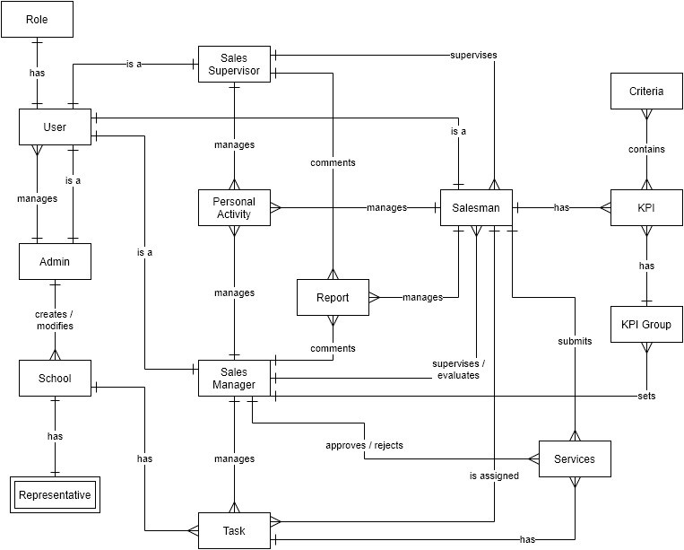

Figure 60. Entity Relationship Diagram

**Entities List**

|  |  |  |
| --- | --- | --- |
| **#** | **Entity** | **Description** |
| 1 | Admin | The Admin is an entity presenting a person who manages accounts and whole schools data of sale department.  Containing information of admin (id, password, full name, phone, email, avatar, address, birthday, isMale, isActive). |
| 2 | Salesman | The Salesman is an entity presenting a person who goes to work with the assigned tasks.  Containing information of Salesman (id, password, full name, phone, email, avatar, address, birthday, isMale, isActive). |
| 3 | Sales Manager | The Sales Manager is an entity presenting a person who manages and assigns the tasks to the Salesmen and also have right to view all services of all tasks.  Containing information of Sales Manager (id, password, full name, phone, email, avatar, address, birthday, isMale, isActive, privateToken). |
| 4 | Sales Supervisor | The Sales Supervisor is an entity presenting a person who manages, assigns the tasks to the Salesmen.  Containing information of Sales Manager (id, password, full name, phone, email, avatar, address, birthday, isMale, isActive). |
| 5 | School | The School is an entity presenting the school that was collected information and was select to become the target.  Contain information of School (id, name, district, address, phone, scale, type, educational level, status, isActive). |
| 6 | Task | The Task is an entity presenting the target that Sales Manager creates base on Schools list and assigns to Salesmen.  Containing information of School (id, purpose, school year, note, isActive). |
| 7 | Report | The Report is an entity presenting the report that Salesmen must submits to Sales Manager.  Containing the report information (id, date, result, description, positivity, difficulty, futurePlan, supervisorComment). |
| 8 | Personal Activity | The Personal Activity is an entity presenting an activity that Salesmen or Sales Managers create in work-plan and execute based on that.  Containing the Personal Activity information (id, title, startTime, endTime, remark, description, isCompleted). |
| 9 | Representative | The Representative is an entity presenting a person who is the representative for the school to contact.  Containing information of Representative (full name, isMale, email, phone). |
| 10 | Service | The Service is an entity presenting a service between a target school and Major Education.  Containing information of Service (id, duration, service, revenueCriteria, note, date). |

Table 67. Entities List

## 4. Non-Functional Requirements

### 4.1 External Interfaces

UI-1: The user interfaces in general should be consistent, simple, clear, intuitive, and reminiscent.

* Some design principles will be taken into consideration: <https://material.io/design/introduction>

UI-2: The user interfaces for the software shall be compatible with: Chrome (version 52 or above), Firefox (version 51 or above), Safari (version 10 or above) browser.

UI-3: The user interfaces should be responsive on multiple screen devices: Laptop, Tablet, and Mobile.

UI-4: The user interfaces should be clear and intuitive message for the users when there is a warning or an error.

UI-5: The user interfaces should ask the users to confirm the action when having major operating actions.

#### Software Interfaces

SI-1: This web application works with: Chrome (version 52 or above), Firefox (version 51 or above), Edge (version 14 or above), Safari (version 10 or above), or Opera (version 38 or above) browser.

#### Hardware Interfaces

HI-1: Since this system is a web application, which it shall work on Laptop, Tablet and Mobile.

HI-2: The system must run over the Internet; all the hardware shall require connect to the Internet.

#### Communications Interfaces

CI-1: The system shall communicate through HTTP protocol over the Internet.

### 4.2 Quality Attributes

#### Usability

- The system is designed simple, and intuitive which the users can easily manage their work.

- The default system language is English.

- The system shall take two hours of training for the users to familiar with usage.

#### Availability

- The system is available 24/7.

#### Security

- The system demands unauthorized users to log in for using the system.

- Each authentic user has a different role and scope for accessing a set of system functions.

- The password field must be obscured with special characters representing typed characters.

- The active session time for this system is two hours, after that the user shall be demanded to log in again.

#### Maintainability

- The source code should be based on a unified convention coding so that developers can easily manage.

- The system is divided into separate components and modules which giving the ability to update or scale up the system.

## 5. Other Requirements

### 5.1 Appendix1 - Messages List

|  |  |  |  |  |
| --- | --- | --- | --- | --- |
| **#** | **Message code** | **Message Type** | **Content** | **Content** |
| 1 | MSG01 | In red, above the text box | Invalid username or password | *Wrong format or invalid entry when user logs in.* |
| 2 | MSG02 | In red, above the text box | Wrong username or password | *Wrong username or password when user logs in.* |
| 3 | MSG03 | In red, under the text box | Invalid username or email | *Wrong format or invalid entry when user resets forgotten password.* |
| 4 | MSG04 | In red, under the text box | Wrong username or email | *Wrong username or password when user resets forgotten password.* |
| 5 | MSG05 | In red, above the text box | Invalid password | *Wrong current password when user changes password.* |
| 6 | MSG06 | In red, under the text box | Incorrect entry | *Wrong format or invalid entry when user updates something.* |
| 7 | MSG07 | Toast message, green | Password has been reset successfully | *Reset forgotten password successfully.* |
| 8 | MSG08 | Toast message, green | Updated Successfully | *Update something successfully.* |
| 9 | MSG09 | Toast message, red | Update Unsuccessfully | *Update something failed.* |
| 10 | MSG10 | Toast message, green | Create Successfully | *Create something successfully.* |
| 11 | MSG11 | In line, italic, gray | No records found | *Table does not have data to show.* |
| 12 | MSG12 | In line, red | Connection Failed or Internal Error | *Trouble with the Internet connection.* |
| 13 | MSG13 | Dialog | The school *[…school name]* is assigned already. If you want to assign to a new PIC, you need to unassign before assigning again. | *The user ticks on the tasks which have already been assigned.* |
| 14 | MSG14 | In line, red | Please choose the right file format. | *When the user import a file to the system.* |

Table 68. Appendix1 - Messages List

# IV. Software Design Description

## 1. Overall Description

### 1.1 Assumptions

This system is designed basing on these following assumptions:

* Web application
* ReactJS
* Spring boot
* MySQL
* 3-tier architecture

### 1.2 Design Constraints

This system should be complied with following items:

* The system should work on Laptop, Tablet, Mobile.
* The system must run over the Internet; all the hardware shall require connect to the Internet.
* The system shall communicate through HTTP protocol over the Internet.
* The system shall available 24/7.

## 2. System Architecture Design

### 2.1 Overall Architecture

Our system is built on three-tier architecture, which allows us to modularize the user interface, business logic, and data storage layers. As a result, we gain great flexibility, code reusable, and easy maintenance for not only developing but also implementing the system.

|  |  |
| --- | --- |
| **Overall Architecture Data Dictionary** | |
| **Name** | **Description** |
| Presentation Tier | This tier provides a user interface and handles user interactions. It communicates with the application tier which provides the results to the browser. |
| Application Tier | This tier contains a set of rules for processing information and business logic. All communication goes through the application tier. |
| Data Tier | This tier comprises the database where the information processed by the application tier is stored. |

Table 69. Overall Architecture Data Dictionary

### 2.2 System Architecture

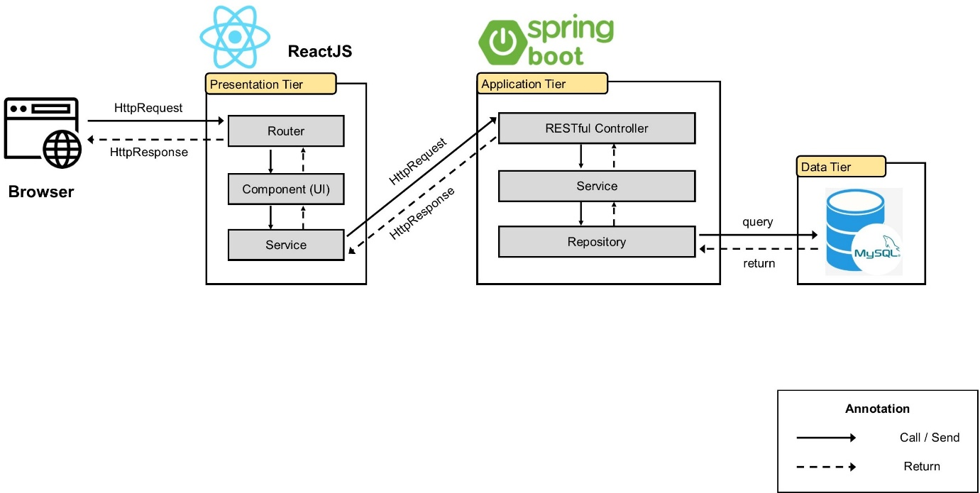

Figure 61. System Architecture

### 2.3 Package Diagram

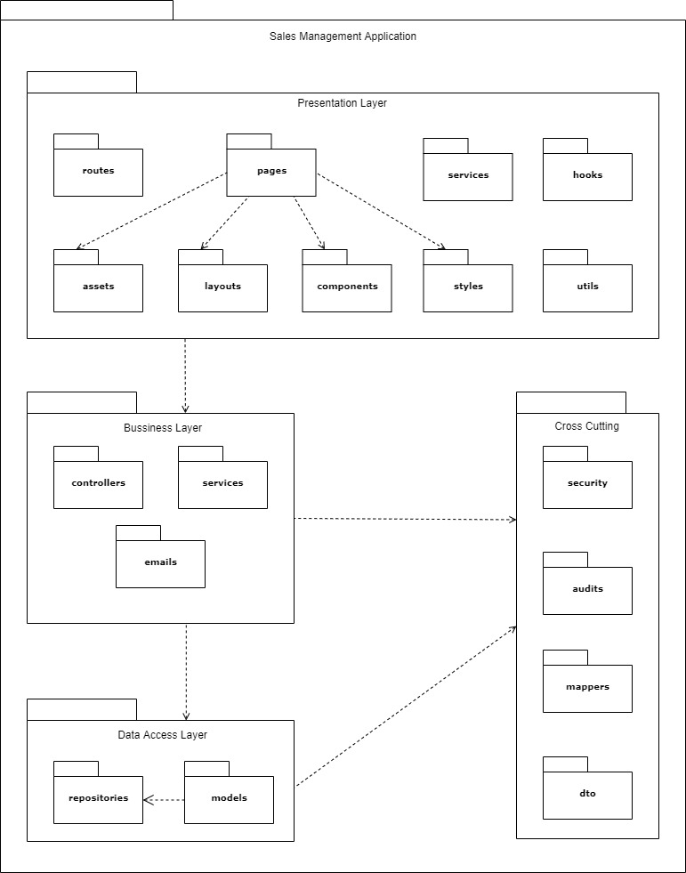

Figure 62. Package Diagram

|  |  |  |
| --- | --- | --- |
| **No** | **Package** | **Description** |
| 01 | routes | The package contains functions for app navigation. |
| 02 | pages | The package contains the pages of the routing. |
| 03 | services | The package contains functions to manage API. |
| 04 | hooks | The package contains custom hook functions. |
| 05 | assets | The package contains images and icons. |
| 06 | layouts | The package contains layout components for the app. |
| 07 | components | The package contains UI components that can be shared. |
| 08 | styles | The package contains global CSS, JavaScript for application-level styles. |
| 09 | utils | The package contains all the helper functions. |
| 10 | controllers | The package contains classes provide RESTful web services. |
| 11 | services | The package contains classes for business logic. |
| 12 | emails | The package contains a class provides email service. |
| 13 | repositories | The package contains classes responsible for communicating with data sources, processing queries, and returning data types requested by the Service layer. |
| 14 | models | The package contains classes that represent persisted data to the database. |
| 15 | security | The package contains classes for JWT handling, authentication, and authorization. |
| 16 | audits | The package contains classes for auditing entity objects. |
| 17 | mappers | The package contains a class to convert data between the DTO and entity objects. |
| 18 | dto | The package contains classes to aggregate and encapsulate data for transfer. |

Table 70. Package Diagram Specifications

## 3. System Detailed Design

### 3.1. Class Diagram

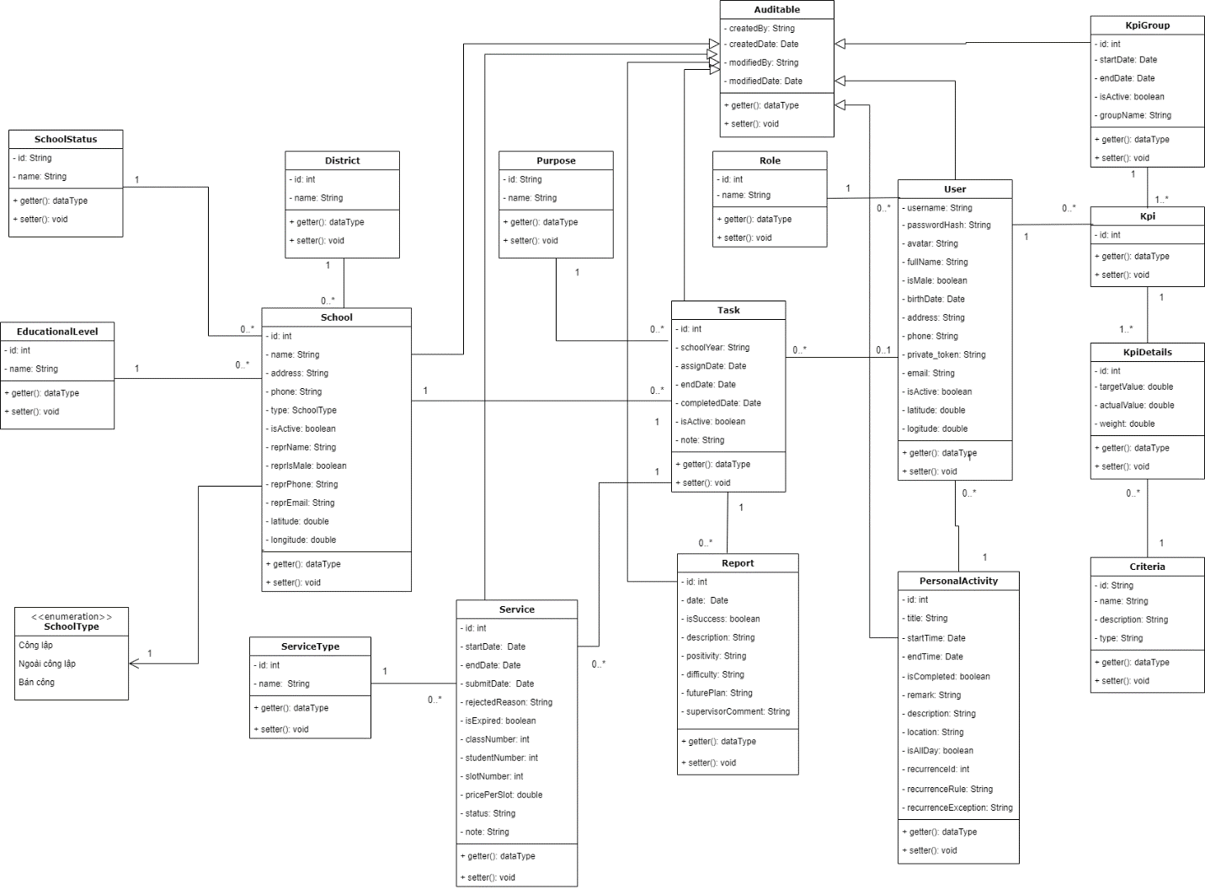

Figure 63. Class Diagram

### 3.2. Sequence Diagram(s)

#### <Administrator> Create new accounts

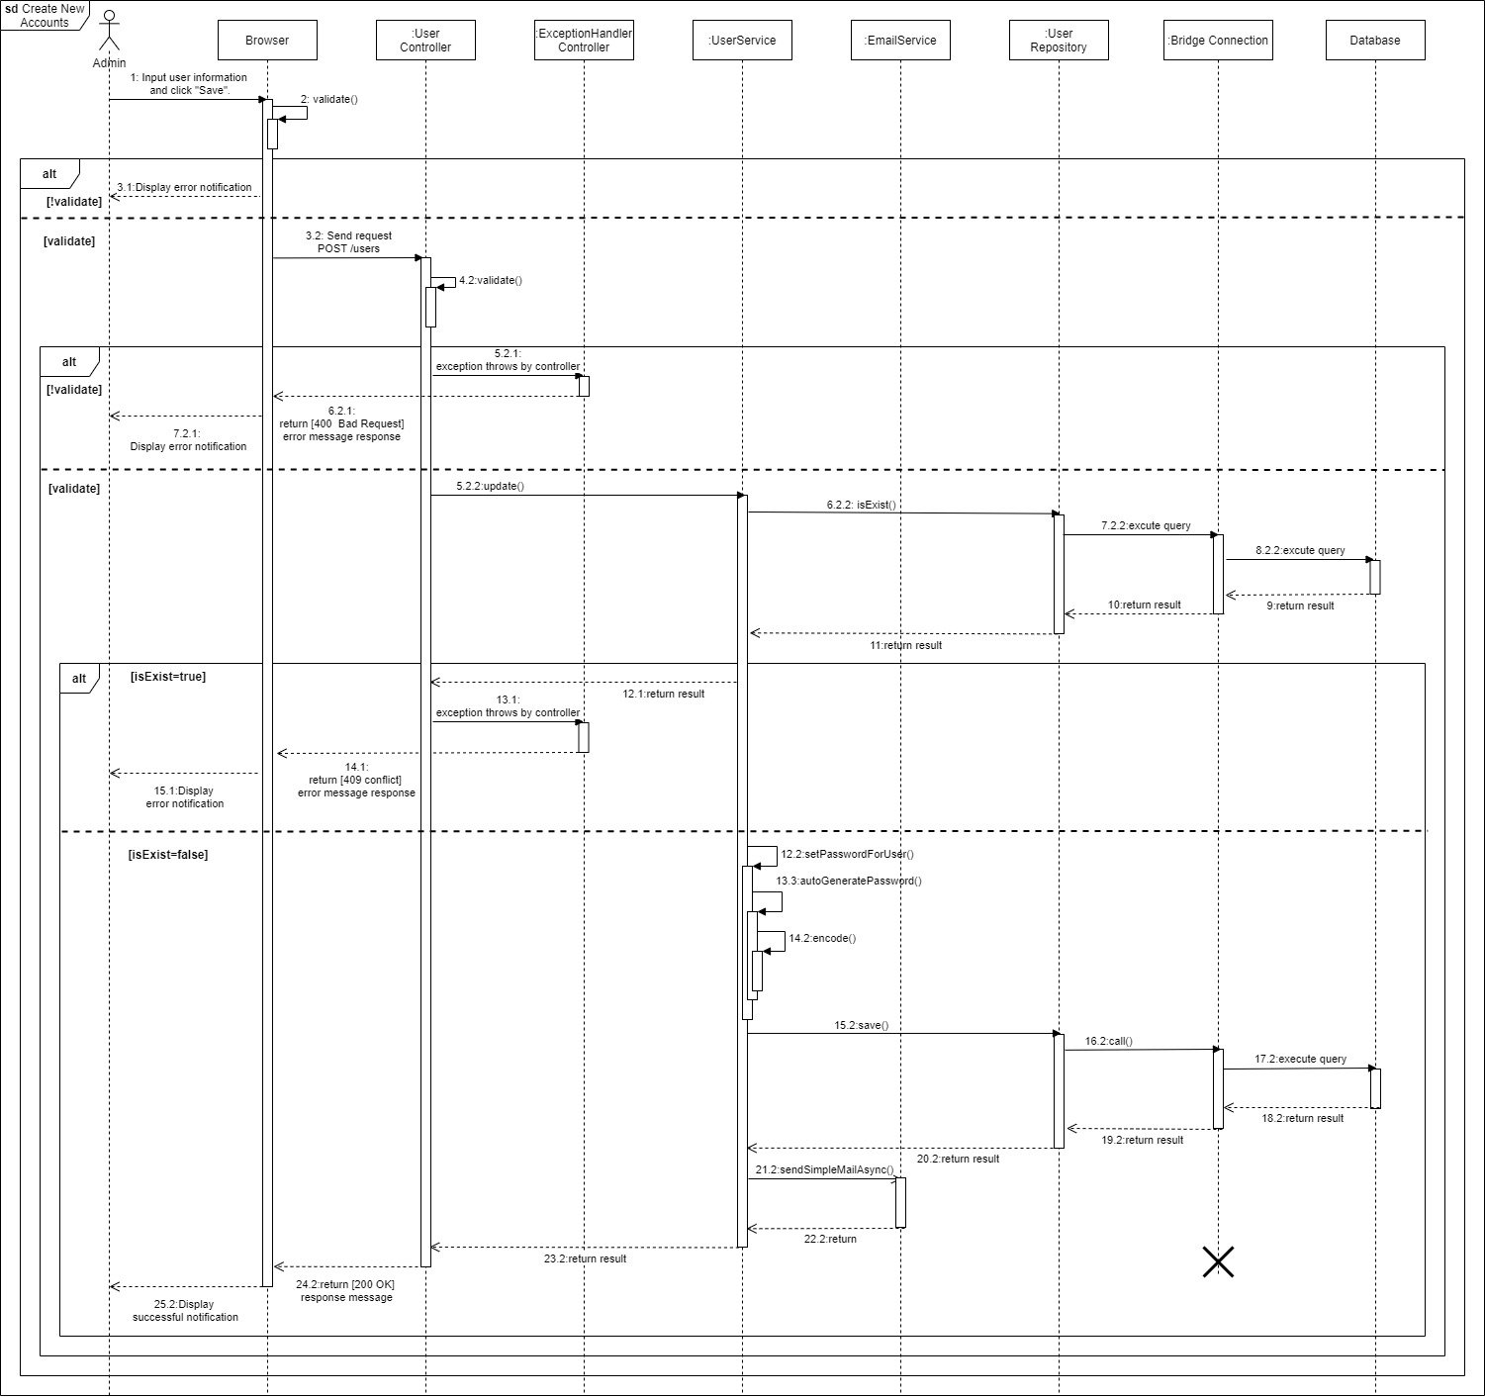

Figure 64. Create new accounts

#### <Administrator> Edit school’s information

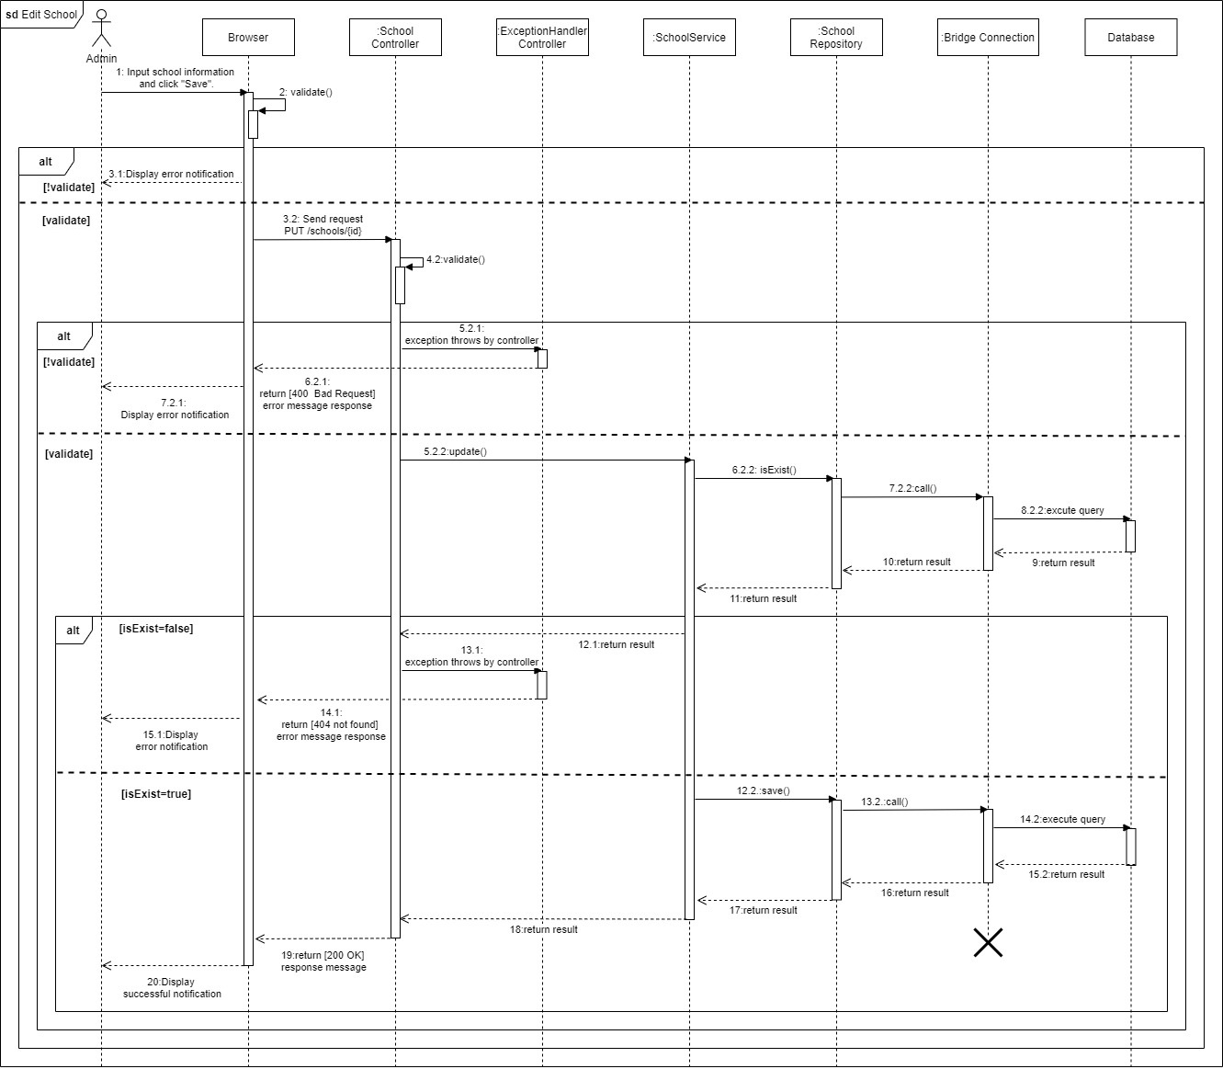

Figure 65. Edit school’s information

#### <Salesman> Remove personal activities

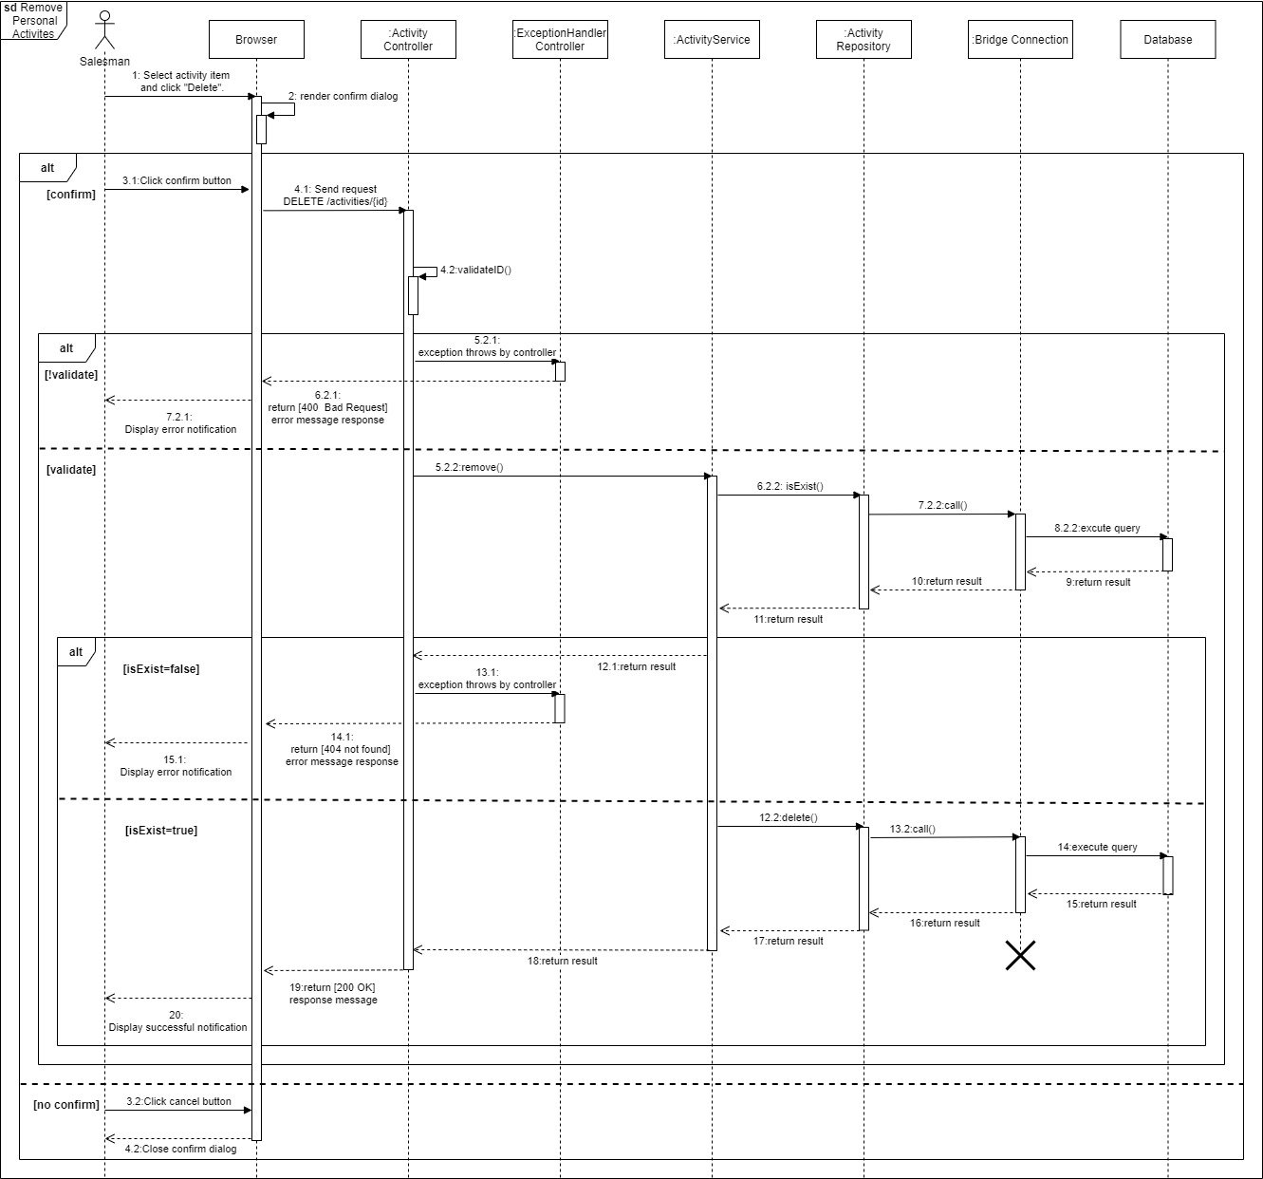

Figure 66. Remove personal activities

#### <Salesman> Edit personal activities

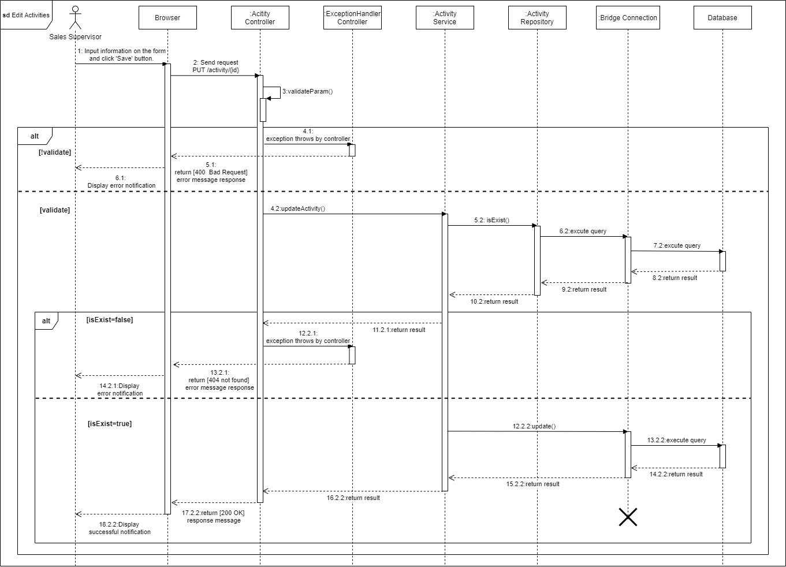

Figure 67. Edit personal activities

#### <Sales Manager> View task details

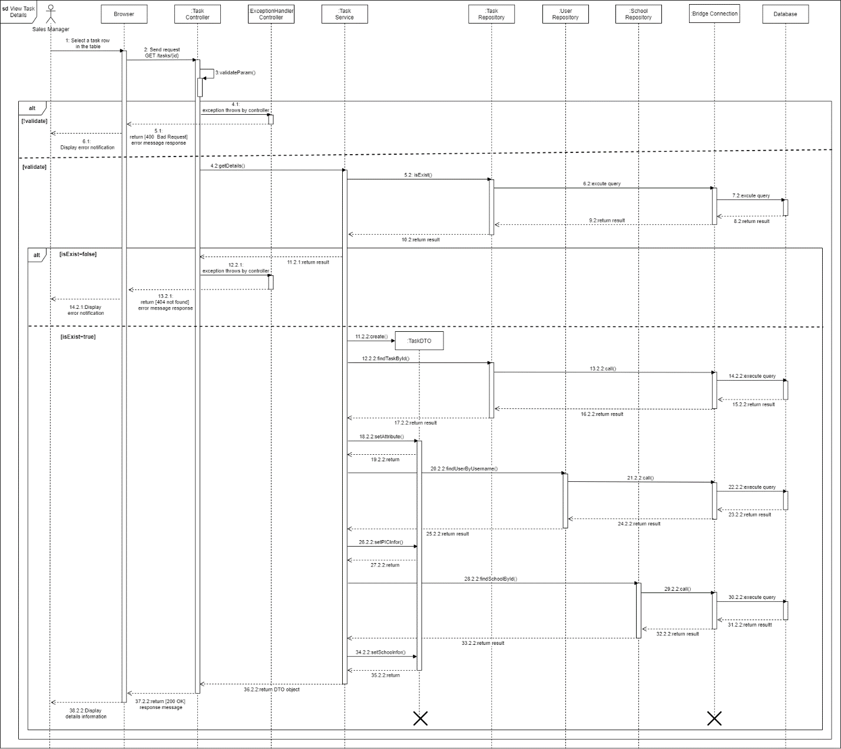

Figure 68. View task details

#### <Salesman> Remove report

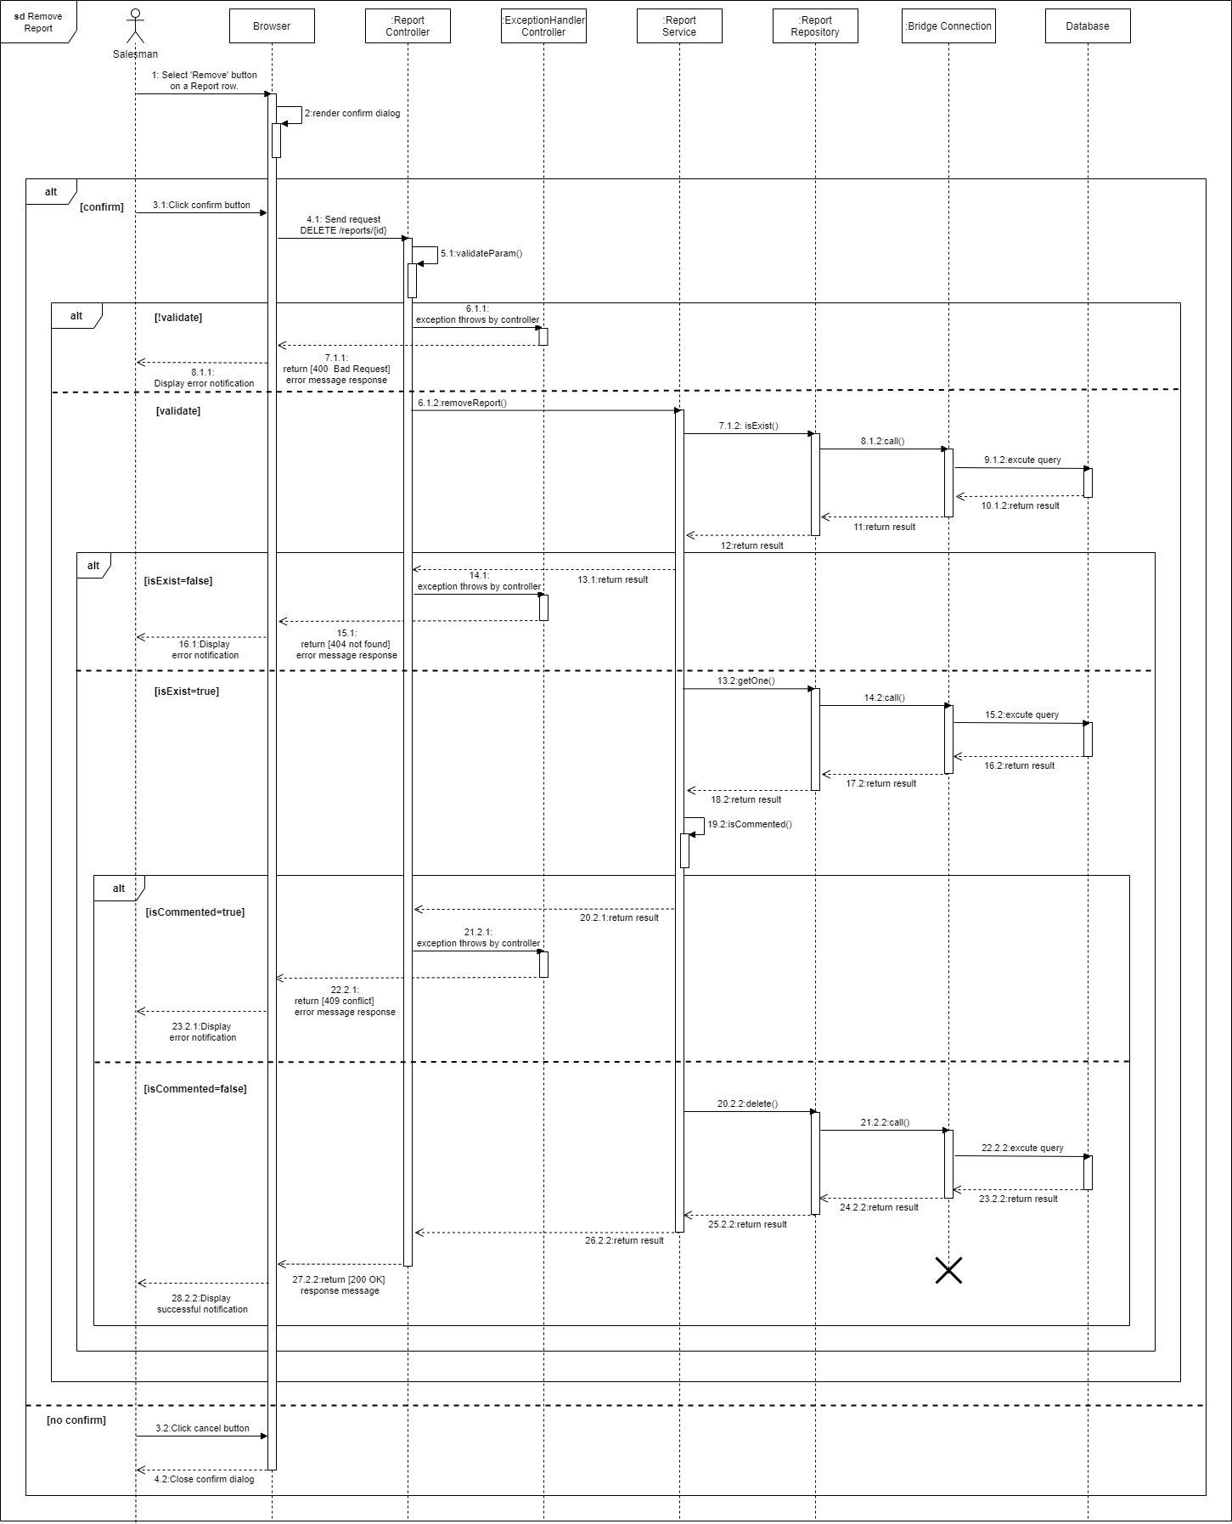

Figure 69. Remove report

#### <Salesman> Edit report

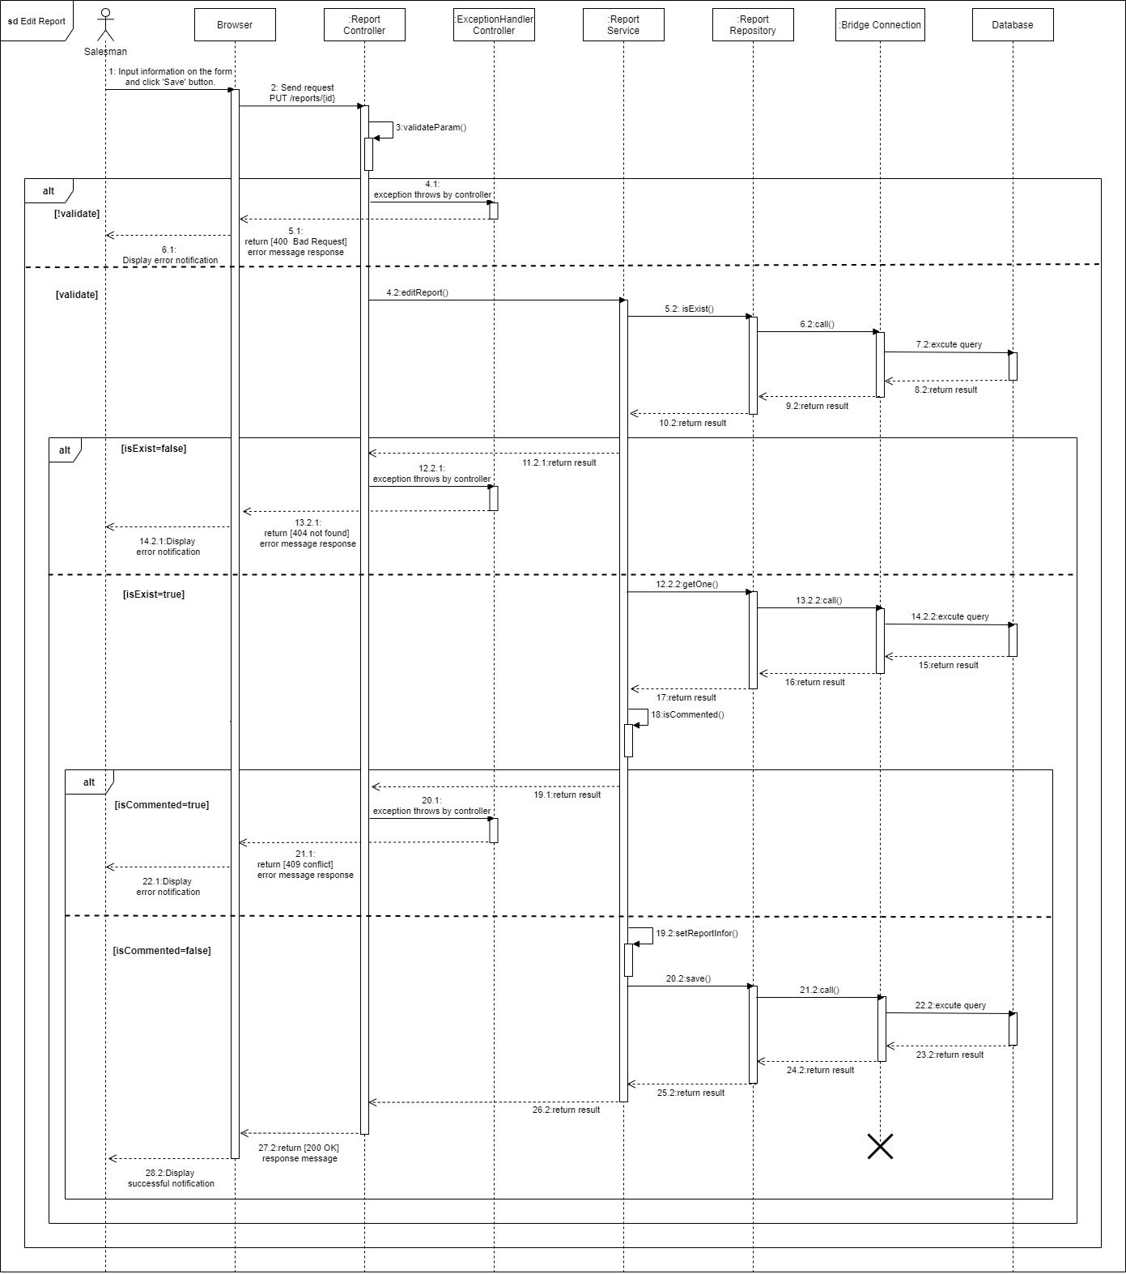

Figure 70. Edit report

### 3.3. Activity Diagram(s)

#### <Sales Manager> Login

Summary: This diagram shows the process by which the sales manager login to the system.

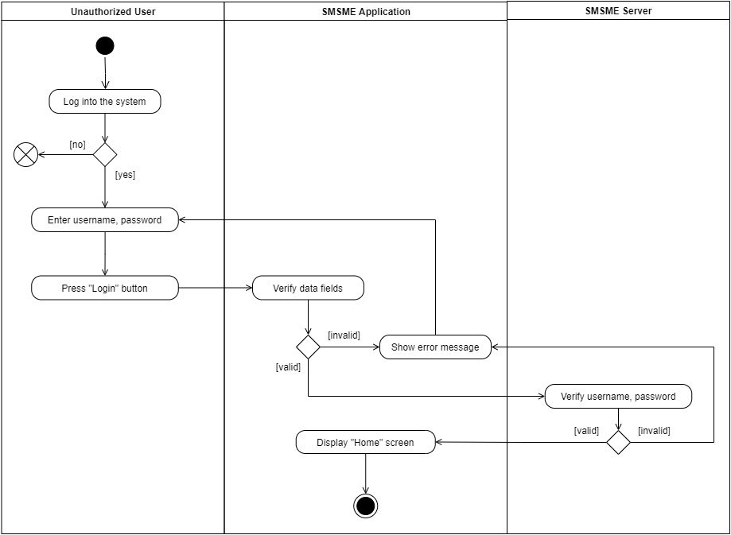

Figure 71. Login

#### <Sales Manager> Create task

Summary: This diagram shows the process by which the sales manager creates a task.

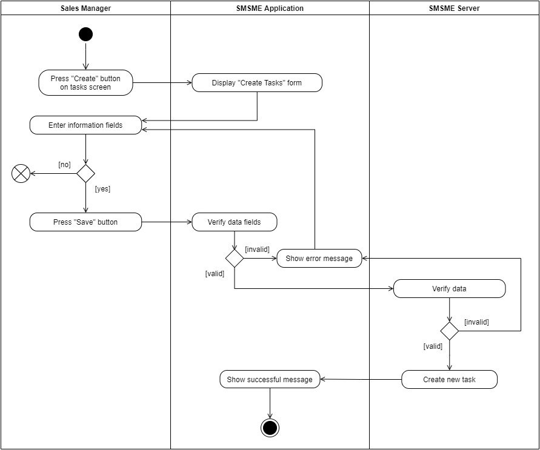

Figure 72. Create tasks

#### <Sales Manager> Update task

Summary: This diagram shows the process by which the sales manager updates a task.

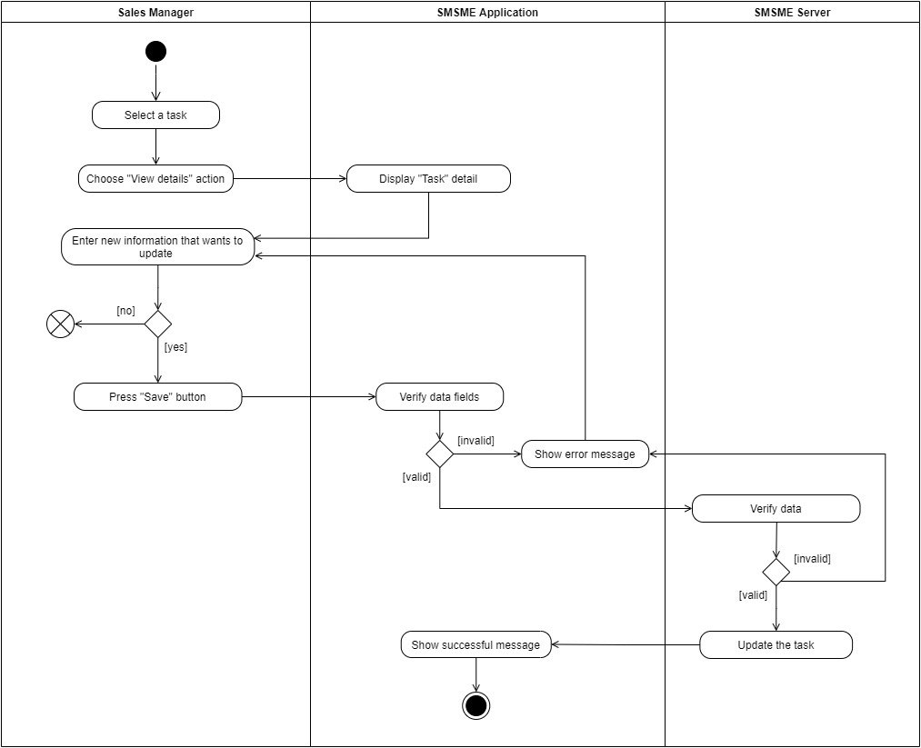

Figure 73. Update task's details

#### <Sales Manager> Remove task

Summary: This diagram shows the process by which the sales manager removes a task.

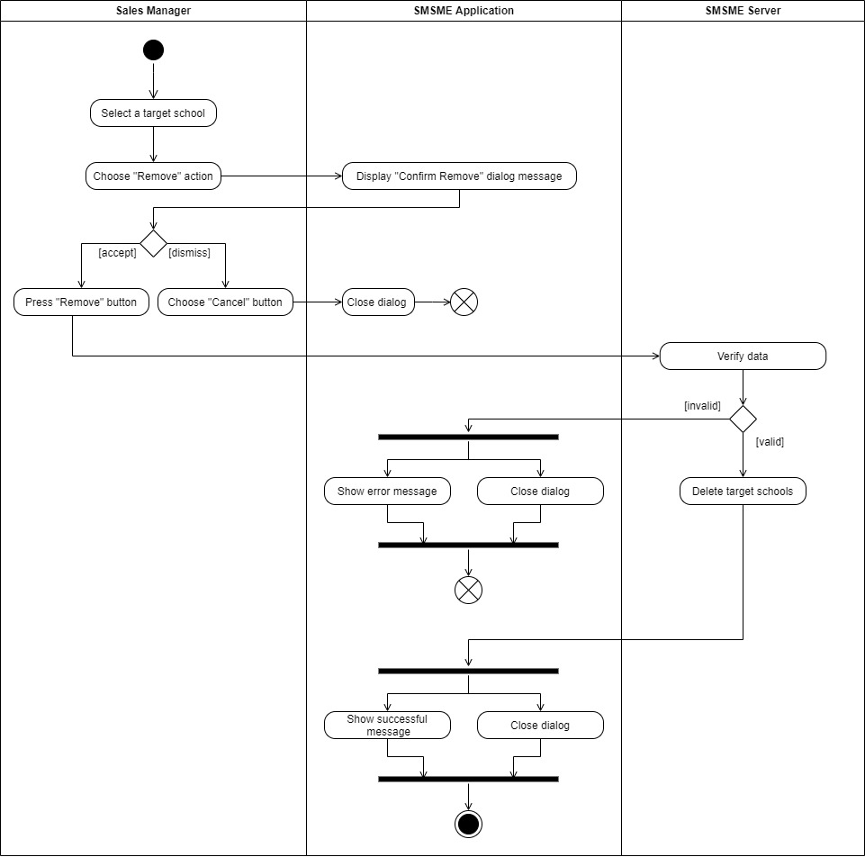

Figure 74. Remove a task

#### <Sales Manager/ Salesman> Create report

Summary: This diagram shows the process by which the sales manager or salesman create a report.

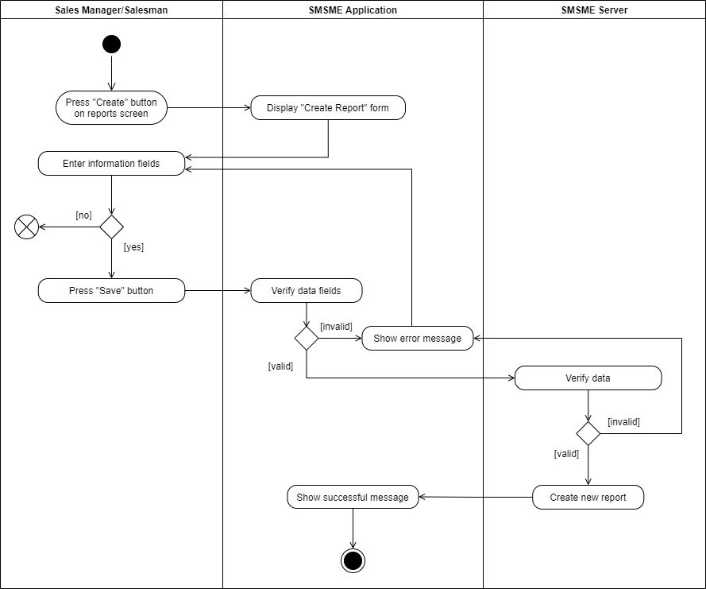

Figure 75. Create reports

#### <Sales Manager/ Salesman> Update report

Summary: This diagram shows the process by which the sales manager or salesman update a report.

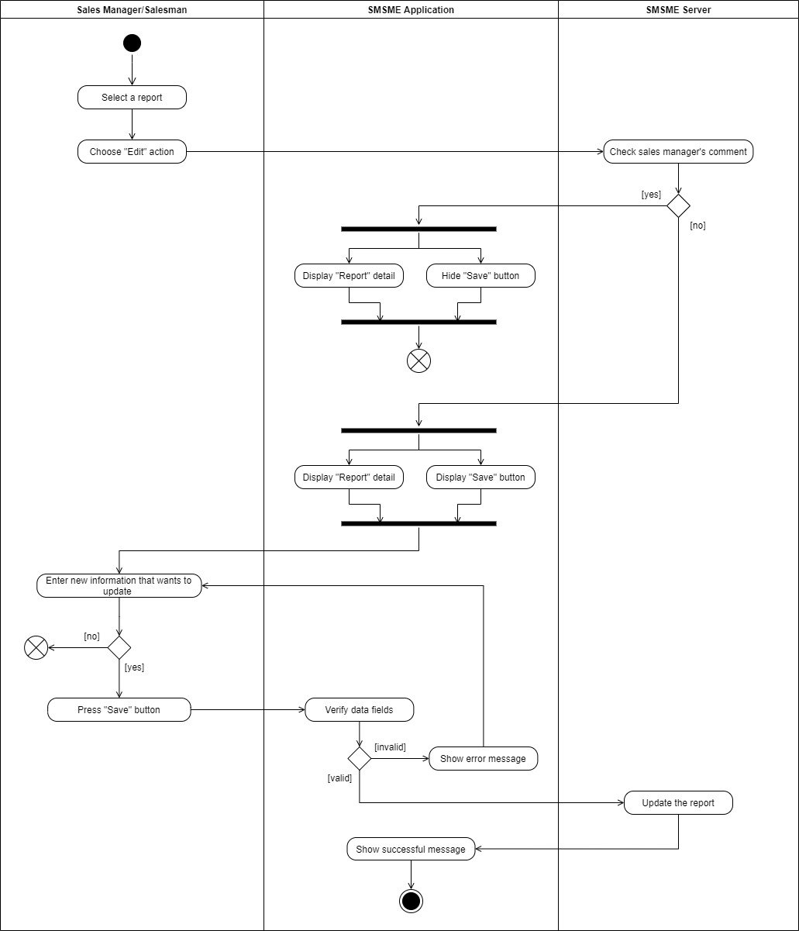

Figure 76. Update report

## 4. Class Specifications

### 4.1 User

|  |  |  |  |
| --- | --- | --- | --- |
| **Attribute** | **Type** | **Visibility** | **Description** |
| username | String | private | The unique identifier of a user |
| passwordHash | String | private | The password hash of the user |
| fullName | String | private | The full name of the user |
| address | String | private | The address of the user |
| email | String | private | The email of the user |
| phone | String | private | The phone number of the user |
| isActive | boolean | private | The active status of the user |
| avatar | String | private | The avatar of the user |
| isMale | boolean | private | The gender of the user (true 🡪 male, false 🡪 female) |
| birthDate | Date | private | The birthdate of the user |
| latitude | double | private | The latitude of user’s location. |
| longitude | double | private | The longitude of user’s location. |

Table 71. Class User Specification - Attributes

|  |  |  |  |  |
| --- | --- | --- | --- | --- |
| **No** | **Method** | **Visibility** | **Return Type** | **Description** |
| 1 | getter | public | dataType | get attribute value |
| 2 | setter | public | void | set attribute value |

Table 72. Class User Specification - Methods

### 4.2 PersonalActivity

|  |  |  |  |
| --- | --- | --- | --- |
| **Attribute** | **Type** | **Visibility** | **Description** |
| id | int | private | The unique identifier of a personal activity |
| title | String | private | The title of the personal activity |
| startTime | Date | private | The start time of the personal activity |
| endTime | Date | private | The end time of the personal activity |
| isCompleted | boolean | private | The completed status of the personal activity |
| remark | String | private | The remark of the personal activity |
| description | String | private | The description of the personal activity |
| location | String | private | The location of the personal activity |
| isAllDay | boolean | private | The duration of the personal activity, if it lasts for whole day or not |
| recurrenceId | int | private | The unique identifier of a recurrence series |
| recurrenceRule | String | private | The rule of the recurrence series |
| recurrenceException | String | private | The exception of the recurrence |

Table 73. Class PersonalActivity Specification - Attributes

|  |  |  |  |  |
| --- | --- | --- | --- | --- |
| **No** | **Method** | **Visibility** | **Return Type** | **Description** |
| 1 | getter | public | dataType | get attribute value |
| 2 | setter | public | void | set attribute value |

Table 74. Class PersonalActivity Specification - Methods

### 4.3 Role

|  |  |  |  |
| --- | --- | --- | --- |
| **Attribute** | **Type** | **Visibility** | **Description** |
| id | int | private | The unique identifier of a role |
| name | String | private | The name of the role |

Table 75. Class Role Specification - Attributes

|  |  |  |  |  |
| --- | --- | --- | --- | --- |
| **No** | **Method** | **Visibility** | **Return Type** | **Description** |
| 1 | getter | public | dataType | get attribute value |
| 2 | setter | public | void | set attribute value |

Table 76. Class Role Specification - Methods

### 4.4 Service

|  |  |  |  |
| --- | --- | --- | --- |
| **Attribute** | **Type** | **Visibility** | **Description** |
| id | int | private | The unique identifier of a memorandum |
| startDate | Date | private | The date when the service was launched. |
| endDate | Date | private | The date when the service was finished. |
| submitDate | Date | private | The date when Salesman sumitted the service that was sold. |
| note | String | private | The additional information of the service. |
| rejectReason | String | private | The reason that the Manager rejects the service information sold by Salesman. |
| isExpired | boolean | private | The service expiration status (true -> out of date, false-> current). |
| classNumber | int | private | The number of classes using the service. |
| studentNumber | int | private | The number of students per class using the service. |
| slotNumber | int | private | The number of lesson. |
| pricePerSlot | double | private | The price per lesson. |
| status | String | private | The status of submitted service (approved/ rejected/ pending). |

Table 77. Class Service Specification - Attributes

|  |  |  |  |  |
| --- | --- | --- | --- | --- |
| **No** | **Method** | **Visibility** | **Return Type** | **Description** |
| 1 | getter | public | dataType | get attribute value |
| 2 | setter | public | void | set attribute value |

Table 78. Class Service Specification - Methods

### 4.5 Task

|  |  |  |  |
| --- | --- | --- | --- |
| **Attribute** | **Type** | **Visibility** | **Description** |
| id | int | private | The unique identifier of a task. |
| schoolYear | String | private | The school year of the task. |
| note | String | private | The note of the task. |
| isActive | boolean | private | The active status of the task (use for soft deleting). |
| assignDate | Date | private | The date when the Manager assigns the task to Salesman. |
| endDate | Date | private | The date when task is finished. |
| completedDate | Date | private | The date when Salesman completes the task. |

Table 79. Class Task Specification - Attributes

|  |  |  |  |  |
| --- | --- | --- | --- | --- |
| **No** | **Method** | **Visibility** | **Return Type** | **Description** |
| 1 | getter | public | dataType | get attribute value |
| 2 | setter | public | void | set attribute value |

Table 80. Class Task Specification - Methods

### 4.6 Report

|  |  |  |  |
| --- | --- | --- | --- |
| **Attribute** | **Type** | **Visibility** | **Description** |
| id | int | private | The unique identifier of a report |
| date | Date | private | The date of the report |
| result | String | private | The result of the report |
| description | String | private | The description of the report |
| positivity | String | private | The positivity of the report |
| difficulty | String | private | The difficulty of the report |
| futurePlan | String | private | The future plan of the report |
| supervisorComment | String | private | The supervisor comment of the report |

Table 81. Class Report Specification - Attributes

|  |  |  |  |  |
| --- | --- | --- | --- | --- |
| **No** | **Method** | **Visibility** | **Return Type** | **Description** |
| 1 | getter | public | dataType | get attribute value |
| 2 | setter | public | void | set attribute value |

Table 82. Class Report Specification - Methods

### 4.7 School

|  |  |  |  |
| --- | --- | --- | --- |
| **Attribute** | **Type** | **Visibility** | **Description** |
| id | int | private | The unique identifier of a school |
| name | String | private | The name of the school |
| address | String | private | The address of the school |
| phone | String | private | The phone number of the school |
| type | SchoolType | private | The school type of the school |
| isActive | boolean | private | The active status of the school |
| reprName | String | private | The name of the representative |
| reprGender | boolean | private | The gender of the representative |
| reprPhone | String | private | The phone number of the representative |
| reprEmail | String | private | The email of the representative |
| latitude | double | private | The latitude of School’s location. |
| longitude | double | private | The longitude of School’s location |

Table 83. Class School Specification - Attributes

|  |  |  |  |  |
| --- | --- | --- | --- | --- |
| **No** | **Method** | **Visibility** | **Return Type** | **Description** |
| 1 | getter | public | dataType | get attribute value |
| 2 | setter | public | void | set attribute value |

Table 84. Class School Specification - Methods

### 4.8 District

|  |  |  |  |
| --- | --- | --- | --- |
| **Attribute** | **Type** | **Visibility** | **Description** |
| id | int | private | The unique identifier of a district |
| name | String | private | The name of the district |

Table 85. Class District Specification - Attributes

|  |  |  |  |  |
| --- | --- | --- | --- | --- |
| **No** | **Method** | **Visibility** | **Return Type** | **Description** |
| 1 | getter | public | dataType | get attribute value |
| 2 | setter | public | void | set attribute value |

Table 86. Class District Specification - Methods

### 4.9 SchoolStatus

|  |  |  |  |
| --- | --- | --- | --- |
| **Attribute** | **Type** | **Visibility** | **Description** |
| id | String | private | The unique identifier of a school status |
| name | String | private | The name of the school status |

Table 87. Class SchoolStatus Specification - Attributes

|  |  |  |  |  |
| --- | --- | --- | --- | --- |
| **No** | **Method** | **Visibility** | **Return Type** | **Description** |
| 1 | getter | public | dataType | get attribute value |
| 2 | setter | public | void | set attribute value |

Table 88. Class SchoolStatus Specification - Methods

### 4.10 Purpose

|  |  |  |  |
| --- | --- | --- | --- |
| **Attribute** | **Type** | **Visibility** | **Description** |
| id | String | private | The unique identifier of a task purpose |
| name | String | private | The name of the task purpose |

Table 89. Class TargetSchoolPurpose Specification - Attributes

|  |  |  |  |  |
| --- | --- | --- | --- | --- |
| **No** | **Method** | **Visibility** | **Return Type** | **Description** |
| 1 | getter | public | dataType | get attribute value |
| 2 | setter | public | void | set attribute value |

Table 90. Class TargetSchoolPurpose Specification - Methods

### 4.11 EducationalLevel

|  |  |  |  |
| --- | --- | --- | --- |
| **Attribute** | **Type** | **Visibility** | **Description** |
| id | int | private | The unique identifier of the educational level. |
| name | String | private | The name of the educational level. |

Table 91. Class EducationalLevel Specification - Attributes

|  |  |  |  |  |
| --- | --- | --- | --- | --- |
| **No** | **Method** | **Visibility** | **Return Type** | **Description** |
| 1 | getter | public | dataType | get attribute value |
| 2 | setter | public | void | set attribute value |

Table 92. Class EducationalLevel Specification - Methods

### 4.12 SchoolType

|  |  |  |  |
| --- | --- | --- | --- |
| **Value** | **Type** | **Visibility** | **Description** |
| Công lập |  |  | Enum constant |
| Ngoài công lập |  |  | Enum constant |
| Bán công |  |  | Enum constant |

Table 93. Enum Class SchoolType Specification

### 4.13 Auditable

|  |  |  |  |
| --- | --- | --- | --- |
| **Value** | **Type** | **Visibility** | **Description** |
| CreatedDate | Date | private | The date of logging created event. |
| CreatedBy | String | private | The user’s username of logging created event. |
| ModifiedDate | Date | private | The date of logging modified event. |
| ModifiedBy | String | private | The user’s username of logging modified event. |

Table 94.Class Auditable Specification - Attributes

|  |  |  |  |  |
| --- | --- | --- | --- | --- |
| **No** | **Method** | **Visibility** | **Return Type** | **Description** |
| 1 | getter | public | dataType | get attribute value. |
| 2 | setter | public | void | set attribute value. |

Table 95. Class Auditable Specification - Methods

### 4.14 Kpi

|  |  |  |  |
| --- | --- | --- | --- |
| **Value** | **Type** | **Visibility** | **Description** |
| id | int | private | The unique identifier of the KPI. |

Table 96. Class Kpi Specification - Attributes

|  |  |  |  |  |
| --- | --- | --- | --- | --- |
| **No** | **Method** | **Visibility** | **Return Type** | **Description** |
| 1 | getter | public | dataType | get attribute value. |
| 2 | setter | public | void | set attribute value. |

Table 97. Class Kpi Specification – Methods

### 4.15 KpiGroup

|  |  |  |  |
| --- | --- | --- | --- |
| **Value** | **Type** | **Visibility** | **Description** |
| id | int | private | The unique identifier of the KPI group. |
| startDate | Date | private | The date when the KPI group is applied. |
| endDate | Date | private | The date when the KPI group is finished. |
| isActive | boolean | private | The active status of the KPI group. |
| groupName | String | private | The name of KPI group. |

Table 98. Class KpiGroup Specification - Attributes

|  |  |  |  |  |
| --- | --- | --- | --- | --- |
| **No** | **Method** | **Visibility** | **Return Type** | **Description** |
| 1 | getter | public | dataType | get attribute value. |
| 2 | setter | public | void | set attribute value. |

Table 99. Class KpiGroup Specification – Methods

### 4.16 KpiDetails

|  |  |  |  |
| --- | --- | --- | --- |
| **Value** | **Type** | **Visibility** | **Description** |
| id | int | private | The unique identifier of the KPI details. |
| targetValue | double | private | The value that Manager sets as the target. |
| actualValue | double | private | The value that Salesman creates. |
| weight | double | private | The weight of the KPI criteria. |

Table 100. Class KpiDetails Specification – Attributes

|  |  |  |  |  |
| --- | --- | --- | --- | --- |
| **No** | **Method** | **Visibility** | **Return Type** | **Description** |
| 1 | getter | public | dataType | get attribute value. |
| 2 | setter | public | void | set attribute value. |

Table 101. Class KpiDeatils Specification – Methods

### 4.17 Criteria

|  |  |  |  |
| --- | --- | --- | --- |
| **Value** | **Type** | **Visibility** | **Description** |
| id | String | private | The unique identifier of the criteria. |
| description | String | private | The description of criteria. |
| name | String | private | The name of criteria. |
| type | String | private | The type of criteria. |

Table 102. Class Criteria Specification – Attributes

|  |  |  |  |  |
| --- | --- | --- | --- | --- |
| **No** | **Method** | **Visibility** | **Return Type** | **Description** |
| 1 | getter | public | dataType | get attribute value. |
| 2 | setter | public | void | set attribute value. |

Table 103. Class Criteria Specification – Methods

## 5. Data & Database Design

### 5.1 Database Design

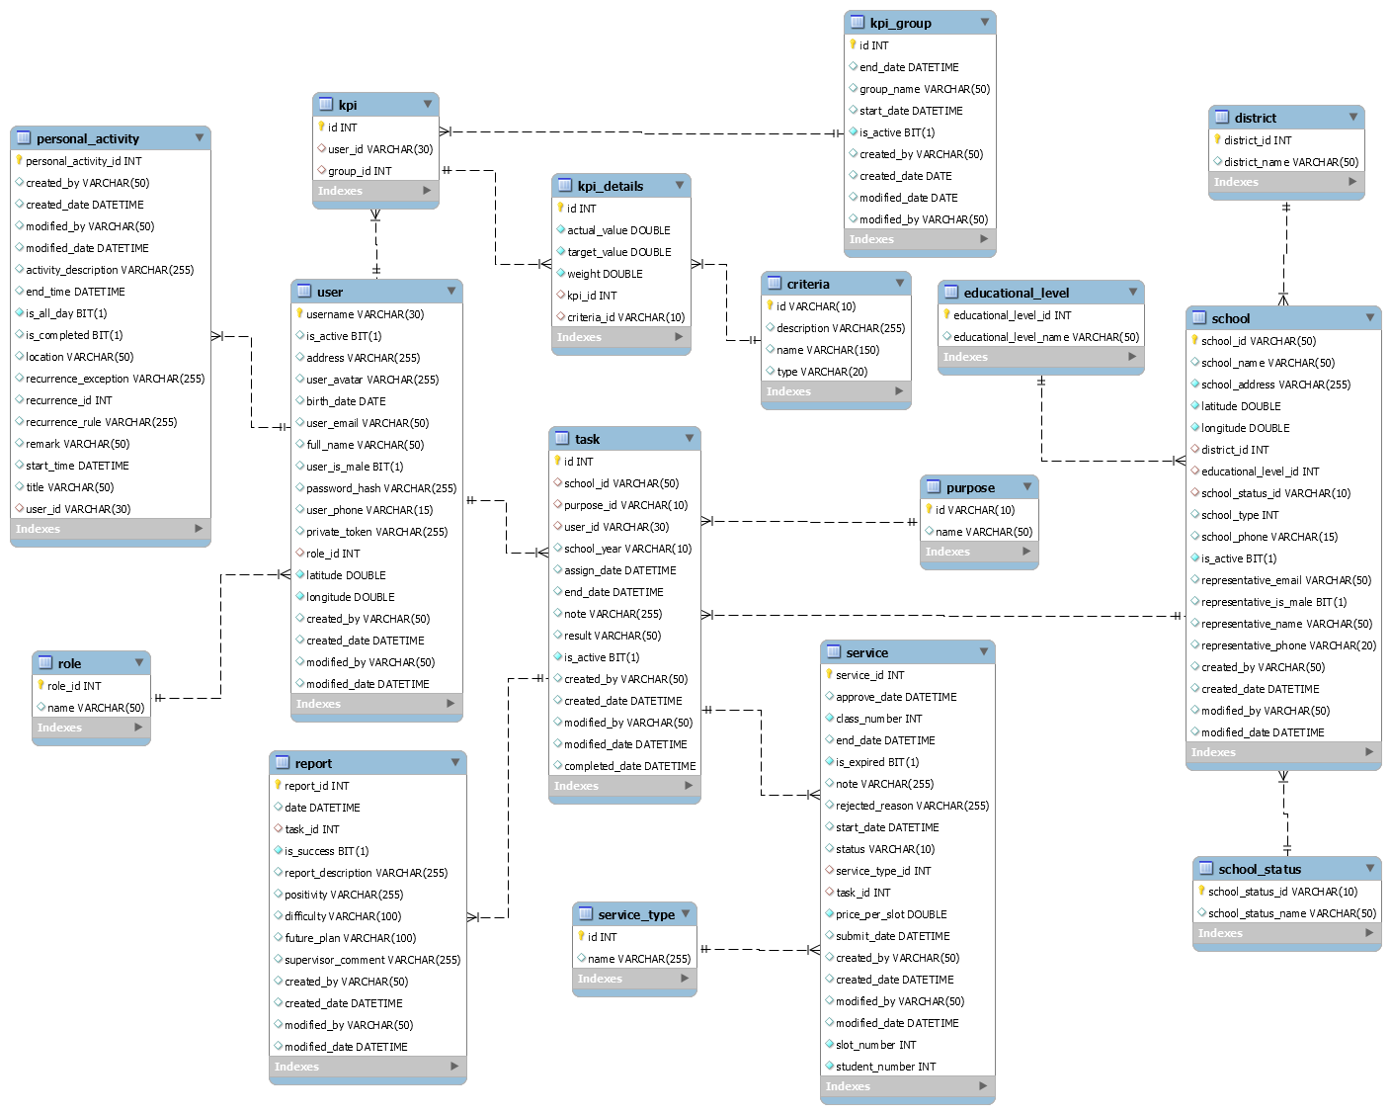

Figure 77. Database Diagram

#### school

|  |  |  |  |  |  |  |  |
| --- | --- | --- | --- | --- | --- | --- | --- |
| **#** | **Field name** | **Type** | **Size** | **Unique** | **Not Null** | **PK/FK** | **Notes** |
| 1 | school_id | string | 50 | X | X | X | Auto generate from school_name + district_id + education_level_id |
| 2 | school_name | varchar | 50 |  | X |  |  |
| 3 | school_phone | varchar | 15 |  |  |  |  |
| 4 | school_address | varchar | 255 |  | X |  |  |
| 5 | is_active | bit | 1 |  | X |  | Use for soft deleting |
| 6 | education_level_id | int |  |  | X | X |  |
| 7 | school_type | int |  |  | X |  |  |
| 8 | district_id | int |  |  | X | X |  |
| 9 | school_status_id | varchar | 10 |  | X | X |  |
| 10 | representative_name | varchar | 50 |  |  |  |  |
| 11 | representative_email | varchar | 50 |  |  |  |  |
| 12 | representative_phone | varchar | 15 |  |  |  |  |
| 13 | representative_is_male | bit | 1 |  |  |  |  |
| 14 | latitude | double |  |  |  |  |  |
| 15 | longitude | double |  |  |  |  |  |
| 16 | created_by | varchar | 50 |  |  |  | Use for auditing |
| 17 | created_date | datetime |  |  |  |  | Use for auditing |
| 18 | modified_by | varchar | 50 |  |  |  | Use for auditing |
| 19 | modified_date | datetime |  |  |  |  | Use for auditing |

Table 104. Description for table "school"

#### district

|  |  |  |  |  |  |  |  |
| --- | --- | --- | --- | --- | --- | --- | --- |
| **#** | **Field name** | **Type** | **Size** | **Unique** | **Not Null** | **PK/FK** | **Notes** |
| 1 | district_id | int |  | X | X | X |  |
| 2 | district_name | varchar | 50 |  | X |  |  |

Table 105. Description for table "district"

#### school_status

|  |  |  |  |  |  |  |  |
| --- | --- | --- | --- | --- | --- | --- | --- |
| **#** | **Field name** | **Type** | **Size** | **Unique** | **Not Null** | **PK/FK** | **Notes** |
| 1 | school_status_id | varchar | 10 | X | X | X |  |
| 2 | school_status_name | varchar | 50 |  | X |  |  |

Table 106. Description for table "school_status"

#### task

|  |  |  |  |  |  |  |  |
| --- | --- | --- | --- | --- | --- | --- | --- |
| **#** | **Field name** | **Type** | **Size** | **Unique** | **Not Null** | **PK/FK** | **Notes** |
| 1 | id | int |  | X | X | X |  |
| 2 | school_year | varchar | 10 |  | X | X |  |
| 3 | school_id | int |  |  | X | X |  |
| 4 | purpose_id | varchar | 10 |  | X | X |  |
| 5 | user_id | varchar | 30 |  |  | X |  |
| 6 | note | varchar | 255 |  |  |  |  |
| 7 | result | varchar | 50 |  |  |  |  |
| 8 | is_active | bit | 1 |  | X |  | Use for soft deleting |
| 9 | assign_date | datetime |  |  |  |  |  |
| 10 | end_date | datetime |  |  |  |  |  |
| 11 | completed_date | datetime |  |  |  |  |  |
| 12 | created_by | varchar | 50 |  |  |  | Use for auditing |
| 13 | created_date | datetime |  |  |  |  | Use for auditing |
| 14 | modified_by | varchar | 50 |  |  |  | Use for auditing |
| 15 | modified_date | datetime |  |  |  |  | Use for auditing |

Table 107. Description for table "target_school"

#### report

|  |  |  |  |  |  |  |  |
| --- | --- | --- | --- | --- | --- | --- | --- |
| **#** | **Field name** | **Type** | **Size** | **Unique** | **Not Null** | **PK/FK** | **Notes** |
| 1 | report_id | int |  | X | X | X |  |
| 2 | date | datetime |  |  | X |  |  |
| 3 | task_id | int |  |  | X | X |  |
| 4 | is_success | bit | 1 |  | X |  |  |
| 5 | report_description | varchar | 255 |  |  |  |  |
| 6 | positivity | varchar | 255 |  |  |  |  |
| 7 | difficulty | varchar | 100 |  |  |  |  |
| 8 | future_plan | varchar | 100 |  |  |  |  |
| 9 | supervisor_comment | varchar | 255 |  |  |  |  |
| 10 | created_by | varchar | 50 |  |  |  | Use for auditing |
| 11 | created_date | datetime |  |  |  |  | Use for auditing |
| 12 | modified_by | varchar | 50 |  |  |  | Use for auditing |
| 13 | modified_date | datetime |  |  |  |  | Use for auditing |

Table 108. Description for table "report"

#### purpose

|  |  |  |  |  |  |  |  |
| --- | --- | --- | --- | --- | --- | --- | --- |
| **#** | **Field name** | **Type** | **Size** | **Unique** | **Not Null** | **PK/FK** | **Notes** |
| 1 | id | varchar | 10 | X | X | X |  |
| 2 | name | varchar | 50 |  | X |  |  |

Table 109. Description for table "target_school_purpose"

#### user

|  |  |  |  |  |  |  |  |
| --- | --- | --- | --- | --- | --- | --- | --- |
| **#** | **Field name** | **Type** | **Size** | **Unique** | **Not Null** | **PK/FK** | **Notes** |
| 1 | username | varchar | 30 | X | X | X |  |
| 2 | password_hash | varchar | 255 |  | X |  | Password is hashed by Bcript Hashing Algorithm. |
| 3 | full_name | varchar | 50 |  |  |  |  |
| 4 | user_email | varchar | 50 |  |  |  |  |
| 5 | user_phone | varchar | 15 |  |  |  |  |
| 6 | role_id | int |  |  | X | X |  |
| 7 | is_active | bit | 1 |  | X |  | Use for soft deleting or when the users quit job. |
| 8 | address | varchar | 255 |  |  |  |  |
| 9 | user_avatar | varchar | 255 |  |  |  | Presigned URL for retriving images from Firebase Storage. |
| 10 | user_is_male | bit | 1 |  | X |  |  |
| 11 | birth_date | date |  |  |  |  |  |
| 12 | private_token | varchar | 255 |  |  |  | This token is used to recovered the forgotten password. |
| 13 | latitude | double |  |  |  |  |  |
| 14 | longitude | double |  |  |  |  |  |
| 15 | created_by | varchar | 50 |  |  |  | Use for auditing |
| 16 | created_date | datetime |  |  |  |  | Use for auditing |
| 17 | modified_by | varchar | 50 |  |  |  | Use for auditing |
| 18 | modified_date | datetime |  |  |  |  | Use for auditing |

Table 110. Description for table "user"

#### role

|  |  |  |  |  |  |  |  |
| --- | --- | --- | --- | --- | --- | --- | --- |
| **#** | **Field name** | **Type** | **Size** | **Unique** | **Not Null** | **PK/FK** | **Notes** |
| 1 | role_id | int |  | X | X | X |  |
| 2 | name | varchar | 30 |  | X |  |  |

Table 111. Description for table "role"

#### personal_activity

|  |  |  |  |  |  |  |  |
| --- | --- | --- | --- | --- | --- | --- | --- |
| **#** | **Field name** | **Type** | **Size** | **Unique** | **Not Null** | **PK/FK** | **Notes** |
| 1 | personal_activity_id | int |  | X | X | X |  |
| 2 | title | varchar | 30 |  | X |  | Title of the to-do activity |
| 3 | remark | varchar | 50 |  |  |  | Result or remark of the activity |
| 4 | activity_description | varchar | 255 |  |  |  |  |
| 5 | start_time | datetime |  |  | X |  |  |
| 6 | end_time | datetime |  |  | X |  |  |
| 7 | user_id | varchar | 30 |  | X | X |  |
| 8 | is_all_day | bit | 1 |  | X |  | The duration of the personal activity, if it lasts for whole day or not |
| 9 | is_completed | bit | 1 |  | X |  | The status of the activity, whether it is completed or not |
| 10 | location | varchar | 50 |  |  |  | Location where this activity happens/will happen. |
| 11 | recurrence_id | int |  |  |  |  | An activity can occur one time or multiple time. If it occurs multiple time, this “recurrence_id” is to specify the series/family of that activity. |
| 12 | recurrence_rule | varchar | 255 |  |  |  | A series contains multiple same activities with the general rule for repeating after a period. |
| 13 | recurrence _exception | varchar | 255 |  |  |  | This list is used to store the “personal_activity_id” of an exception in the series. |
| 14 | created_by | varchar | 50 |  |  |  | Use for auditing |
| 15 | created_date | datetime |  |  |  |  | Use for auditing |
| 16 | modified_by | varchar | 50 |  |  |  | Use for auditing |
| 17 | modified_date | datetime |  |  |  |  | Use for auditing |

Table 112. Description for table "personal_activity"

#### service

|  |  |  |  |  |  |  |  |
| --- | --- | --- | --- | --- | --- | --- | --- |
| **#** | **Field name** | **Type** | **Size** | **Unique** | **Not Null** | **PK/FK** | **Notes** |
| 1 | service_id | int |  | X | X | X |  |
| 2 | approved_date | datetime |  |  | X |  |  |
| 3 | note | varchar | 255 |  |  |  |  |
| 4 | class_number | int |  |  |  |  |  |
| 5 | start_date | datetime |  |  | X |  |  |
| 6 | end_date | datetime |  |  |  |  |  |
| 7 | submit_date | datetime |  |  |  |  |  |
| 8 | task_id | int |  |  | X | X |  |
| 9 | is_expired | bit | 1 |  | X |  |  |
| 10 | service_type_id | int |  |  |  | X |  |
| 11 | status | varchar | 10 |  |  |  |  |
| 12 | price_per_slot | double |  |  |  |  |  |
| 13 | slot_number | int |  |  |  |  |  |
| 14 | student_number | int |  |  |  |  |  |
| 15 | rejectReason | varchar | 255 |  |  |  |  |
| 16 | created_by | varchar | 50 |  |  |  | Use for auditing |
| 17 | created_date | datetime |  |  |  |  | Use for auditing |
| 18 | modified_by | varchar | 50 |  |  |  | Use for auditing |
| 19 | modified_date | datetime |  |  |  |  | Use for auditing |

Table 113. Description for table "service"

#### service_type

|  |  |  |  |  |  |  |  |
| --- | --- | --- | --- | --- | --- | --- | --- |
| **#** | **Field name** | **Type** | **Size** | **Unique** | **Not Null** | **PK/FK** | **Notes** |
| 1 | id | int |  | X | X | X |  |
| 2 | name | varchar | 255 |  | X |  |  |

Table 114. Desription for table "service_type"

#### kpi

|  |  |  |  |  |  |  |  |
| --- | --- | --- | --- | --- | --- | --- | --- |
| **#** | **Field name** | **Type** | **Size** | **Unique** | **Not Null** | **PK/FK** | **Notes** |
| 1 | id | int |  | X | X | X |  |
| 2 | user_id | String | 30 |  | X | X |  |
| 3 | group_id | int |  |  | X | X |  |

Table 115. Desription for table "kpi"

#### kpi_group

|  |  |  |  |  |  |  |  |
| --- | --- | --- | --- | --- | --- | --- | --- |
| **#** | **Field name** | **Type** | **Size** | **Unique** | **Not Null** | **PK/FK** | **Notes** |
| 1 | id | int |  | X | X | X |  |
| 2 | group_name | varchar | 50 |  | X |  |  |
| 3 | start_date | datetime |  |  | X |  |  |
| 4 | end_date | datetime |  |  |  |  |  |
| 5 | is_active | bit | 1 |  |  |  |  |
| 6 | created_by | varchar | 50 |  |  |  | Use for auditing |
| 7 | created_date | datetime |  |  |  |  | Use for auditing |
| 8 | modified_by | varchar | 50 |  |  |  | Use for auditing |
| 9 | modified_date | datetime |  |  |  |  | Use for auditing |

Table 116. Desription for table "kpi_group"

#### kpi_details

|  |  |  |  |  |  |  |  |
| --- | --- | --- | --- | --- | --- | --- | --- |
| **#** | **Field name** | **Type** | **Size** | **Unique** | **Not Null** | **PK/FK** | **Notes** |
| 1 | id | int |  | X | X | X |  |
| 2 | actual_value | double |  |  | X |  |  |
| 3 | target_value | double |  |  | X |  |  |
| 4 | weight | double |  |  | X |  |  |
| 5 | is_active | bit | 1 |  | X |  |  |
| 6 | kpi_id | int |  |  | X | X |  |
| 7 | criteria_id | varchar | 10 |  | X | X |  |

Table 117. Desription for table "kpi_details"

#### criteria

|  |  |  |  |  |  |  |  |
| --- | --- | --- | --- | --- | --- | --- | --- |
| **#** | **Field name** | **Type** | **Size** | **Unique** | **Not Null** | **PK/FK** | **Notes** |
| 1 | id | varchar | 10 | X | X | X |  |
| 2 | description | varchar | 255 |  | X |  |  |
| 3 | name | varchar | 150 |  | X |  |  |
| 4 | type | varchar | 20 |  |  |  |  |

Table 118. Desription for table "criteria"

#### educational_level

|  |  |  |  |  |  |  |  |
| --- | --- | --- | --- | --- | --- | --- | --- |
| **#** | **Field name** | **Type** | **Size** | **Unique** | **Not Null** | **PK/FK** | **Notes** |
| 1 | educational_level_id | int |  | X | X | X |  |
| 2 | educational_level_name | varchar | 50 |  |  |  |  |

Table 119. Desription for table "educational_level"

### 5.2 Data File Design

We use firebase to store images.

|  |  |  |  |
| --- | --- | --- | --- |
| **#** | **File Name** | **Type** | **Notes** |
| 1 | avatars | jpg, jpeg, png | The images are used for user avatar. |
| 2 | Import_Sample.xlsx | xlsx | The sample sheet for user import guidance. |

Table 120. Data File Design

# V. Software Testing Documentation

## 1. Overall Description

### 1.1 Test Model

Based on the user requirements, team resources, and project conditions, our team has come up with using the prototype model as a software development model. In this model, a prototype is built, tested, and reworked until it is accepted by the user.

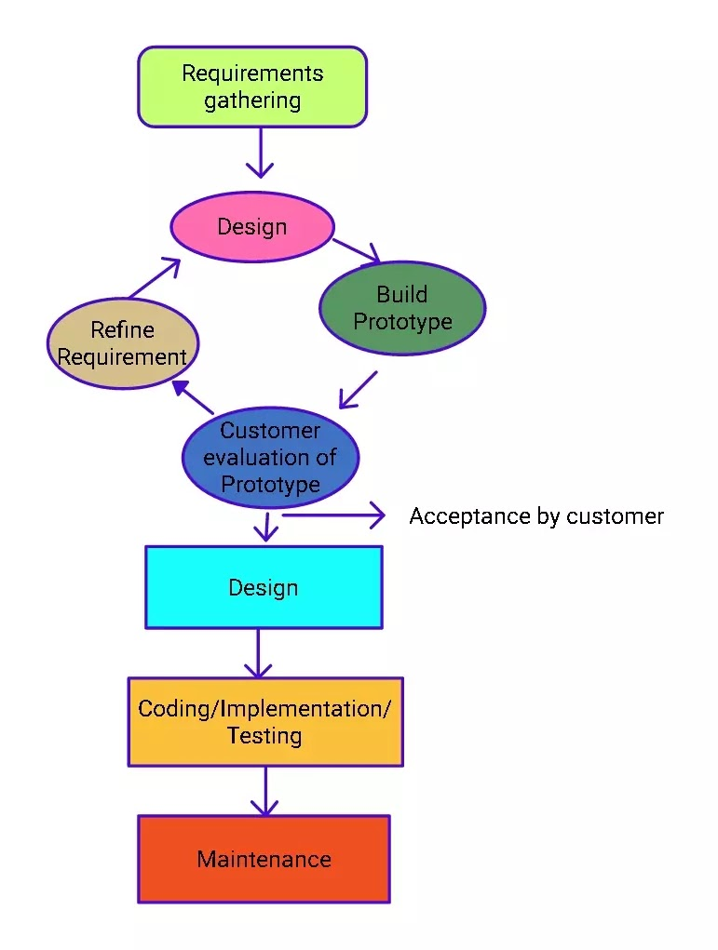

Figure 78. Prototype model

References: <https://www.geeksforgeeks.org/software-engineering-prototyping-model/>

### 1.2 Testing Levels

|  |  |
| --- | --- |
| **Testing Level** | **Description** |
| Unit Testing | Checks the software modules are fit for use |
| Integration Testing | Checks the integrated logic of the software module group |
| System Testing | Checks the whole system if it works as expected or not |
| Acceptance Testing | Checks the software if the user requirements are met or not |

Table 121. Testing Levels

### 1.3 Testing Types

|  |  |
| --- | --- |
| **Testing types** | **Description** |
| Functional Testing | * Unit Testing * Integration Testing * System Testing * Interface Testing * Regression Testing * Beta Testing |
| Non-functional Testing | * Performance Testing |

Table 122. Testing Types

## 2. Test Plan

### 2.1 Test Stages

|  |  |  |  |  |
| --- | --- | --- | --- | --- |
| **Type of Test** | **Stage of Test** | | | |
| ***Unit*** | ***Integration*** | ***System*** | ***Acceptance*** |
| Interface Testing | X |  | X |  |
| Performance Testing |  | X |  |  |
| Regression Testing | X | X |  |  |
| Beta Testing |  |  |  | X |

Table 123. Test Stages

### 2.2 Resources

#### Human Resources

|  |  |  |
| --- | --- | --- |
| **Worker/Doer** | **Role** | **Specific Responsibilities/Comments** |
| Phạm Thị Ngọc Hà | Leader | * Functional Testing * Non-functional Testing |
| Lê Gia Nguyên | Member | * Functional Testing * Non-functional Testing |
| Nguyễn Hoàng Gia | Member | * Functional Testing * Non-functional Testing |

Table 124. Human Resources

#### Environment

|  |  |  |  |
| --- | --- | --- | --- |
| **Purpose** | **Tool** | **Provider** | **Version** |
| Unit Testing | Postman | Postman, Inc | 8.2.1 |
| Unit Testing  Integration Testing  System Testing  Interface Testing  Regression Testing  Performance Testing | Chrome | Google LLC | 89 |

Table 125. Environment

### 2.3 Test Milestones

|  |  |  |  |
| --- | --- | --- | --- |
| **Milestone Task** | **Effort (md)** | **Start Date** | **End Date** |
| Setup the environment | 2 | 09/04/2021 | 09/04/2021 |
| Admin role function unit test | 2 | 09/04/2021 | 09/04/2021 |
| Admin role integration test | 3 | 09/04/2021 | 09/04/2021 |
| Admin role interface test | 2 | 09/04/2021 | 09/04/2021 |
| Salesman role function unit test | 4 | 09/04/2021 | 09/04/2021 |
| Salesman role integration test | 5 | 09/04/2021 | 09/04/2021 |
| Salesman role interface test | 4 | 09/04/2021 | 09/04/2021 |
| Sales manager role function unit test | 4 | 10/04/2021 | 10/04/2021 |
| Sales manager role integration test | 5 | 10/04/2021 | 10/04/2021 |
| Sales manager role interface test | 4 | 10/04/2021 | 10/04/2021 |
| Admin role regression test | 3 | 11/042021 | 11/042021 |
| Admin role performance test | 3 | 11/042021 | 11/042021 |
| Salesman role regression test | 5 |  |  |
| Salesman role performance test | 3 |  |  |
| Sales manager role regression test | 5 |  |  |
| Sales manager role performance test | 3 |  |  |
| Sales supervisor role function unit test | 3 |  |  |
| Sales supervisor role integration test | 3 |  |  |
| Sales supervisor role interface test | 3 |  |  |
| Sales supervisor role regression test | 4 |  |  |
| Sales supervisor role performance test | 3 |  |  |
| System test | 7 |  |  |
| Beta test | 10 |  |  |

Table 126. Test Milestones

### 2.4 Deliverables

|  |  |  |
| --- | --- | --- |
| No | Deliverables | Due Date |
| 1 | Report5_Unit Test Case | 12/04/2021 |
| 2 | Report5_ Test Case Document | 13/04/2021 |

Table 127. Deliverables

## 3. Test Cases

|  |  |
| --- | --- |
| **No** | **Filename** |
| 1 | [Report5_Unit Test Case.xls](Report5_Unit%20Test%20Case.xls) |
| 2 | [Report5_Test Case Document.xls](Report5_Test%20Case%20Document.xlsx) |

Table 128. Test Cases

## 4. Test Reports

|  |  |
| --- | --- |
| **No** | **Filename** |
| 1 | [Report5_Unit Test Case.xls](Report5_Unit%20Test%20Case.xls) |

Table 129. Test Reports

# VI. Release Package & User Guides

## 1. Deliverable Package

### 1.1 Source codes & documents

| **No.** | **Items** | **Sub-Items** | **Type** | **Version** |
| --- | --- | --- | --- | --- |
| ***Code Package*** | | | | |
| 1 | Web Apps |  | New | 1.0.0 |
| 2 | API Services |  | New | 1.0.0 |
| ***Database*** | | | | |
| 1 | Tables | service.sql | New | 1.0.0 |
| district.sql | New | 1.0.0 |
| personal_activity.sql | New | 1.0.0 |
| report.sql | New | 1.0.0 |
| role.sql | New | 1.0.0 |
| school.sql | New | 1.0.0 |
| school_status.sql | New | 1.0.0 |
| target_school.sql | New | 1.0.0 |
| target_school_purpose.sql | New | 1.0.0 |
| user.sql | New | 1.0.0 |
| ***Documents*** | | | | |
| 1 | Introduction | Report1_Project Introduction.docx | New | 1.0.0 |
| 2 | Management Plan | Report2_Project Management Plan.docx | New | 1.0.0 |
| 3 | Requirement | Report3_Software Requirement Specification.docx | New | 1.0.0 |
| 4 | Design | Report4_Software Design Document.docx | New | 1.0.0 |
| 5 | Testing | Report5_Test Documentation.docx | New | 1.0.0 |
| Report5_Test Case Document.docx | New | 1.0.0 |
| Report5_Unit Test Case.docx | New | 1.0.0 |
| 6 | User Guides | Report6_Software User Guides.docx | New | 1.0.0 |
| 7 | Final | Report7_Final Project Report.docx | New | 1.0.0 |

Table 130. Source codes & documents

### 1.2 Known Issues, Limitations & Restrictions

* The current system does not provide a mobile app version for the user.
* The current system does not support communication channel with customers.
* The web application responsive interface has not stable yet.
* The interface still lacks consistency, may or may not cause uncomfortable for the user.
* The current application only supports English default.
* The system lacks testing, which leads to application performance or bugs that may cause during implementation.
* During the lack of team resources, some main features of the application have not been implemented.

## 2. Installation Guides

### System Requirements

#### 2.1.1 Hardware Requirements

* Scince this system is a web application, all the devices using the system must run over the Internet.
* Our system is deployed on the server, which the minimum requirements services to run in the following:

For Web App

|  |  |
| --- | --- |
| **Hardware** | **Minimum Requirements** |
| vCPU | 1 |
| Operation System | Linux Server/Window server |
| Memory (GiB) | 1GiB (=1.07374 GB) |

Table 131. <Installation guides> Hardware requirements for Web App

For API Services

|  |  |
| --- | --- |
| **Hardware** | **Minimum Requirements** |
| vCPU | 1 |
| Operation System | Linux Server/Window server |
| Memory | 1GiB (=1.07374 GB) |

Table 132. <Installation guides> Hardware requirements for API service

For Database

|  |  |
| --- | --- |
| **Hardware** | **Minimum Requirements** |
| vCPU | 1 |
| Operation System | Linux server/Window server |
| Computer Memory | 1GiB (=1.07374 GB) |

Table 133. <Installation guides> Hardware requirements for Database

#### 2.1.2 Software Requirements

This web application works with: Chrome (version 52 or above), Firefox (version 51 or above), Edge (version 14 or above), Safari (version 10 or above), or Opera (version 38 or above) browser.

### 2.2 Setup Files

N/A

### 2.3 Installation Instruction

N/A

## 3. User Manual

### 3.1 Terms and definitions

* This system is built for Major Education with a project code SMSME, which stands for Sales Management System for Major Education.
* This system is an enterprise application, with the license rules and terms of use belong to Major Education.

### 3.2 System requirements

#### 3.2.1 Hardware Requirements

* Since this system is a web application, all the devices using the system must run over the Internet.
* Our system is deployed on the server, which the minimum requirements services to run in the following:

For Web App

|  |  |
| --- | --- |
| **Hardware** | **Minimum Requirements** |
| vCPU | 1 |
| Operation System | Linux Server/Window server |
| Memory (GiB) | 1GiB (=1.07374 GB) |

Table 134. <User Manual> Hardware requirements for Web App

For API Services

|  |  |
| --- | --- |
| **Hardware** | **Minimum Requirements** |
| vCPU | 1 |
| Operation System | Linux Server/Window server |
| Memory (GiB) | 1GiB (=1.07374 GB) |

Table 135. <User Manual> Hardware requirements for API Services

For Database

|  |  |
| --- | --- |
| **Hardware** | **Minimum Requirements** |
| vCPU | 1 |
| Operation System | Linux server/Window server |
| Memory (GiB) | 1GiB (=1.07374 GB) |

Table 136. <User Manual> Hardware requirements for Database

#### 3.2.2 Software Requirements

This web application works with: Chrome (version 52 or above), Firefox (version 51 or above), Edge (version 14 or above), Safari (version 10 or above), or Opera (version 38 or above) browser.

### 3.3 Application Usage

#### 3.3.1 Overview

The target users that SMSME mainly aims to are salesmen and sales managers of the Sales Department of Major Education.

For salesmen, this software would help them manage their work-plan as well as their tasks easier and more visually, submit daily reports more directly and they can also monitor other salesmen’s works.

For sales managers, they would not have to collect and analyze all salesmen’s reports manually. Now they can supervise salesmen or search for reports more easily. Moreover, they can see the overall picture of the company's business process, including what schools are lead or customers, who are the most effective salesman,…

#### 3.3.2 Accounts

Purpose

* The admin manages user accounts.

Functions

* View list of accounts.
* View account’s details.
* Search accounts.
* Create accounts.
* Edit account’s information.

User interface(s)

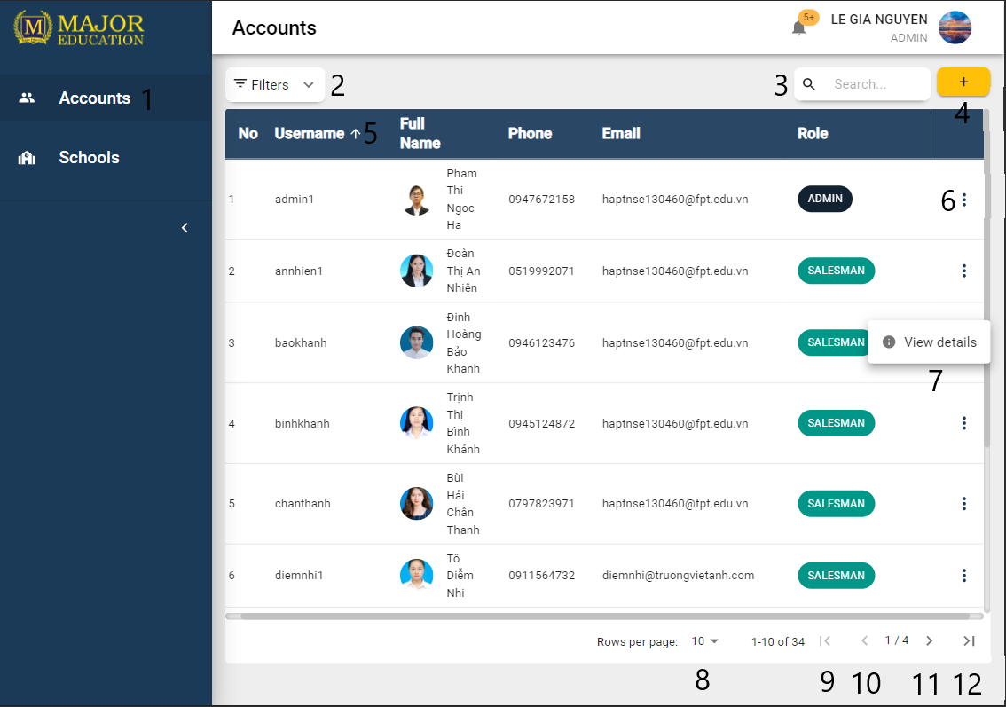

Figure 79. List of Accounts

|  |  |
| --- | --- |
| **Step** | **Description** |
| Pre-condition | User logged in as role “Admin” |
| 1 | Click on “Accounts” on the sidebar |

Table 137. View all Accounts <steps>

|  |  |  |  |  |  |  |
| --- | --- | --- | --- | --- | --- | --- |
| **No** | **Field Name** | **Description** | **Read only** | **Required** | **Control Type** | **Data Type** |
| 3 | Search | Search users by username, full name, phone, and user email. | No | No | Text Field | String |

Table 138. View all Accounts <fields>

|  |  |  |  |  |
| --- | --- | --- | --- | --- |
| **No** | **Function** | **Description** | **Validation** | **Outcome** |
| 2 | Filter button | Open/Collapse Filter zone | No | An accordion which contains filters inside |
| 4 | Create accounts | Create new user account | No | A “Create Accounts” form |
| 5 | Sort |  | No |  |
| 6 | Open menu options | Show menu options of actions which are allowed for a specific role | No |  |
| 7 | Menu Option | Option “View details” to show more details of the table’s row data | No |  |
| 8 | Change limit of the table | Select number of rows per page to display on the table (pagination) | No |  |
| 9 | First page | Move to the first page in the table | No |  |
| 10 | Previous page | Move to the page in the table | No |  |
| 11 | Next page | Move to the next page in the table | No |  |
| 12 | Last page | Move to the last page in the table | No |  |

Table 139. View all Accounts <functions>

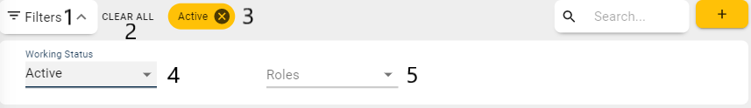

Figure 80. Accounts Filters

|  |  |
| --- | --- |
| **Step** | **Description** |
| 1 | Click on the filters button |

Table 140. Account Filters <steps>

|  |  |  |  |  |  |  |
| --- | --- | --- | --- | --- | --- | --- |
| **No** | **Field Name** | **Description** | **Read only** | **Required** | **Control Type** | **Data Type** |
| 4 | Working status | Filter users by their working status (is working or quit job…) | No | No | Select | String |
| 5 | Roles | Filter users by their roles | No | No | Select | String |

Table 141. Accounts Filters <fields>

|  |  |  |  |  |
| --- | --- | --- | --- | --- |
| **No** | **Function** | **Description** | **Validation** | **Outcome** |
| 2 | Clear All filters | Clear all selected filters and reset all filters to default value | No |  |
| 3 | Remove a filter | Each selected filter is display as a chip. Clicks on “x” button to remove that chip and reset the according filter to default value | No |  |

Table 142. Accounts Filters <functions>

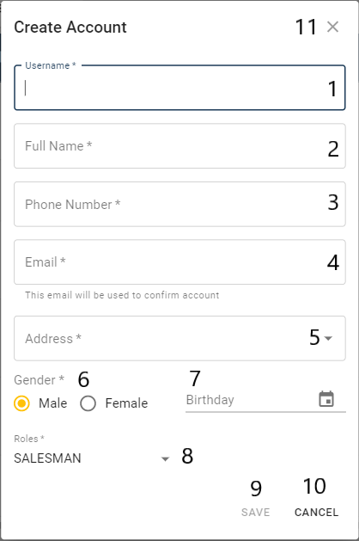

Figure 81. Create Account Form

|  |  |
| --- | --- |
| **Step** | **Description** |
| Pre-condition | Click on the create account button |

Table 143. Create Account Form <steps>

|  |  |  |  |  |  |  |
| --- | --- | --- | --- | --- | --- | --- |
| **No** | **Field Name** | **Description** | **Read only** | **Required** | **Control Type** | **Data Type** |
| 1 | Username | Username of the user | No | Yes | Text Field | String |
| 2 | Full Name | Full name of the user | No | Yes | Text Field | String |
| 3 | Phone Number | Phone number of the user | No | Yes | Text Field | String |
| 4 | Email | Email of the user | No | Yes | Text Field | String |
| 5 | Address | Address of the user | No | Yes | Text Field | String |
| 6 | Gender | Gender of the user | No | Yes | Checkbox | Boolean |
| 7 | Birthday | Birthday of the user | No | No | Text Field | Date |
| 8 | Roles | Role of the user | No | Yes | Combo Box | String |

Table 144 Create Account Form <fields>

|  |  |  |  |  |
| --- | --- | --- | --- | --- |
| **No** | **Function** | **Description** | **Validation** | **Outcome** |
| 9 | Save | Create a new account | Yes | Notify create successfully |
| 10 | Cancel | Cancel create a new account | No | Close the form |
| 11 | Close Icon | Cancel create a new account | No | Close the form |

Table 145 Create Account Form <functions>

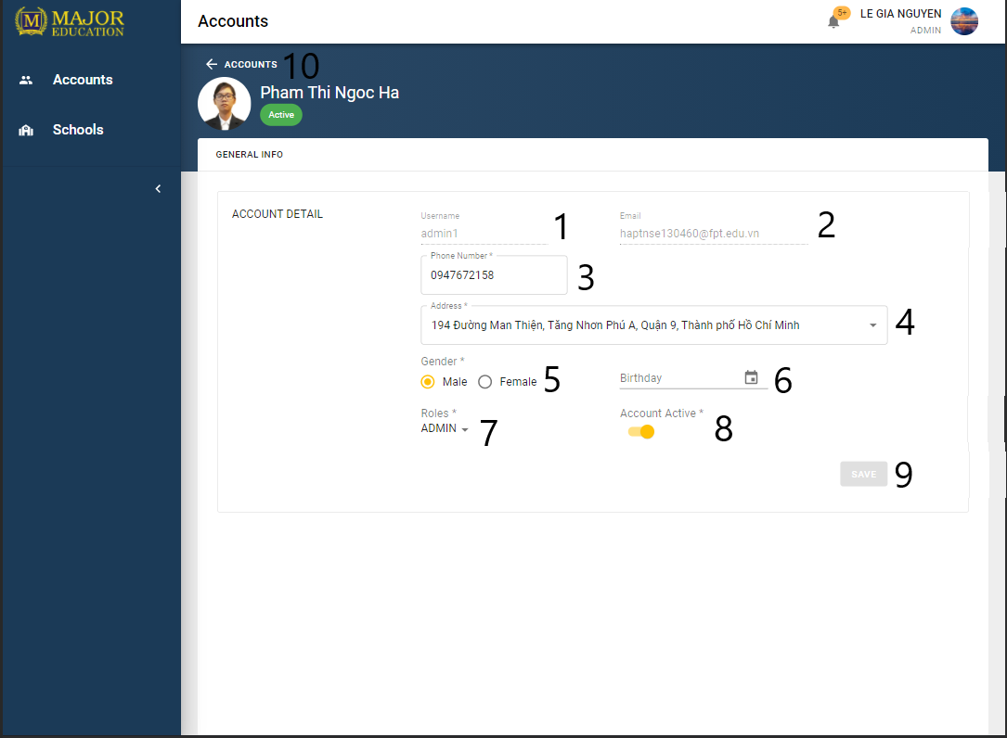

Figure 82. Account’s details

|  |  |
| --- | --- |
| **Step** | **Description** |
| Pre-condition | User logged in as role “Admin” |
| Pre-condition | Click on “View details” option on the menu item of the table |

Table 146. View Accounts details <steps>

|  |  |  |  |  |  |  |
| --- | --- | --- | --- | --- | --- | --- |
| **No** | **Field Name** | **Description** | **Read only** | **Required** | **Control Type** | **Data Type** |
| 1 | Username | Username of the user | Yes | Yes | Text Field | String |
| 2 | Email | Email of the user | Yes | Yes | Text Field | String |
| 3 | Phone number | Phone number of the users | No | Yes | Text Field | String |
| 4 | Address | Address of the user | No | Yes | Text Field | String |
| 5 | Gender | Gender of the user | No | Yes | Checkbox | Boolean |
| 6 | Birthday | Birthday of the user | No | No | Text Field | Date |
| 7 | Roles | Role of the user | No | Yes | Combo Box | String |
| 8 | Account Active | Working status of the user | No | Yes | Switch | Boolean |

Table 147. View Account details <fields>

|  |  |  |  |  |
| --- | --- | --- | --- | --- |
| **No** | **Function** | **Description** | **Validation** | **Outcome** |
| 9 | Save | Update account info | Yes | Notify update successfully |
| 10 | Go back | Go back to accounts page | No | Redirect to Accounts page |

Table 148. View Account details <functions>

#### 3.3.3 Schools

Purpose

* The admin manages school’s info.
* The sales manager edits school’s info.
* The sales supervisor edits school’s info.
* The salesman edits school’s info.

Functions

* View list of schools.
* View school’s details.
* Search schools.
* Create schools.
* Edit school’s information.

User interface(s)

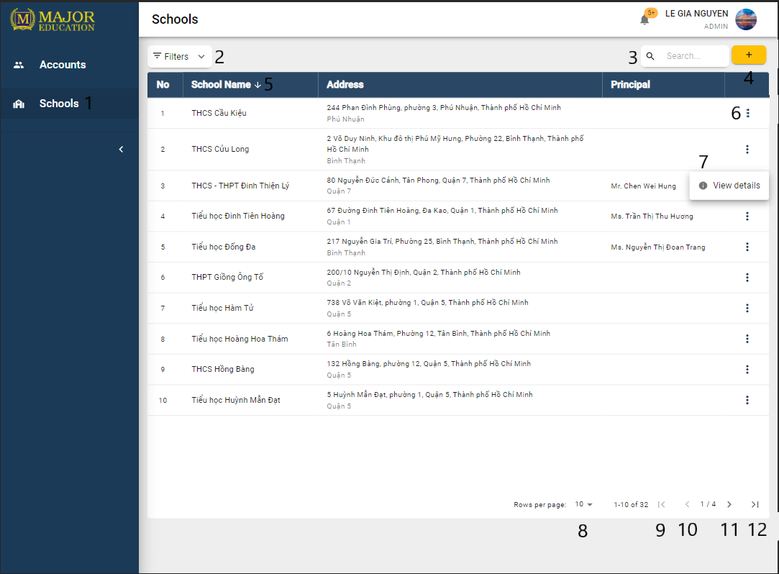

Figure 83. List of Schools

|  |  |
| --- | --- |
| **Step** | **Description** |
| Pre-condition | User logged in as role “Admin” |
| 1 | Click on “Schools” on the sidebar |

Table 149. View all Schools <steps>

|  |  |  |  |  |  |  |
| --- | --- | --- | --- | --- | --- | --- |
| **No** | **Field Name** | **Description** | **Read only** | **Required** | **Control Type** | **Data Type** |
| 3 | Search | Search schools by school name, address, principal | No | No | Text Field | String |

Table 150. View all Schools <fields>

|  |  |  |  |  |
| --- | --- | --- | --- | --- |
| **No** | **Function** | **Description** | **Validation** | **Outcome** |
| 2 | Filter button | Open/Collapse Filter zone | No | An accordion which contains filters inside |
| 4 | Create schools | Create new school | No | A menu list |
| 5 | Sort |  | No |  |
| 6 | Open menu options | Show menu options of actions which are allowed for a specific role | No |  |
| 7 | Menu Option | Option “View details” to show more details of the table’s row data | No |  |
| 8 | Change limit of the table | Select number of rows per page to display on the table (pagination) | No |  |
| 9 | First page | Move to the first page in the table | No |  |
| 10 | Previous page | Move to the page in the table | No |  |
| 11 | Next page | Move to the next page in the table | No |  |
| 12 | Last page | Move to the last page in the table | No |  |

Table 151. View all Schools <functions>

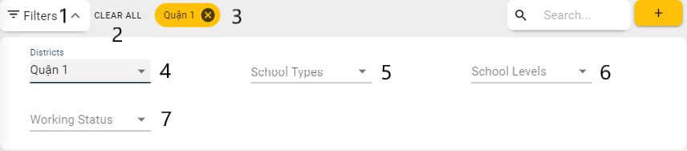

Figure 84. Schools Filters

|  |  |
| --- | --- |
| **Step** | **Description** |
| 1 | Click on the filters button |

Table 152. Schools Filters <steps>

|  |  |  |  |  |  |  |
| --- | --- | --- | --- | --- | --- | --- |
| **No** | **Field Name** | **Description** | **Read only** | **Required** | **Control Type** | **Data Type** |
| 4 | Districts | Filter schools by the districts | No | No | Select | String |
| 5 | School Types | Filter schools by the school types | No | No | Select | String |
| 6 | School Levels | Filter schools by the educational level | No | No | Select | String |
| 7 | Working status | Filter schools by the working status | No | No | Select | String |

Table 153. Schools Filters <fields>

|  |  |  |  |  |
| --- | --- | --- | --- | --- |
| **No** | **Function** | **Description** | **Validation** | **Outcome** |
| 2 | Clear All filters | Clear all selected filters and reset all filters to default value | No |  |
| 3 | Remove a filter | Each selected filter is display as a chip. Clicks on “x” button to remove that chip and reset the according filter to default value | No |  |

Table 154. Schools Filters <functions>

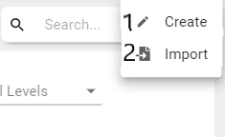

Figure 85. Create School Menu

|  |  |
| --- | --- |
| **Step** | **Description** |
| Pre-condition | Click on the create school button |

Table 155 Create School Menu <steps>

|  |  |  |  |  |
| --- | --- | --- | --- | --- |
| **No** | **Function** | **Description** | **Validation** | **Outcome** |
| 1 | Create | Create a new school info by using form | No | A “Create School” form |
| 2 | Import | Create a new school info by using import file | No | A “Import File” dialog |

Table 156. Create School Menu <functions>

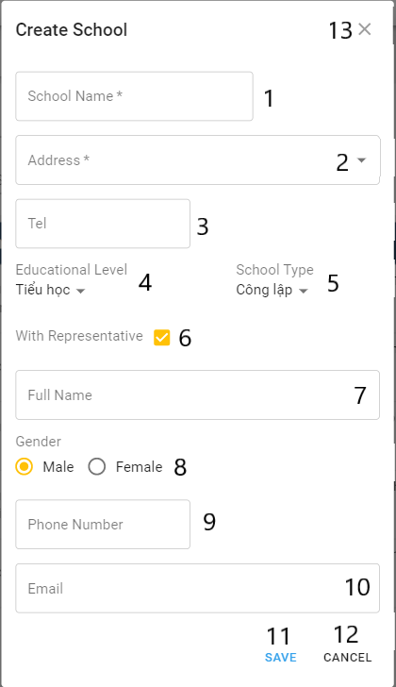

Figure 86. Create School Form

|  |  |
| --- | --- |
| **Step** | **Description** |
| Pre-condition | Choose “Create” from create school menu |

Table 157. Create School Form <steps>

|  |  |  |  |  |  |  |
| --- | --- | --- | --- | --- | --- | --- |
| **No** | **Field Name** | **Description** | **Read only** | **Required** | **Control Type** | **Data Type** |
| 1 | School Name | Name of the school | No | Yes | Text Field | String |
| 2 | Address | Address of the school | No | Yes | Text Field | String |
| 3 | Tel | Telephone number of the school | No | No | Text Field | String |
| 4 | Educational Level | Educational Level of the school | No | No | Combo Box | String |
| 5 | School Type | School Type of the school | No | No | Combo Box | String |
| 6 | With Representative | Check if the school has the representative info | No | No | Check box | Boolean |
| 7 | Full Name | Full name of the  representative | No | No | Text Field | String |
| 8 | Gender | Gender of the representative | No | No | Checkbox | Boolean |
| 9 | Phone number | Phone number of the representative | No | No | Text Field | String |
| 10 | Email | Email of the representative | No | No | Text Field | String |

Table 158 Create School Form <fields>

|  |  |  |  |  |
| --- | --- | --- | --- | --- |
| **No** | **Function** | **Description** | **Validation** | **Outcome** |
| 11 | Save | Create a new account | Yes | Notify create successfully |
| 12 | Cancel | Cancel create a new account | No | Close the form |
| 13 | Close Icon | Cancel create a new account | No | Close the form |

Table 159 Create School Form <functions>

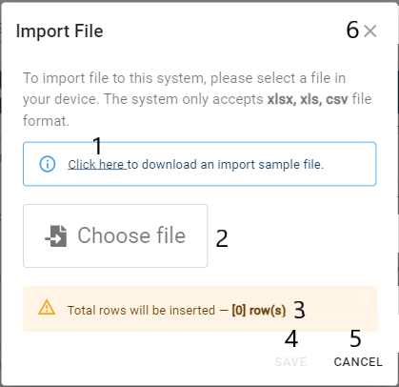

Figure 87. Import Schools

|  |  |
| --- | --- |
| **Step** | **Description** |
| Pre-condition | Choose “Import” from create school menu |

Table 160. Import Schools <steps>

|  |  |  |  |  |  |  |
| --- | --- | --- | --- | --- | --- | --- |
| **No** | **Field Name** | **Description** | **Read only** | **Required** | **Control Type** | **Data Type** |
| 3 | Validate file info checker | Check validate row inserted successfully | No | No | Text Field | String |

Table 161 . Import Schools <fields>

|  |  |  |  |  |
| --- | --- | --- | --- | --- |
| **No** | **Function** | **Description** | **Validation** | **Outcome** |
| 1 | Sample file | Download an import sample file | No | An import sample file |
| 2 | Choose file | Choose file to import | No |  |
| 4 | Save | Create school’s info by the imported file | Yes | Notify import successfully |
| 5 | Cancel | Cancel import file | No | Close the dialog |

Table 162. Import Schools <functions>

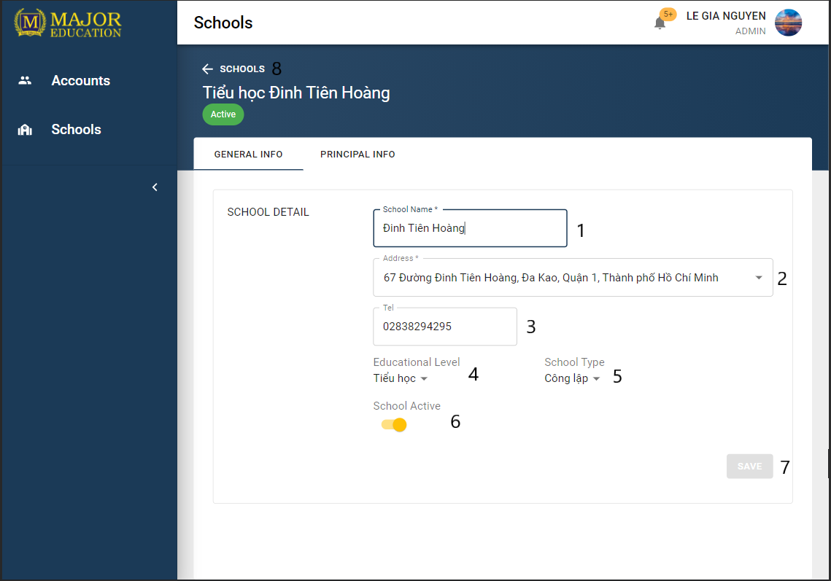

Figure 88. School’s details<General Info>

|  |  |
| --- | --- |
| **Step** | **Description** |
| Pre-condition | User logged in as role “Admin” |
| Pre-condition | Click on “View details” option on the menu item of the table |
| Pre-condition | “General info” tab selected |

Table 163. View Schools details <steps>

|  |  |  |  |  |  |  |
| --- | --- | --- | --- | --- | --- | --- |
| **No** | **Field Name** | **Description** | **Read only** | **Required** | **Control Type** | **Data Type** |
| 1 | School Name | Name of the school | No | Yes | Text Field | String |
| 2 | Address | Address of the school | No | Yes | Text Field | String |
| 3 | Tel | Telephone number of the school | No | No | Text Field | String |
| 4 | Educational Level | Educational Level of the school | No | No | Combo Box | String |
| 5 | School Type | School Type of the school | No | No | Combo Box | String |
| 8 | School Active | Working status of the school | No | Yes | Switch | Boolean |

Table 164. View School details <fields>

|  |  |  |  |  |
| --- | --- | --- | --- | --- |
| **No** | **Function** | **Description** | **Validation** | **Outcome** |
| 9 | Save | Update school info | Yes | Notify update successfully |
| 10 | Go back | Go back to school’s page | No | Redirect to Schools page |

Table 165. View School details <functions>

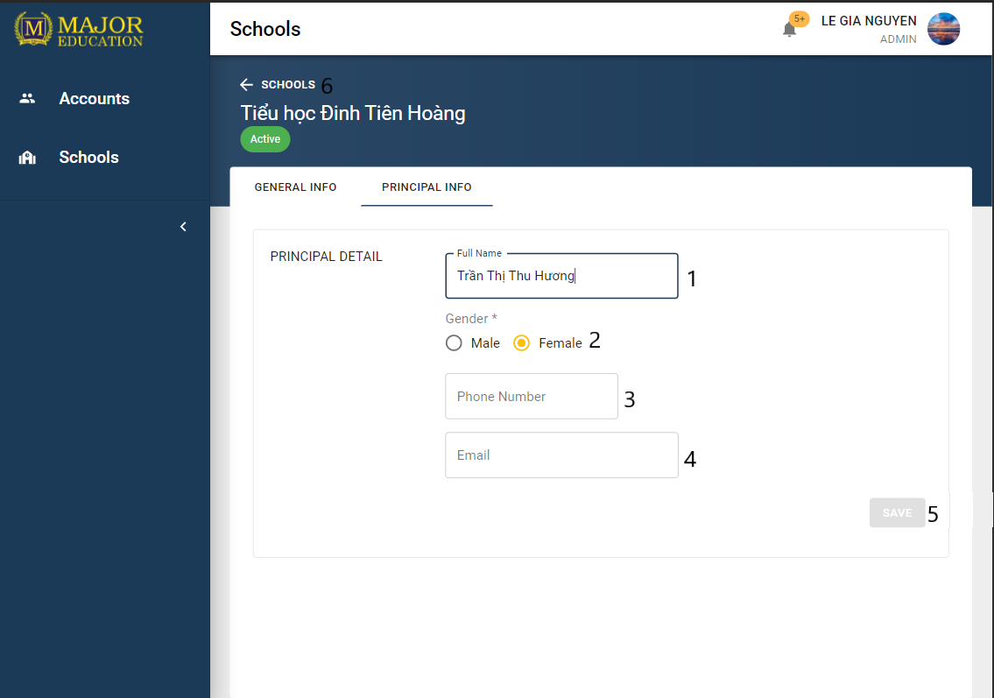

Figure 89. School’s details<Principal Info>

|  |  |
| --- | --- |
| **Step** | **Description** |
| Pre-condition | User logged in as role “Admin” |
| Pre-condition | Click on “View details” option on the menu item of the table |
| Pre-condition | “Principal info” tab selected |

Table 166. View School details <steps>

|  |  |  |  |  |  |  |
| --- | --- | --- | --- | --- | --- | --- |
| **No** | **Field Name** | **Description** | **Read only** | **Required** | **Control Type** | **Data Type** |
| 1 | Full Name | Full name of the principal | No | No | Text Field | String |
| 2 | Gender | Gender of the principal | No | No | Checkbox | Boolean |
| 3 | Phone number | Phone number of the principal | No | No | Text Field | String |
| 4 | Email | Email of the principal | No | No | Text Field | String |

Table 167. View School details <fields>

|  |  |  |  |  |
| --- | --- | --- | --- | --- |
| **No** | **Function** | **Description** | **Validation** | **Outcome** |
| 9 | Save | Update principal info | Yes | Notify update successfully |
| 10 | Go back | Go back to school’s page | No | Redirect to Schools page |

Table 168. View School details <functions>

#### 3.3.4 Tasks

Purpose

* The sales manager manages tasks.
* The sales supervisor manages tasks.
* The salesman view assigned of tasks.

Functions

* View list of tasks.
* View task detail.
* Search tasks.
* Create tasks.
* Edit tasks information.
* Assign salesmen to tasks.
* Remove tasks.

User interface(s)

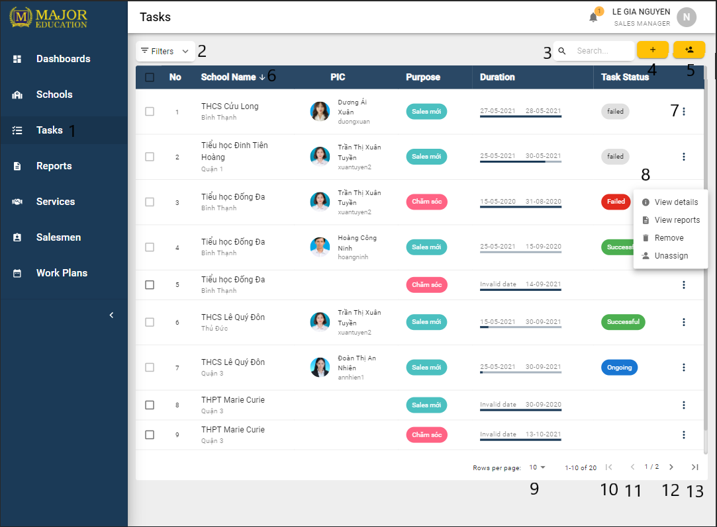

Figure 90. List of Tasks<Manager view>

|  |  |
| --- | --- |
| **Step** | **Description** |
| Pre-condition | User logged in as role “Sales Manager” |
| 1 | Click on “Tasks” on the sidebar |

Table 169. View all Tasks <steps>

|  |  |  |  |  |  |  |
| --- | --- | --- | --- | --- | --- | --- |
| **No** | **Field Name** | **Description** | **Read only** | **Required** | **Control Type** | **Data Type** |
| 3 | Search | Search schools by school name, PIC | No | No | Text Field | String |

Table 170. View all Tasks <fields>

|  |  |  |  |  |
| --- | --- | --- | --- | --- |
| **No** | **Function** | **Description** | **Validation** | **Outcome** |
| 2 | Filter button | Open/Collapse Filter zone | No | An accordion which contains filters inside |
| 4 | Create tasks | Create new tasks | No | A “Create Tasks” dialog |
| 5 | Assign tasks | Assign tasks to salesman | No | A “Assign Salesman to Tasks” dialog |
| 6 | Sort |  | No |  |
| 7 | Open menu options | Show menu options of actions which are allowed for a specific role | No |  |
| 8 | Menu Option | Option “View details” to show more details of the table’s row data.  Option “View reports” to show reports of the tasks.  Option “Remove” to remove a task.  Option “Assign/Unassign” salesman to the task. | No |  |
| 9 | Change limit of the table | Select number of rows per page to display on the table (pagination) | No |  |
| 10 | First page | Move to the first page in the table | No |  |
| 11 | Previous page | Move to the page in the table | No |  |
| 12 | Next page | Move to the next page in the table | No |  |
| 13 | Last page | Move to the last page in the table | No |  |

Table 171. View all Tasks <functions>

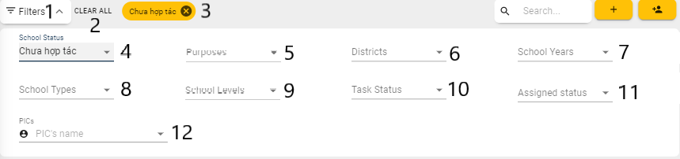

Figure 91. Tasks Filters<Sales Manager view>

|  |  |
| --- | --- |
| **Step** | **Description** |
| Pre-condition | User logged in as role “Sales Manager” |
| 1 | Click on the filters button |

Table 172. Tasks Filters <steps>

|  |  |  |  |  |  |  |
| --- | --- | --- | --- | --- | --- | --- |
| **No** | **Field Name** | **Description** | **Read only** | **Required** | **Control Type** | **Data Type** |
| 4 | School Status | Filter schools by the school status | No | No | Select | String |
| 5 | Purposes | Filter schools by the sales purposes | No | No | Select | String |
| 6 | Districts | Filter schools by the districts | No | No | Select | String |
| 7 | School Years | Filter schools by the school years | No | No | Select | String |
| 8 | School Types | Filter schools by the school types | No | No | Select | String |
| 9 | School Levels | Filter schools by the educational levels | No | No | Select | String |
| 10 | Task Status | Filter schools by the task status | No | No | Select | String |
| 11 | Assign Status | Filter schools by the assign status | No | No | Select | String |
| 12 | PIC’s name | Filter schools by the PIC’s name | No | No | Select | String |

Table 173. Tasks Filters <fields>

|  |  |  |  |  |
| --- | --- | --- | --- | --- |
| **No** | **Function** | **Description** | **Validation** | **Outcome** |
| 2 | Clear All filters | Clear all selected filters and reset all filters to default value | No |  |
| 3 | Remove a filter | Each selected filter is display as a chip. Clicks on “x” button to remove that chip and reset the according filter to default value | No |  |

Table 174. Tasks Filters <functions>

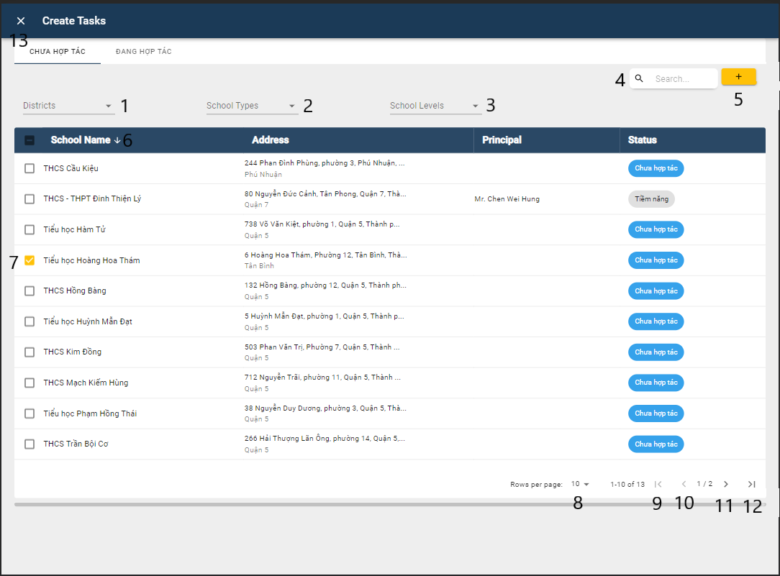

Figure 92. View Create Tasks

|  |  |
| --- | --- |
| **Step** | **Description** |
| Pre-condition | User logged in as role “Sales Manager” |
| 1 | Click on “Create Tasks” button |

Table 175. View Create Tasks <steps>

|  |  |  |  |  |  |  |
| --- | --- | --- | --- | --- | --- | --- |
| **No** | **Field Name** | **Description** | **Read only** | **Required** | **Control Type** | **Data Type** |
| 1 | Districts | Filter schools by the districts | No | No | Select | String |
| 2 | School Types | Filter schools by the school types | No | No | Select | String |
| 3 | School Levels | Filter schools by the educational levels | No | No | Select | String |
| 4 | Search | Search schools by school name, address, principal | No | No | Text Field | String |

Table 176. View Create Tasks <fields>

|  |  |  |  |  |
| --- | --- | --- | --- | --- |
| **No** | **Function** | **Description** | **Validation** | **Outcome** |
| 5 | Add School | Add schools for the creating task | No | Open a dialog to confirm create tasks |
| 6 | Sort |  | No |  |
| 7 | Select box | Select schools for the creating task | No |  |
| 8 | Change limit of the table | Select number of rows per page to display on the table (pagination) | No |  |
| 9 | First page | Move to the first page in the table | No |  |
| 10 | Previous page | Move to the page in the table | No |  |
| 11 | Next page | Move to the next page in the table | No |  |
| 12 | Last page | Move to the last page in the table | No |  |

Table 177. View Create Tasks <functions>

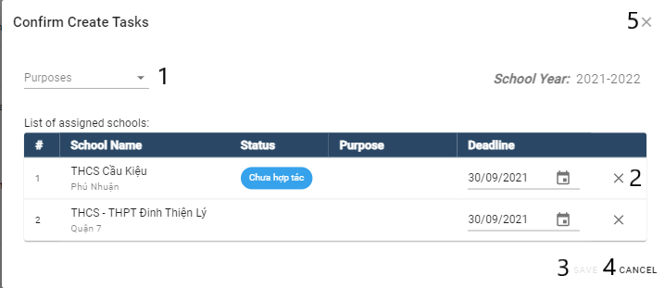

Figure 93. Confirm Create Tasks Dialog

|  |  |
| --- | --- |
| **Step** | **Description** |
| Pre-condition | Add school from the create tasks dialog |

Table 178. Confirm Create Tasks <steps>

|  |  |  |  |  |  |  |
| --- | --- | --- | --- | --- | --- | --- |
| **No** | **Field Name** | **Description** | **Read only** | **Required** | **Control Type** | **Data Type** |
| 1 | Purposes | Sales purpose for the chosen schools | No | No | Combo box | String |
| 2 | Deadline | Deadline for the task | No | No | Text Field | Date |

Table 179. Confirm Create Tasks <fields>

|  |  |  |  |  |
| --- | --- | --- | --- | --- |
| **No** | **Function** | **Description** | **Validation** | **Outcome** |
| 3 | Save | Submit a service | Yes | Notify create successfully |
| 4 | Cancel | Cancel create a new account | No | Close the form |
| 5 | Close Icon | Cancel create a new account | No | Close the form |

Table 180 . Confirm Create Tasks <functions>

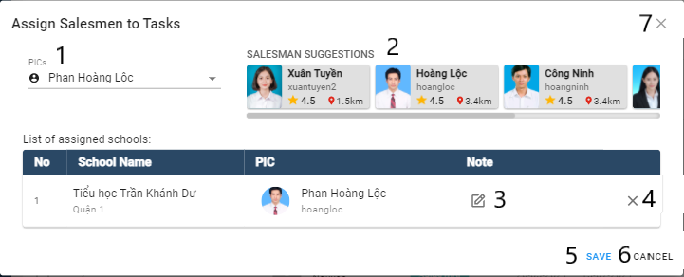

Figure 94. Assign Tasks to Salesman

|  |  |
| --- | --- |
| **Step** | **Description** |
| Pre-condition | User logged in as role “Sales Manager” |
| Pre-condition | Select task to assign |
| Pre-condition | Click on “Assign Tasks” button |

Table 181. Assign Tasks to Salesman <steps>

|  |  |  |  |  |  |  |
| --- | --- | --- | --- | --- | --- | --- |
| **No** | **Field Name** | **Description** | **Read only** | **Required** | **Control Type** | **Data Type** |
| 1 | PIC | PIC’s name | No | No | Text Field | String |
| 3 | Note | Note for the assigning | No | No | Text Field | Date |

Table 182. Assign Tasks to Salesman <fields>

|  |  |  |  |  |
| --- | --- | --- | --- | --- |
| **No** | **Function** | **Description** | **Validation** | **Outcome** |
| 2 | Salesman suggestions | Helper for the assigning tasks to salesman | No |  |
| 4 | Remove | Helper for the criteria of the service | No |  |
| 5 | Save | Assign salesman to the tasks | Yes | Notify create successfully |
| 6 | Cancel | Cancel create a new account | No | Close the form |
| 7 | Close Icon | Cancel create a new account | No | Close the form |

Table 183 Assign Tasks to Salesman <functions>

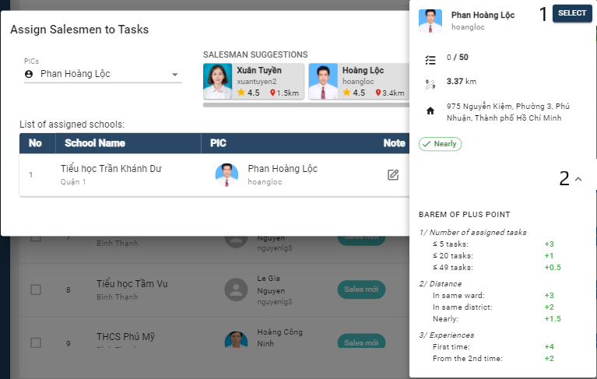

Figure 95. Assign Tasks to Salesman<Salesman Suggestion>

|  |  |
| --- | --- |
| **Step** | **Description** |
| Pre-condition | User logged in as role “Sales Manager” |
| Pre-condition | Select task to assign |
| Pre-condition | Click on “Assign Tasks” button |

Table 184. Assign Tasks to Salesman <steps>

|  |  |  |  |  |
| --- | --- | --- | --- | --- |
| **No** | **Function** | **Description** | **Validation** | **Outcome** |
| 1 | Select | Select suggested salesman to the tasks | No |  |
| 2 | Barem of suggestions | Helper to understand the suggestion | No |  |

Table 185 Assign Tasks to Salesman <functions>

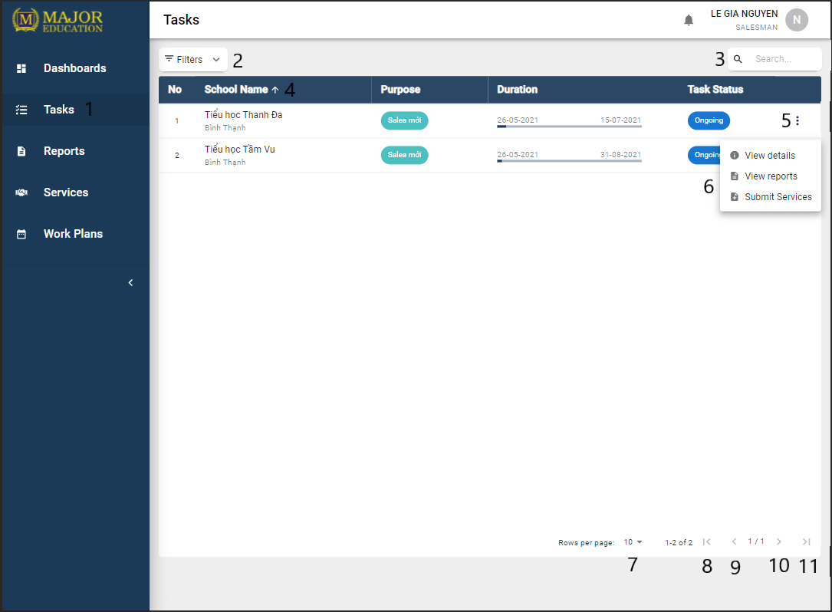

Figure 96. List of Tasks<Salesman view>

|  |  |
| --- | --- |
| **Step** | **Description** |
| Pre-condition | User logged in as role “Salesman” |
| 1 | Click on “Tasks” on the sidebar |

Table 186. View all Tasks <steps>

|  |  |  |  |  |  |  |
| --- | --- | --- | --- | --- | --- | --- |
| **No** | **Field Name** | **Description** | **Read only** | **Required** | **Control Type** | **Data Type** |
| 3 | Search | Search schools by school name | No | No | Text Field | String |

Table 187. View all Tasks <fields>

|  |  |  |  |  |
| --- | --- | --- | --- | --- |
| **No** | **Function** | **Description** | **Validation** | **Outcome** |
| 2 | Filter button | Open/Collapse Filter zone | No | An accordion which contains filters inside |
| 4 | Sort |  | No |  |
| 5 | Open menu options | Show menu options of actions which are allowed for a specific role | No |  |
| 6 | Menu Option | Option “View details” to show more details of the table’s row data.  Option “View reports” to show reports of the tasks.  Option “Submit Service” to report a service of the task. | No |  |
| 9 | Change limit of the table | Select number of rows per page to display on the table (pagination) | No |  |
| 10 | First page | Move to the first page in the table | No |  |
| 11 | Previous page | Move to the page in the table | No |  |
| 12 | Next page | Move to the next page in the table | No |  |
| 13 | Last page | Move to the last page in the table | No |  |

Table 188. View all Tasks <functions>

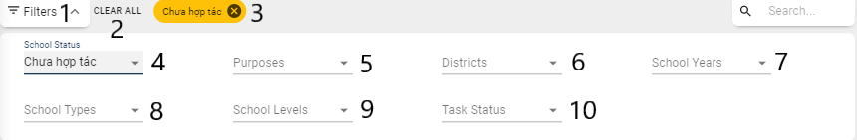

Figure 97. Tasks Filters<Salesman view>

|  |  |
| --- | --- |
| **Step** | **Description** |
| Pre-condition | User logged in as role “Salesman” |
| 1 | Click on the filters button |

Table 189. Tasks Filters <steps>

|  |  |  |  |  |  |  |
| --- | --- | --- | --- | --- | --- | --- |
| **No** | **Field Name** | **Description** | **Read only** | **Required** | **Control Type** | **Data Type** |
| 4 | School Status | Filter schools by the school status | No | No | Select | String |
| 5 | Purposes | Filter schools by the sales purposes | No | No | Select | String |
| 6 | Districts | Filter schools by the districts | No | No | Select | String |
| 7 | School Years | Filter schools by the school years | No | No | Select | String |
| 8 | School Types | Filter schools by the school types | No | No | Select | String |
| 9 | School Levels | Filter schools by the educational levels | No | No | Select | String |
| 10 | Task Status | Filter schools by the task status | No | No | Select | String |

Table 190. Tasks Filters <fields>

|  |  |  |  |  |
| --- | --- | --- | --- | --- |
| **No** | **Function** | **Description** | **Validation** | **Outcome** |
| 2 | Clear All filters | Clear all selected filters and reset all filters to default value | No |  |
| 3 | Remove a filter | Each selected filter is display as a chip. Clicks on “x” button to remove that chip and reset the according filter to default value | No |  |

Table 191. Tasks Filters <functions>

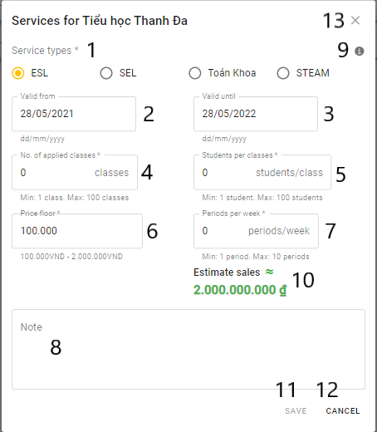

Figure 98. Summit Service

|  |  |
| --- | --- |
| **Step** | **Description** |
| Pre-condition | Choose “Create” from create school menu |

Table 192. Summit Service <steps>

|  |  |  |  |  |  |  |
| --- | --- | --- | --- | --- | --- | --- |
| **No** | **Field Name** | **Description** | **Read only** | **Required** | **Control Type** | **Data Type** |
| 1 | Service Types | Type of the service | No | Yes | Checkbox | String |
| 2 | Validate from | Service day start | No | No | Text Field | Date |
| 3 | Validate until | Service day end | No | No | Text Field | Date |
| 4 | No. applied classes | Number of classes apply to the service | No | No | Text Field | String |
| 5 | Student per class | Number of students per class | No | No | Text Field | String |
| 6 | Price Floor | Price floor of the service | No | No | Text Field | String |
| 7 | Periods per week | Number of periods per week | No | No | Text Field | String |
| 8 | Note | Note of the service | No | No | Text Field | String |

Table 193. Summit Service <fields>

|  |  |  |  |  |
| --- | --- | --- | --- | --- |
| **No** | **Function** | **Description** | **Validation** | **Outcome** |
| 9 | Criteria Description | Helper for the criteria of the service | No |  |
| 10 | Estimate Sales | Helper for the sales price | No |  |
| 11 | Save | Submit a service | Yes | Notify create successfully |
| 12 | Cancel | Cancel create a new account | No | Close the form |
| 13 | Close Icon | Cancel create a new account | No | Close the form |

Table 194 Summit Service <functions>

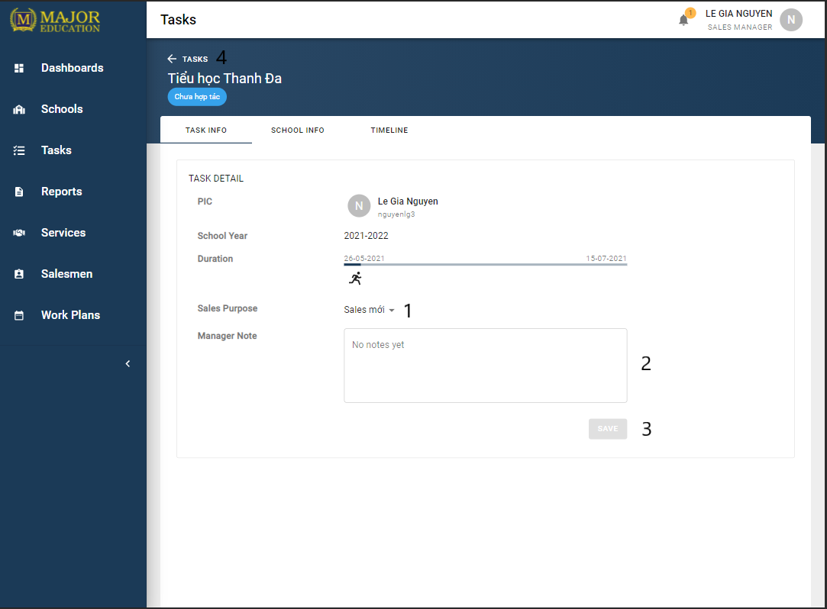

Figure 99. Task’s details<Task Info>

|  |  |
| --- | --- |
| **Step** | **Description** |
| Pre-condition | User logged in as role “Sales Manager” |
| Pre-condition | Click on “View details” option on the menu item of the table |
| Pre-condition | “Task info” tab selected |

Table 195. View Task details <steps>

|  |  |  |  |  |  |  |
| --- | --- | --- | --- | --- | --- | --- |
| **No** | **Field Name** | **Description** | **Read only** | **Required** | **Control Type** | **Data Type** |
| 1 | Sales Purpose | Sales purpose of the task | No | No | Combo Box | String |
| 2 | Manager Note | Managers note for the task | No | No | Text Field | String |

Table 196. View Task details <fields>

|  |  |  |  |  |
| --- | --- | --- | --- | --- |
| **No** | **Function** | **Description** | **Validation** | **Outcome** |
| 3 | Save | Update task info | Yes | Notify update successfully |
| 4 | Go back | Go back to tasks page | No | Redirect to Tasks page |

Table 197. View Task details <functions>

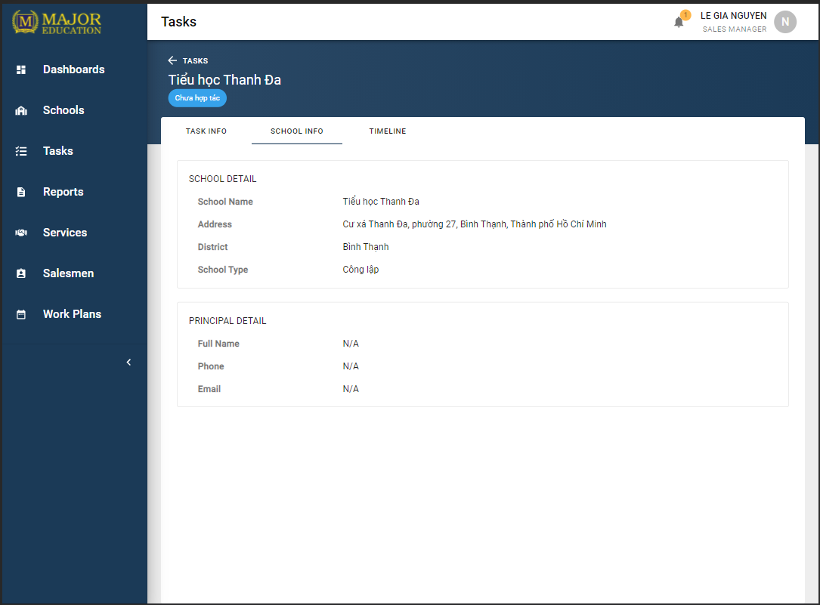

Figure 100. Task’s details<School Info>

|  |  |
| --- | --- |
| **Step** | **Description** |
| Pre-condition | User logged in as role “Sales Manager” |
| Pre-condition | Click on “View details” option on the menu item of the table |
| Pre-condition | “School info” tab selected |

Table 198. View Task details <steps>

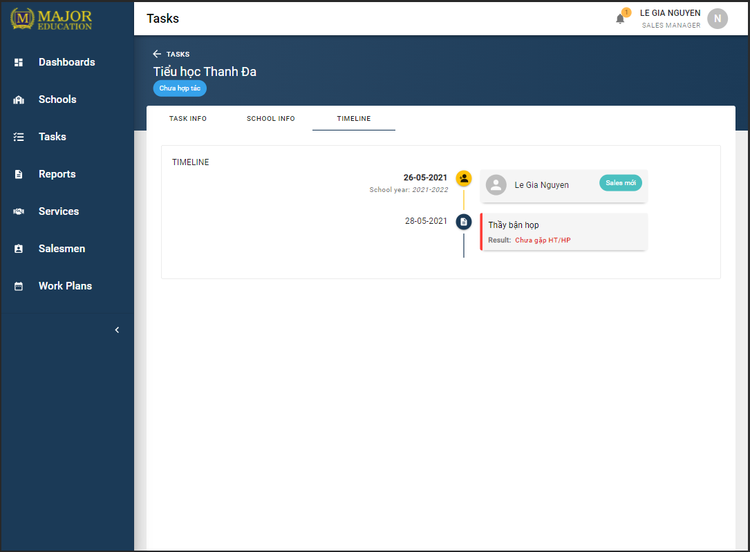

Figure 101. Task’s details<Timeline>

|  |  |
| --- | --- |
| **Step** | **Description** |
| Pre-condition | User logged in as role “Sales Manager” |
| Pre-condition | Click on “View details” option on the menu item of the table |
| Pre-condition | “Timeline” tab selected |

Table 199. View Task details <steps>

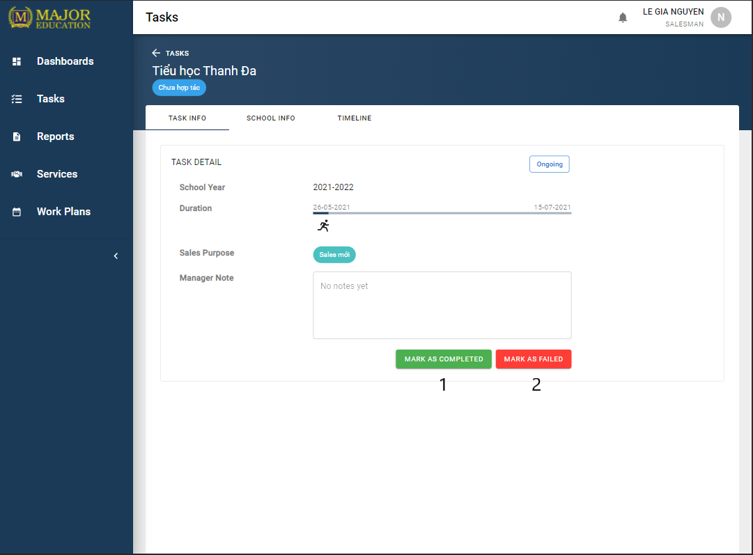

Figure 102. Task’s details<Task Info>

|  |  |
| --- | --- |
| **Step** | **Description** |
| Pre-condition | User logged in as role “Salesman” |
| Pre-condition | Click on “View details” option on the menu item of the table |
| Pre-condition | “Task info” tab selected |

Table 200. View Task details <steps>

|  |  |  |  |  |
| --- | --- | --- | --- | --- |
| **No** | **Function** | **Description** | **Validation** | **Outcome** |
| 3 | Mask as Complete | Mark the target as complete | No |  |
| 4 | Mark as Failed | Mark the target as failed | No |  |

Table 201. View Task details <functions>

#### 3.3.5 Reports

Purpose

* The sales manager manages personal daily reports.
* The sales supervisor manages personal daily reports.
* The salesman manages personal daily reports.
* The sales manager comments on salesman’s report.
* The sales department monitors their reports.

Functions

* View list of reports.
* View report’s details.
* Search reports.
* Create reports.
* Edit report's information.
* Comment reports.
* Remove reports.

User interface(s)

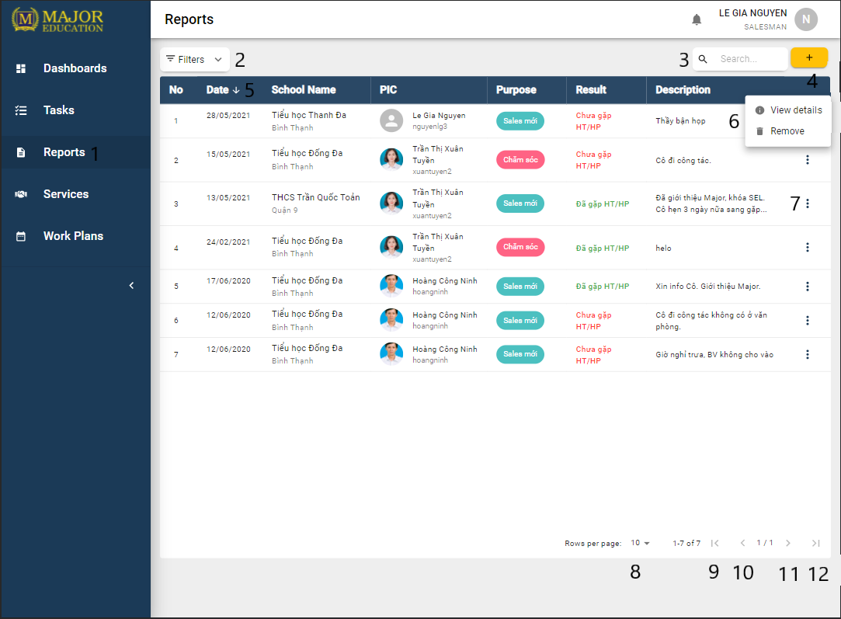

Figure 103. List of Reports

|  |  |
| --- | --- |
| **Step** | **Description** |
| Pre-condition | User logged in as role “Salesman” |
| 1 | Click on “Reports” on the sidebar |

Table 202. View all Reports <steps>

|  |  |  |  |  |  |  |
| --- | --- | --- | --- | --- | --- | --- |
| **No** | **Field Name** | **Description** | **Read only** | **Required** | **Control Type** | **Data Type** |
| 3 | Search | Search reports by school name, PIC, description | No | No | Text Field | String |

Table 203. View all Reports <fields>

|  |  |  |  |  |
| --- | --- | --- | --- | --- |
| **No** | **Function** | **Description** | **Validation** | **Outcome** |
| 2 | Filter button | Open/Collapse Filter zone | No | An accordion which contains filters inside |
| 4 | Create reports | Create new report | No | A “Create Report” form |
| 5 | Sort |  | No |  |
| 6 | Menu Option | Option “View details” to show more details of the table’s row data.  Option “Remove” to remove only when report does not have any manager comment. | No |  |
| 7 | Open menu options | Show menu options of actions which are allowed for a specific role | No |  |
| 8 | Change limit of the table | Select number of rows per page to display on the table (pagination) | No |  |
| 9 | First page | Move to the first page in the table | No |  |
| 10 | Previous page | Move to the page in the table | No |  |
| 11 | Next page | Move to the next page in the table | No |  |
| 12 | Last page | Move to the last page in the table | No |  |

Table 204. View all Reports <functions>

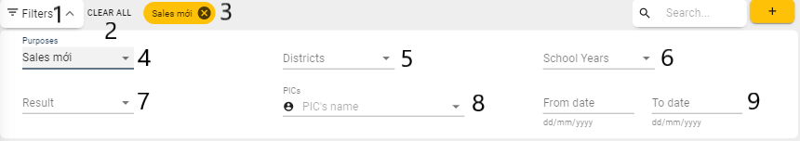

Figure 104. Reports Filters

|  |  |
| --- | --- |
| **Step** | **Description** |
| 1 | Click on the filters button |

Table 205. Reports Filters <steps>

|  |  |  |  |  |  |  |
| --- | --- | --- | --- | --- | --- | --- |
| **No** | **Field Name** | **Description** | **Read only** | **Required** | **Control Type** | **Data Type** |
| 4 | Purposes | Filter reports by the sales purpose | No | No | Select | String |
| 5 | Districts | Filter reports by the school district | No | No | Select | String |
| 6 | School Years | Filter reports by the school years | No | No | Select | String |
| 7 | Result | Filter reports by the result | No | No | Select | String |
| 8 | PIC’s name | Filter reports by the PIC’s name | No | No | Select | String |
| 9 | From date to date | Filter reports by date | No | No | Select | String |

Table 206. Reports Filters <fields>

|  |  |  |  |  |
| --- | --- | --- | --- | --- |
| **No** | **Function** | **Description** | **Validation** | **Outcome** |
| 2 | Clear All filters | Clear all selected filters and reset all filters to default value | No |  |
| 3 | Remove a filter | Each selected filter is display as a chip. Clicks on “x” button to remove that chip and reset the according filter to default value | No |  |

Table 207. Reports Filters <functions>

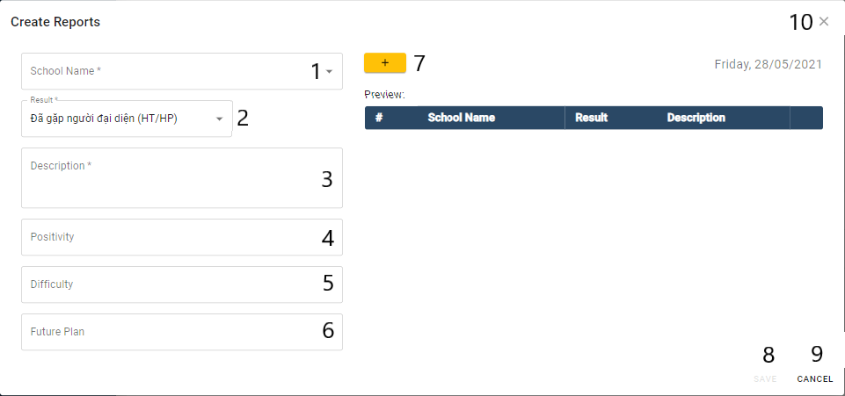

Figure 105. Create Reports Form

|  |  |
| --- | --- |
| **Step** | **Description** |
| Pre-condition | Click on the create reports button |

Table 208. Create Reports Form <steps>

|  |  |  |  |  |  |  |
| --- | --- | --- | --- | --- | --- | --- |
| **No** | **Field Name** | **Description** | **Read only** | **Required** | **Control Type** | **Data Type** |
| 1 | School Name | Name of the school | No | Yes | Text Field | String |
| 2 | Result | Result of the report | No | Yes | Combo Box | String |
| 3 | Description | Description of the report | No | Yes | Text Field | String |
| 4 | Positivity | Positivity of the result | No | No | Text Field | String |
| 5 | Difficulty | Difficulty of the result | No | No | Text Field | String |
| 6 | Future Plan | Future Plan for the result | No | No | Text Field | String |

Table 209. Create Reports Form <fields>

|  |  |  |  |  |
| --- | --- | --- | --- | --- |
| **No** | **Function** | **Description** | **Validation** | **Outcome** |
| 7 | Add | Add a report to create reports list | Yes | Show the reports list |
| 8 | Save | Create a new account | No | Notify create successfully |
| 9 | Cancel | Cancel create a new account | No | Close the form |
| 10 | Close Icon | Cancel create a new account | No | Close the form |

Table 210. Create Reports Form <functions>

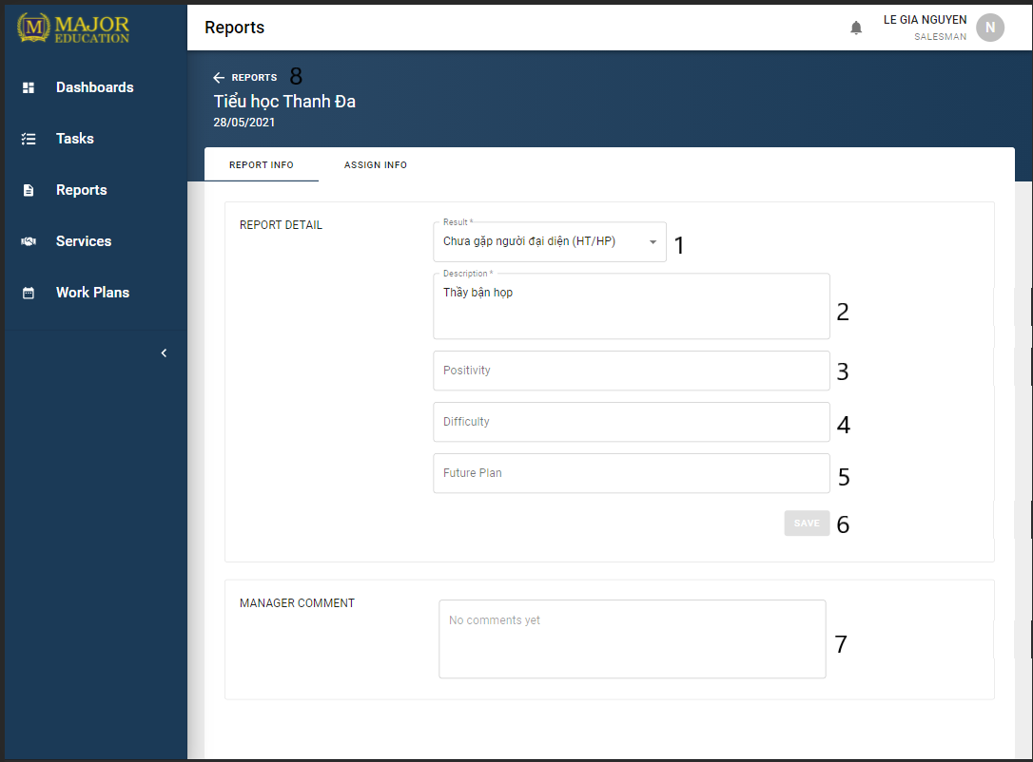

Figure 106. Report’s details<Report Info>

|  |  |
| --- | --- |
| **Step** | **Description** |
| Pre-condition | User logged in as role “Salesman” |
| Pre-condition | Click on “View details” option on the menu item of the table |
| Pre-condition | Report has not been commented by the manager/supervisor |
| Pre-condition | “Report info” tab selected |

Table 211. View Report details <steps>

|  |  |  |  |  |  |  |
| --- | --- | --- | --- | --- | --- | --- |
| **No** | **Field Name** | **Description** | **Read only** | **Required** | **Control Type** | **Data Type** |
| 1 | Result | Result of the report | No | Yes | Combo Box | String |
| 2 | Description | Description of the report | No | Yes | Text Field | String |
| 3 | Positivity | Positivity of the result | No | No | Text Field | String |
| 4 | Difficulty | Difficulty of the result | No | No | Text Field | String |
| 5 | Future Plan | Future Plan for the result | No | No | Text Field | String |
| 7 | Manager Comment | A comment of the manager | No | No | Text Field | String |

Table 212. View Report details <fields>

|  |  |  |  |  |
| --- | --- | --- | --- | --- |
| **No** | **Function** | **Description** | **Validation** | **Outcome** |
| 6 | Save | Update report info | Yes | Notify update successfully |
| 8 | Go back | Go back to school’s page | No | Redirect to Schools page |

Table 213. View Report details <functions>

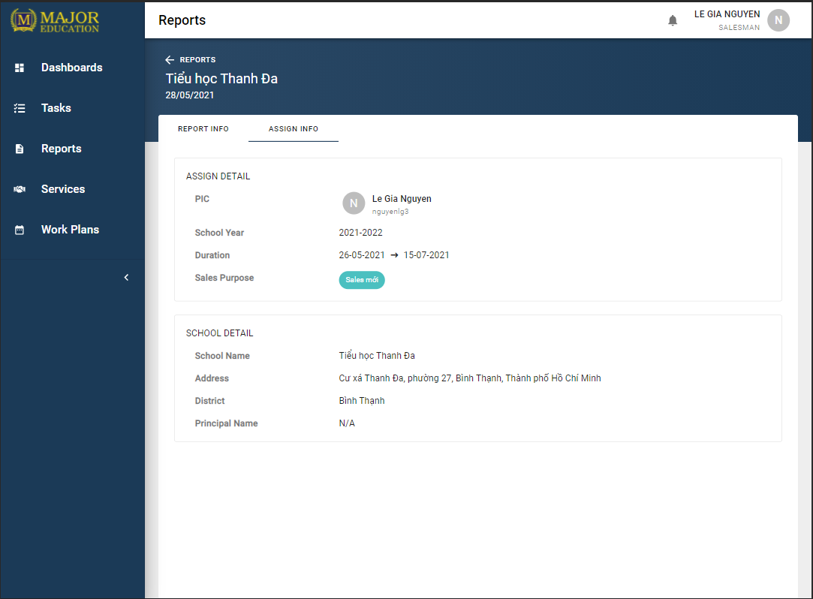

Figure 107. Report’s details<Assign Info>

|  |  |
| --- | --- |
| **Step** | **Description** |
| Pre-condition | User logged in as role “Salesman” |
| Pre-condition | Click on “View details” option on the menu item of the table |
| Pre-condition | “Assign info” tab selected |

Table 214. View Report details <steps>

#### 3.3.6. Profiles

Purpose

* The user edits personal profile.

Functions

* View profile.
* Edit profile.

User interface(s)

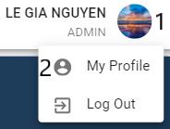

Figure 108. View profiles <steps>

|  |  |
| --- | --- |
| **Step** | **Description** |
| Pre-condition | User logged in the application |
| 1 | Click on the user info in the top-right corner of the screen |
| 2 | In the menu list, select “My Profile” option |

Table 215. View profiles <steps>

|  |  |  |  |  |
| --- | --- | --- | --- | --- |
| **No** | **Function** | **Description** | **Validation** | **Outcome** |
| 1 | [User Menu] | A button covers the user info and the user menu | No | A menu list shown below |
| 2 | My Profile | A button covers the “My Profile” menu item | No | Redirect to Profiles screen |

Table 216. View profiles <functions>

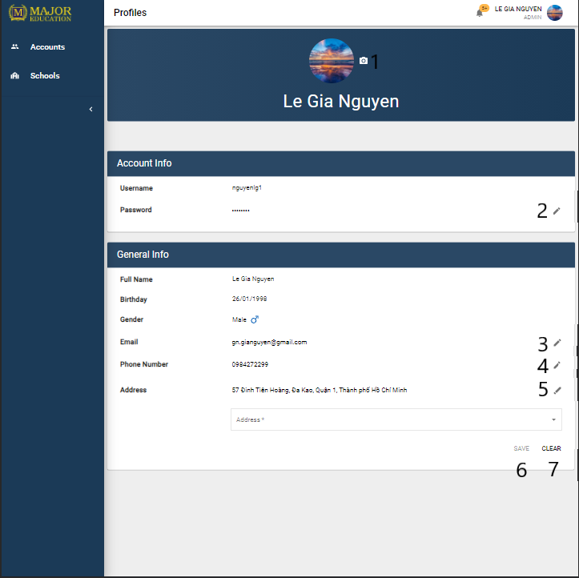

Figure 109 Profile

|  |  |
| --- | --- |
| **Step** | **Description** |
| Pre-condition | User logged in the application |
| 1 | Click on the icon button to edit profile |

Table 217. Edit profiles <steps>

|  |  |  |  |  |
| --- | --- | --- | --- | --- |
| **No** | **Function** | **Description** | **Validation** | **Outcome** |
| 1 | Upload avatar | An “camera” icon button for uploading avatar image | Yes | Let the user choose one image from their device storage |
| 2 | Change password | An “pen” icon button for opening edit form | Yes | A form to edit will be shown |
| 3 | Edit email | An “pen” icon button for opening edit form | Yes | A form to edit will be shown |
| 4 | Edit phone number | An “pen” icon button for opening edit form | Yes | A form to edit will be shown |
| 5 | Edit address | An “pen” icon button for opening edit form | Yes | A form to edit will be shown |
| 6 | Save | Update profile info | Yes | Notify update successfully |
| 7 | Cancel | Cancel create a new account | No | Close the form |

Table 218. Edit profiles <functions>

#### 3.3.7 Workplans

Purpose

* The user manages personal workplans.

Functions

* View workplans.
* View personal activities details.
* Create personal activities.
* Edit personal activities.
* Remove personal activities.

User interface(s)

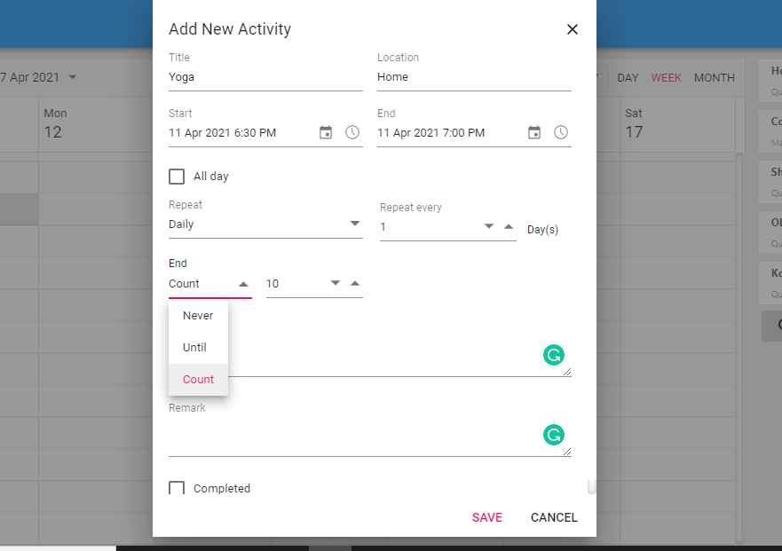

Figure 110 Add New Daily Activity

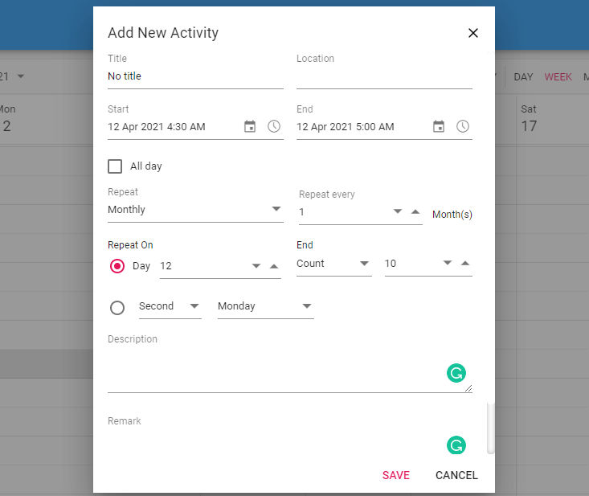

Figure 111 Add New Monthly Activity

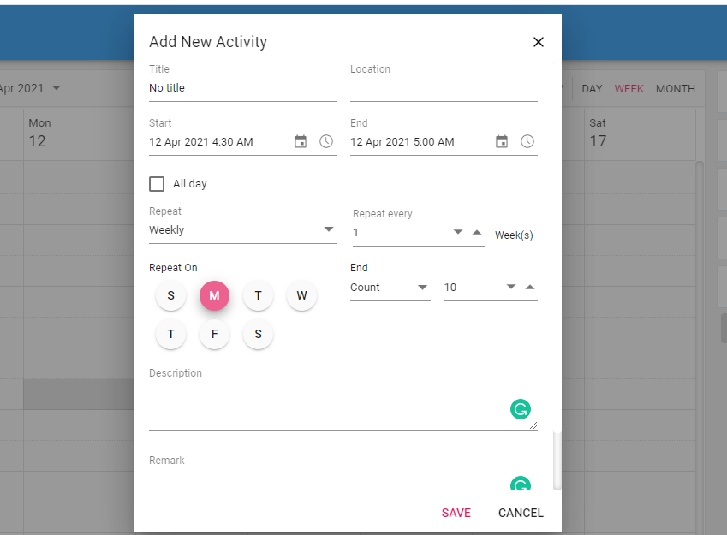

Figure 112 Add New Weekly Activity

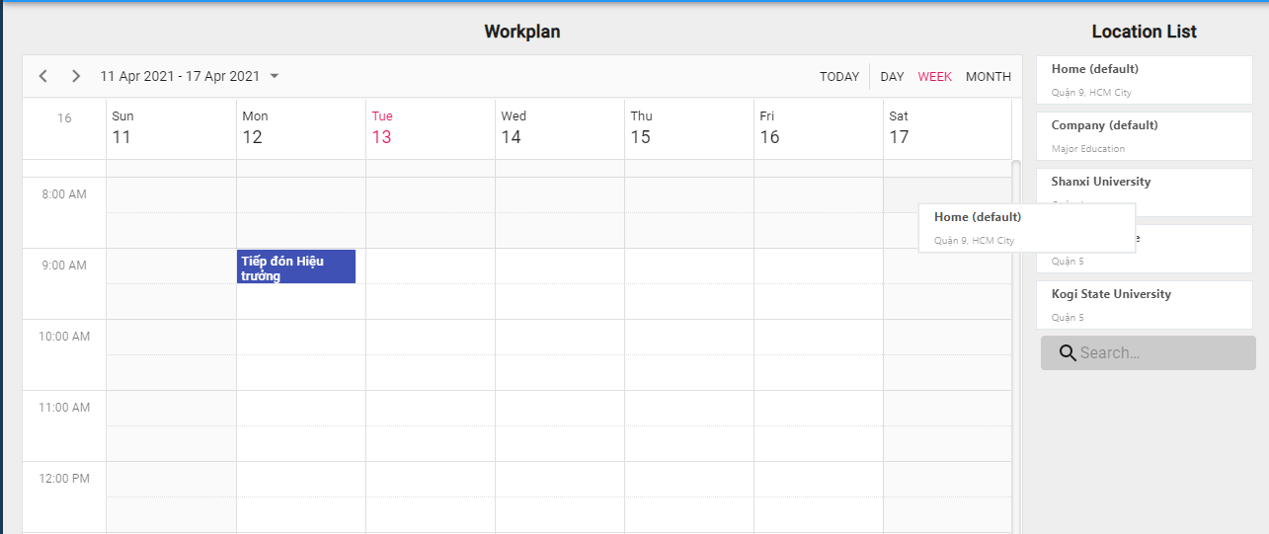

Figure 113 Drag Location Card to Add new

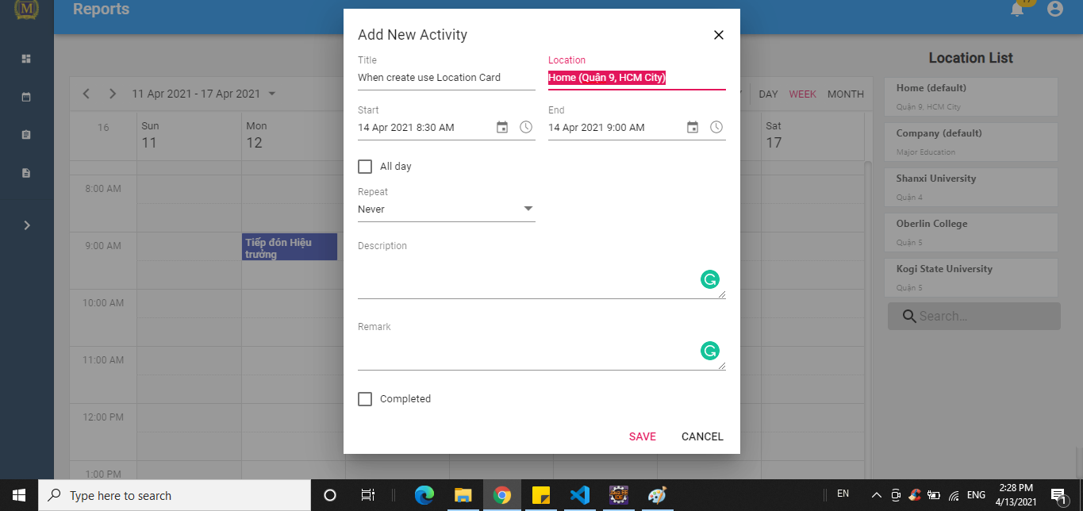

Figure 114 Add New Activity by Dragging Location Card

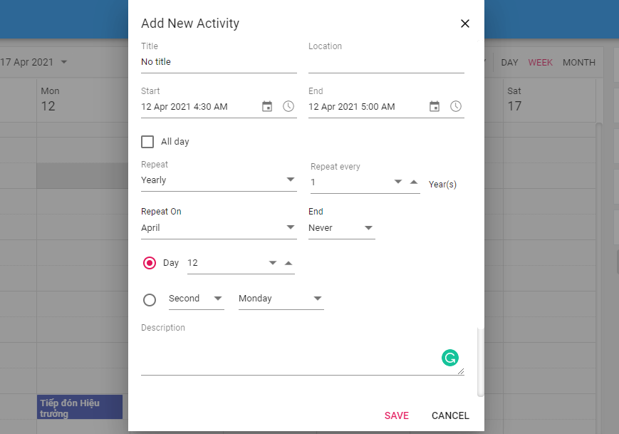

Figure 115 Add New Yearly Activity

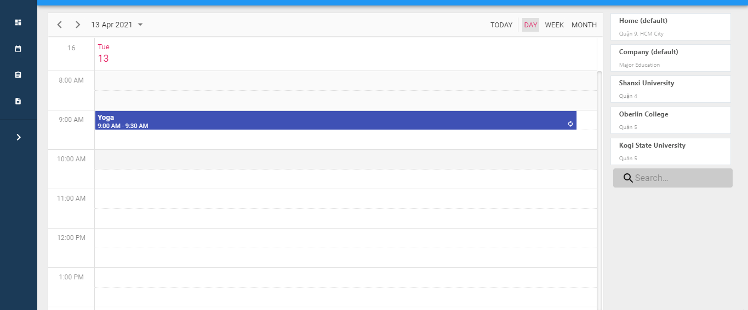

Figure 116 Day view

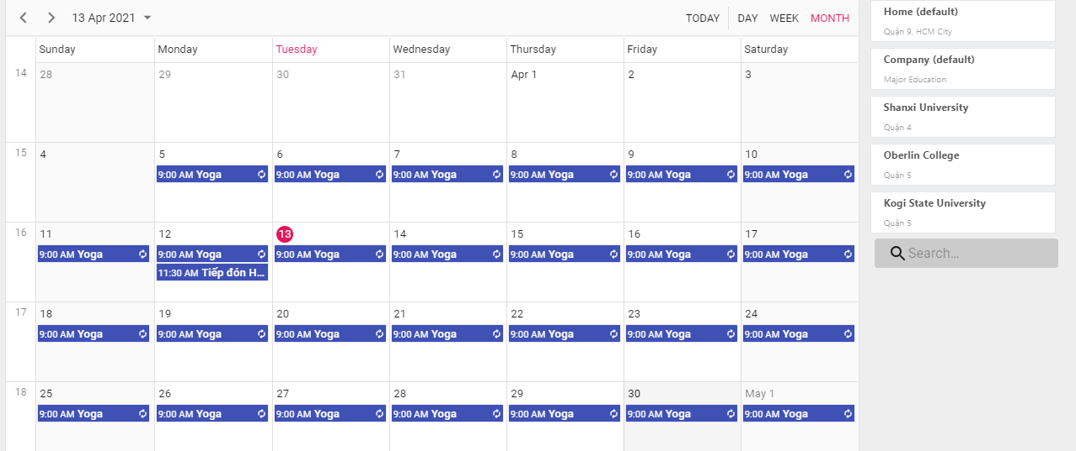

Figure 117 Monthly view

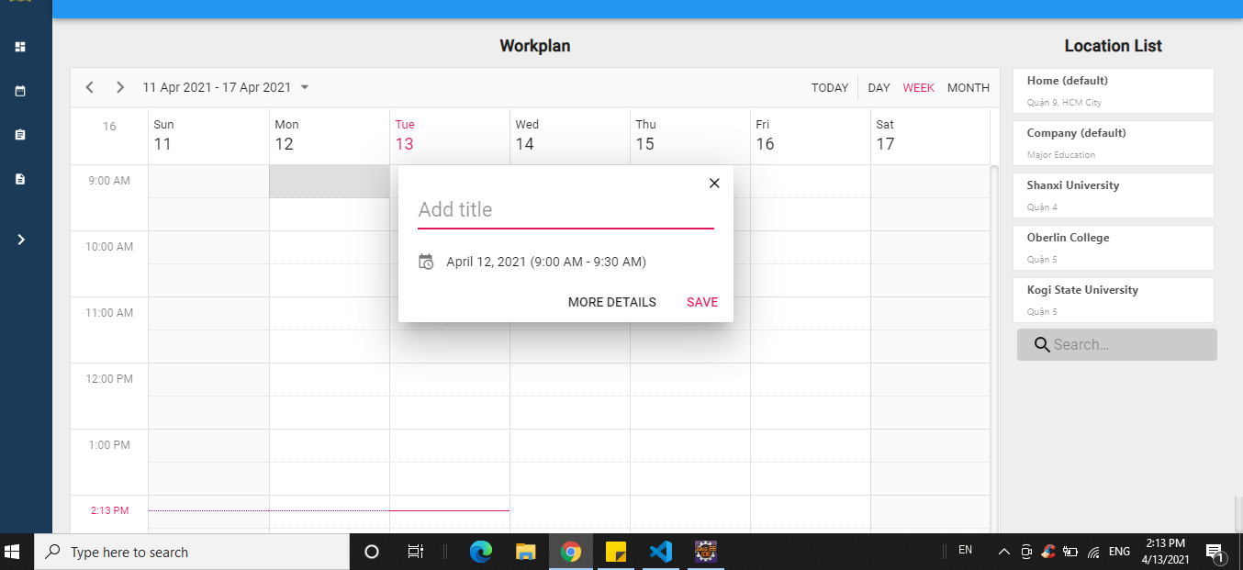

Figure 118 Quick Add Form

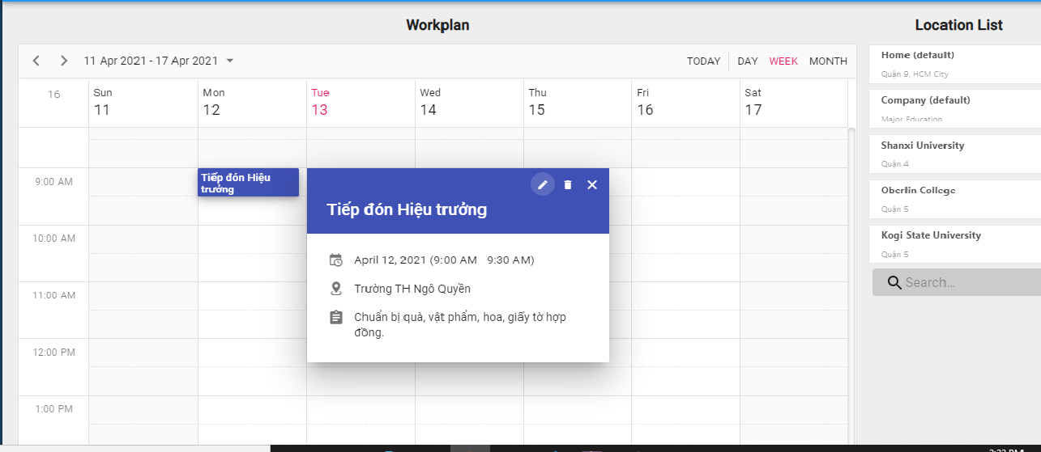

Figure 119 Quick Details

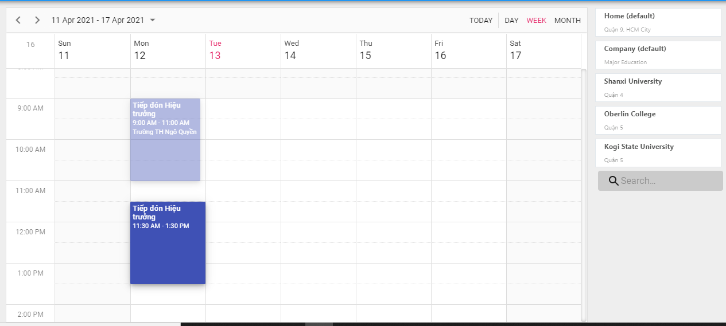

Figure 120 Edit by Drag Activity

#### 3.3.8 Dashboards

Purpose

* The sales department tracks their work process.

Functions

* View dashboards.

User interface(s)

N/A

#### 3.3.9 Services

Purpose

* The sales manager supervises services.
* The salesman tracks assigned services.

Functions

* View list of services.
* View contract’s details.
* Search services.
* Edit service’s information.

User interface(s)

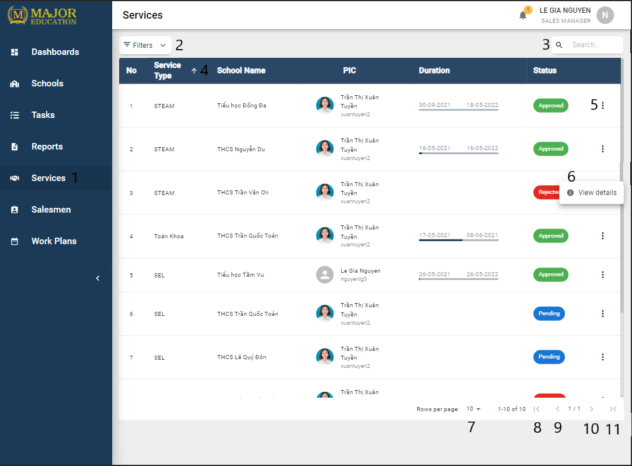

Figure 121. List of Services

|  |  |
| --- | --- |
| **Step** | **Description** |
| Pre-condition | User logged in as role “Sales Manager” |
| 1 | Click on “Services” on the sidebar |

Table 219. View all Services <steps>

|  |  |  |  |  |  |  |
| --- | --- | --- | --- | --- | --- | --- |
| **No** | **Field Name** | **Description** | **Read only** | **Required** | **Control Type** | **Data Type** |
| 3 | Search | Search services by school name, PIC, service type | No | No | Text Field | String |

Table 220 View all Services <fields>

|  |  |  |  |  |
| --- | --- | --- | --- | --- |
| **No** | **Function** | **Description** | **Validation** | **Outcome** |
| 2 | Filter button | Open/Collapse Filter zone | No | An accordion which contains filters inside |
| 4 | Sort |  | No |  |
| 5 | Menu Option | Option “View details” to show more details of the table’s row data.  Option “Remove” to remove only when report does not have any manager comment. | No |  |
| 6 | Open menu options | Show menu options of actions which are allowed for a specific role | No |  |
| 7 | Change limit of the table | Select number of rows per page to display on the table (pagination) | No |  |
| 8 | First page | Move to the first page in the table | No |  |
| 9 | Previous page | Move to the page in the table | No |  |
| 10 | Next page | Move to the next page in the table | No |  |
| 11 | Last page | Move to the last page in the table | No |  |

Table 221 View all Services <functions>

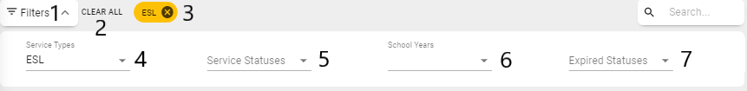

Figure 122. Services Filters

|  |  |
| --- | --- |
| **Step** | **Description** |
| 1 | Click on the filters button |

Table 222. Services Filters <steps>

|  |  |  |  |  |  |  |
| --- | --- | --- | --- | --- | --- | --- |
| **No** | **Field Name** | **Description** | **Read only** | **Required** | **Control Type** | **Data Type** |
| 4 | Service Types | Filter services by types | No | No | Select | String |
| 5 | Service Status | Filter services by the status | No | No | Select | String |
| 6 | School Years | Filter services by the school years | No | No | Select | String |
| 7 | Expired Status | Filter services by the expired status | No | No | Select | String |

Table 223. Services Filters<fields>

|  |  |  |  |  |
| --- | --- | --- | --- | --- |
| **No** | **Function** | **Description** | **Validation** | **Outcome** |
| 2 | Clear All filters | Clear all selected filters and reset all filters to default value | No |  |
| 3 | Remove a filter | Each selected filter is display as a chip. Clicks on “x” button to remove that chip and reset the according filter to default value | No |  |

Table 224. Services Filters <functions>

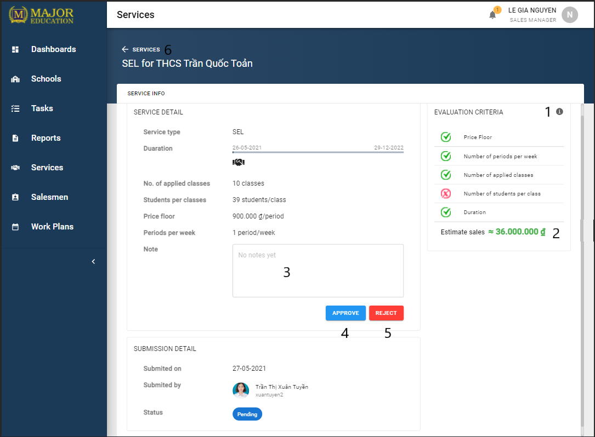

Figure 123. Service's detail

|  |  |
| --- | --- |
| **Step** | **Description** |
| Pre-condition | User logged in as role “Sales Manager” |
| Pre-condition | Click on “View details” option on the menu item of the table |

Table 225. View Service details <steps>

|  |  |  |  |  |  |  |
| --- | --- | --- | --- | --- | --- | --- |
| **No** | **Field Name** | **Description** | **Read only** | **Required** | **Control Type** | **Data Type** |
| 3 | Note | Note for the service | No | No | Text Field | String |

Table 226. View Service details <fields>

|  |  |  |  |  |
| --- | --- | --- | --- | --- |
| **No** | **Function** | **Description** | **Validation** | **Outcome** |
| 1 | Criteria Description | Helper for the criteria of the service | No |  |
| 2 | Estimate Sales | Helper for the sales price | No |  |
| 4 | Approve | Approve the service | No |  |
| 5 | Reject | Reject the service | No |  |
| 6 | Go back | Go back to services page | No | Redirect to Services page |

Table 227. View Service details <functions>

#### 3.3.10 Logins

Purpose

* The unauthorized user logins the system.
* The user retrieves their password.

Functions

* Login with username and password.
* Forgot password.

User interface(s)

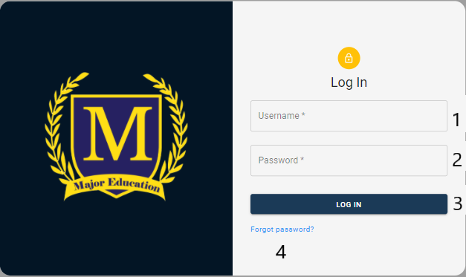

Figure 124 Login

|  |  |
| --- | --- |
| **Step** | **Description** |
| Pre-condition | Go to login page of the app |

Table 228. Login screen <steps>

|  |  |  |  |  |  |  |
| --- | --- | --- | --- | --- | --- | --- |
| **No** | **Field Name** | **Description** | **Read only** | **Required** | **Control Type** | **Data Type** |
| 1 | Username | Username of the user | No | Yes | Text Field | String |
| 2 | Password | Password of the user | No | Yes | Text Field | Password |

Table 229. Login screen <fields>

|  |  |  |  |  |
| --- | --- | --- | --- | --- |
| **No** | **Function** | **Description** | **Validation** | **Outcome** |
| 3 | LOG IN | Log the user into the application | Yes | Redirect to the Home page |
| 4 | Forgot password | Let the user retrieves their password | No | Redirect to the Password Reset page |

Table 230. Login screen <functions>

#### 3.3.11 Logout

Purpose

* The authorized user logouts the system

Functions

* Logout

User interface(s)

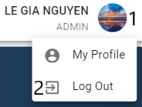

Figure 125 Logout

|  |  |
| --- | --- |
| **Step** | **Description** |
| Pre-condition | User logged in the application |
| 1 | Click on the user info in the top-right corner of the screen |
| 2 | In the menu list, select “Log Out” option |

Table 231. Log out <steps>

|  |  |  |  |  |
| --- | --- | --- | --- | --- |
| **No** | **Function** | **Description** | **Validation** | **Outcome** |
| 1 | [User Menu] | A button covers the user info and the user menu | No | A menu list shown below |
| 2 | Log Out | A button covers the “Log Out” menu item | No | Redirect to Login screen |

Table 232. Log out <functions>

### 3.4 Troubleshooting

#### 3.4.1 Web app layout broke during cross-device use

Problems:

* The application responsive interface has not supported for all devices.

Workaround:

* Refresh the web app page.
* Contacts the system developers for more supports.

#### 3.4.2 Avatar or images loading time is long

Problems:

* The Internet connection is slow or unstable.

Workaround:

* Refresh the web app page.
* Connect with a better Internet connection.

#### 3.4.3 Data record loading time is long

Problems:

* The Internet connection is slow or unstable.

Workaround:

* Refresh the web app page.
* Connect with a better Internet connection.

## ４．ユーザーマニュアル

### 4.1　用語と定義

この販売管理システムはMajorEducationのため、開発されたものですから、すべての利用規約はそれらに属している。

### 4.2　システム要件

#### 4.2.1 　ハードウェア要件

* このシステムはWebアプリケーションですから、システムを使用されるとき、インターネットで接続する必要がある。
* 私たちのシステムはサーバーにデプロイされており、実行するための最小要件サービスは次のとおりです。

Webアプリの場合

|  |  |
| --- | --- |
| **ハードウェア** | **最小要件** |
| vCPU | 1 |
| オペレーションシステム | Linux Server/Window server |
| メモリー(GiB) | 1GiB (=1.07374 GB) |

Table 233. 「システム要件」 Web アプリの場合

API サービスの場合

|  |  |
| --- | --- |
| **Hardware** | **最小要件** |
| vCPU | 1 |
| オペレーションシステム | Linux Server/Window server |
| メモリー(GiB) | 1GiB (=1.07374 GB) |

Table 234. 「システム要件」 API サービスの場合

Databaseの場合

|  |  |
| --- | --- |
| **Hardware** | **最小要件** |
| vCPU | 1 |
| オペレーションシステム | Linux server/Window sẻver |
| メモリー(GiB) | 1GiB (=1.07374 GB) |

Table 235. 「システム要件」 Database の場合

#### 4.2.2　ソフトウェア要件

このWebアプリケーションは、Chrome（バージョン52以上）、Firefox（バージョン51以上）、Edge（バージョン14以上）、Safari（バージョン10以上）、またはOpera（バージョン38以上）ブラウザーで動作する。

### 4.3　アプリケーションの使用

#### 4.3.1　概要

この販売管理システムの主にユーザーはMajorEducationの販売部門です。

#### 4.3.2　アカウント

目標

* ユーザーアカウントを管理する。

機能

* アカウントのリストの表示
* アカウントの詳細の表示
* アカウントの検索
* アカウントの作成
* アカウントの情報の編集

ユーザーインターフェース



Figure 126アカウントリスト



Figure 127 アカウントフィルター



Figure 128 アカウントの作成



Figure 129 アカウント詳細

#### 4.3.3　スクール

目標

* スクールを管理する。

機能

* スクールのリストの表示
* スクールの詳細の表示
* スクールの検索
* スクールの作成
* スクールの情報の編集

ユーザーインターフェース



Figure 130スクールリスト



Figure 131 スクールフィルター



Figure 132 スクールの作成



Figure 133 スクールの作成 ＜フォーム＞



Figure 134スクールの作成 ＜インポートファイル＞



Figure 135スクールの詳細

#### 4.3.4　タスク

目標

* タスクを管理する。

機能

* タスクのリストの表示
* タスクの詳細の表示
* タスクの検索
* タスクの作成
* タスク情報の編集
* タスクにセールスマンの割当
* タスクの削除

ユーザーインターフェース



Figure 136タスク



Figure 137タスクフィルター



Figure 138•タスクの作成



Figure 139タスクの作成



Figure 140•タスクにセールスマンの割当



Figure 141タスクの詳細



Figure 142タスクの詳細

#### 4.3.5　レポート

目標

* レポートを管理する。

機能

* レポートのリストの表示
* レポートの詳細の表示
* レポートの検索
* レポートの作成
* レポートの情報の編集
* コメントレポート
* レポートの削除

ユーザーインターフェース



Figure 143レポートのリスト



Figure 144レポートフィルター



Figure 145レポートの作成



Figure 146レポートの詳細

#### 4.3.6　プロフィール

目標

* プロフィールを管理する。

機能

* プロフィールの表示
* プロファイルの編集

ユーザーインターフェース

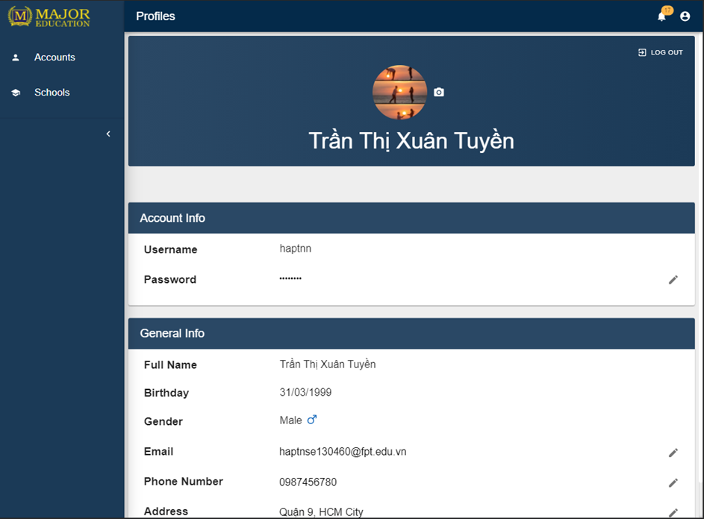

Figure 147プロフィール

#### 4.3.7　作業計画

目標

* 作業計画を管理する。

機能

* 作業計画の表示
* 個人的な活動の詳細の表示
* 個人的な活動の作成
* 個人的な活動の編集
* 個人的な活動の削除

ユーザーインターフェース



Figure 148デイビュー



Figure 149月表示



Figure 150 クイック追加



Figure 151 活動の詳細

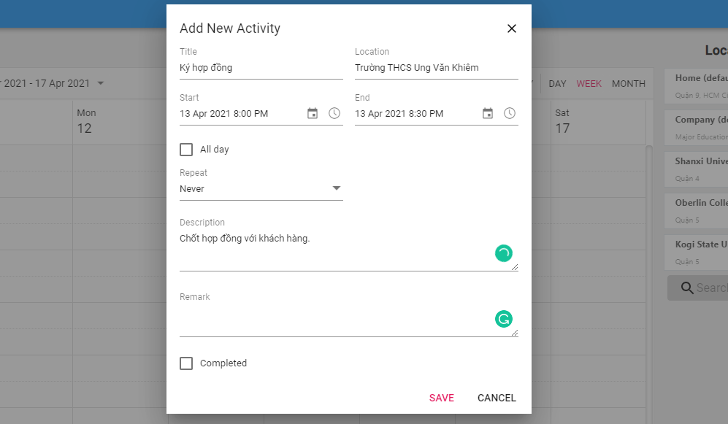

Figure 152 詳細追加



Figure 153 ドラッグして編集

#### 4.3.8　ダッシュボード

目標

* 営業部門は営業プロセスを追跡する。

機能

* ダッシュボードの表示

ユーザーインターフェース

N/A

#### 4.3.9　サービス

目標

* サービスを管理する。

機能

* サービスのリストの表示
* サービスの詳細の表示
* サービスの検索
* サービスの作成
* サービスの情報の編集

ユーザーインターフェース



Figure 154サービスのリスト



Figure 155サービスフィルター



Figure 156サービスの詳細

#### 4.3.10　ログイン

目標

* 許可されていないユーザーがシステムにログインする。
* ユーザーのパスワードをリセットしする。

機能

* ユーザー名とパスワードでログイン
* パスワードリマインダー

ユーザーインターフェース

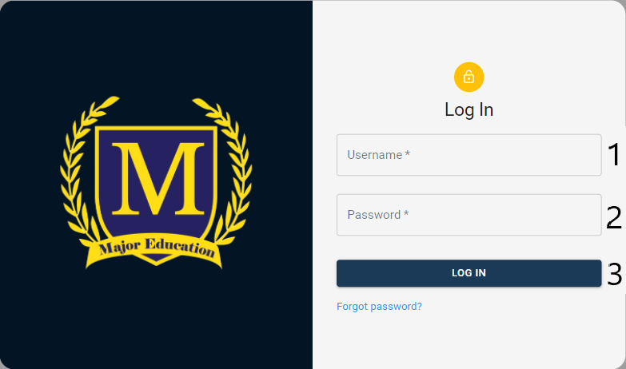

Figure 157ログイン

#### 4.3.11　ログアウト

目標

* 許可されたユーザーがシステムからログアウトする。

機能

* ログアウト

ユーザーインターフェース



Figure 158ログアウト

### 4.4　トラブルシューティング

#### 4.4.1　Webアプリ画面レイアウトが崩れる

問題

* アプリケーションレスポンシブUIは、すべてのデバイスでまだサポートされていないことです。

解決

* Webのページをリフレッシュしてください。
* その他のサポートについては、システム開発者に連絡してください。

#### 4.4.2　画像の読み込み時間が遅い

問題

* インターネット接続が遅い。

解決

* Webのページをリフレッシュしてください。
* もっと良いインターネットに接続してください。

#### 4.4.3　テーブルデータの読み込み時間が遅い

問題

* インターネット接続が遅い。

解決

* Webのページをリフレッシュしてください。
* もっと良いインターネットに接続してください。

# VII. Appendix

## 1. References

* OMG Unified Modeling LanguageTM (OMG UML) Superstructure

<https://www.omg.org/spec/UML/2.4.1/Superstructure/PDF>

* UML Diagram

<https://www.uml-diagrams.org/>

* ReactJS

https://reactjs.org/

* Material design

https://material.io/design

* Material-UI

https://material-ui.com/

* Spring boot

https://spring.io/projects/spring-boot

* Firebase

https://firebase.google.com/

1. This *Definition and Acronyms* table focuses mainly on the definitions of the terms we used in our project scope, which strictly related to our business rules and user requirements of Sales Department of the Major Education.

   Therefore, in this document, some terms may be different than the common knowledge.
2. Source: <https://www.careerexplorer.com/careers/sales-manager/>.
3. Source: <https://www.salary.com/research/job-description/benchmark/sales-supervisor-job-description>.
4. Source: <https://www.businessmanagementideas.com/marketing/sales-person/sales-person/21207>.
5. Source: <https://kpi.org/KPI-Basics>.